August 2020 Newsletter of the HC Seattle
Dear Friends of Austria!
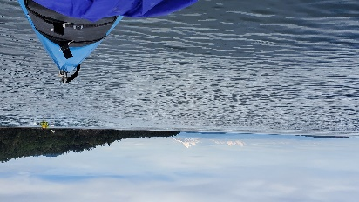 This can only be found in WA State – A snow covered mountain viewed from the sea, only a jumping Orca is missing. Anybody’s guess where this photo was taken? (Answer at the end of the newsletter!). The pleasant summertime in WA helps to cope with the miserable Covid-19 situation. Stunning nature offers so much beauty and a source of energy, from hiking, biking, kayaking, swimming, all we can do while adhering to social distancing!
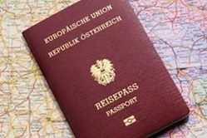 The new Passport Service for adults (with fingerprints) at the Honorary Consulate of Austria in Seattle was in high demand since its start about 2 months ago. There is no need to travel to Los Angeles anymore because of the passport application!
For required documents, forms to download, etc., please check the website of the Consulate General in Los Angeles: www.austria-la.org -> Service für BürgerInnen -> Dokumente -> Passport: https://www.bmeia.gv.at/gk-los-angeles/service-fuer-buergerinnen/ausweise-dokumente/reisepass/
For scheduling an appointment in Seattle and information: office@austrianconsulateseattle.org or Tel: 425 395 4382.
TODAY - HEUTE - TODAY - HEUTE - TODAY - HEUTE - TODAY – HEUTE – TODAY - HEUTE
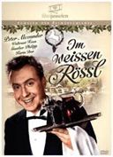 Thursday, August 27; 7-9pm: movie "Im Weissen Rössl am Wolfgangsee" with Peter Alexander and Waltraud Haas, a 1960 jewel of Austrian movies. Hope many of you can join and have fun watching this classic movie!
https://us02web.zoom.us/j/84483487812
Meeting ID: 844 8348 7812
For more info please contact Jürgen Schatzer: juergen.schatzer@gmail.com.
NEWS FROM AND ABOUT AUSTRIA
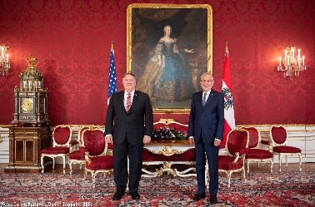 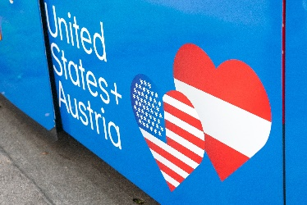 August 14-16: US Secretary of State Mike Pompeo visited Austria to discuss bilateral and global issues. During a visit with Austrians President VanDerBellen, the focus was on the importance of multilateral cooperation particularly in fostering economic recovery after the pandemic, including increased trade & investment ties with Austria. Highlighting 180+ years of US-Austrian ties, tramcars on 7 different lines throughout Vienna will now display messages showcasing the strong US-Austrian friendship.
75 years ago, on August 15, 1945: The first process took place at the Vienna Courthouse dealing with war criminals. Capital punishment was handed down to most of the participants of the killings of 102 Jews during the march from the concentration camp Engerau to Deutsch-Altenburg in March 1945.
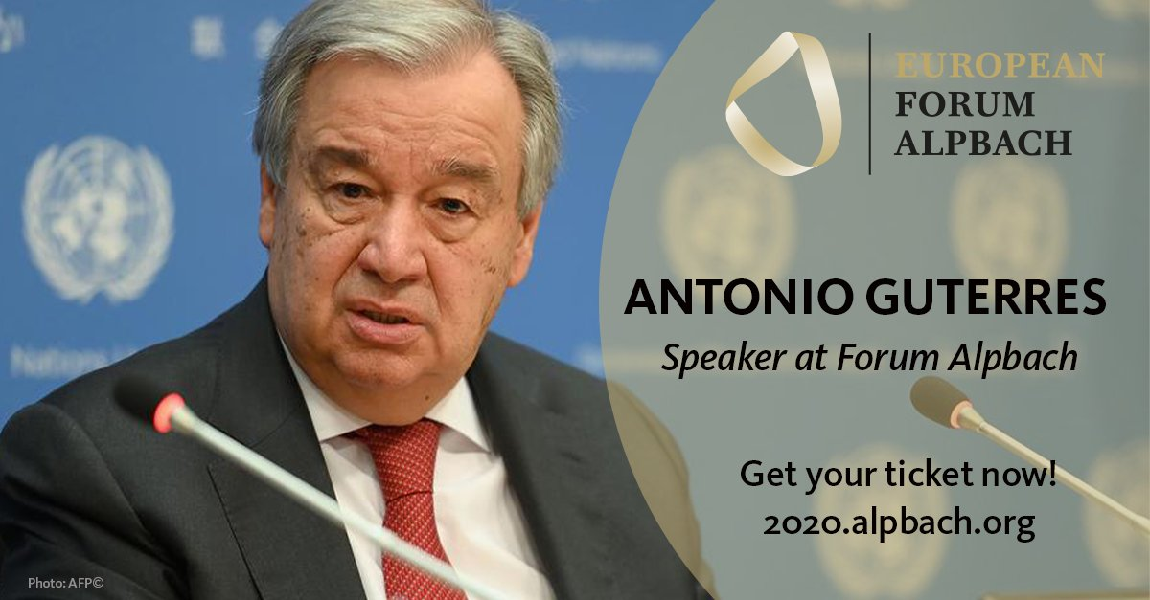August 17: Due to COVID-19, this year the Forum Alpbach took place online, but the organizers are sure it was nevertheless a great place to exchange European ideas, including with the UN Secretary-General Antonio Guterres who talked about the future of multilateralism and the United Nations.
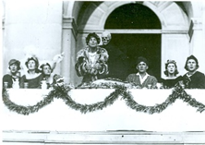 August 22: 100 years ago was the premier of Hugo von Hofmannthal’s play “Jedermann” performed at the Salzburg Festival, played then by Alexander Moissi, followed by actor celebrities like Attila Hörbiger, Will Quadflieg, Curd Jürgens, Klaus Maria Brandauer, Gert Voss, Peter Simonischek (record with 91 performances) to this year’s Tobias Moretti.
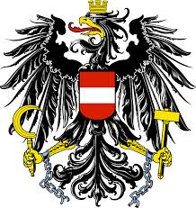 On September 1, 2020, the amendment to the Austrian Citizenship Act (“Staatsbürgerschaftsgesetz”) will go into effect in recognition of Austria’s historical responsibility and as a further gesture in its efforts to achieve reconciliation with the victims of National Socialism and their descendants. According to the new § 58c para. 1a of the Austrian Citizenship Act descendants of victims of the National Socialist regime can acquire Austrian citizenship by means of a declaration (“Anzeige”), without having to give up their current citizenship or nationality in return. It is expected to be of high demand. For further information see the website of the Austrian Consulate General in Los Angeles: https://www.bmeia.gv.at/en/austrian-consulate-general-los-angeles/service-for-citizens/citizenship-for-descendants-of-victims-of-national-socialism/.
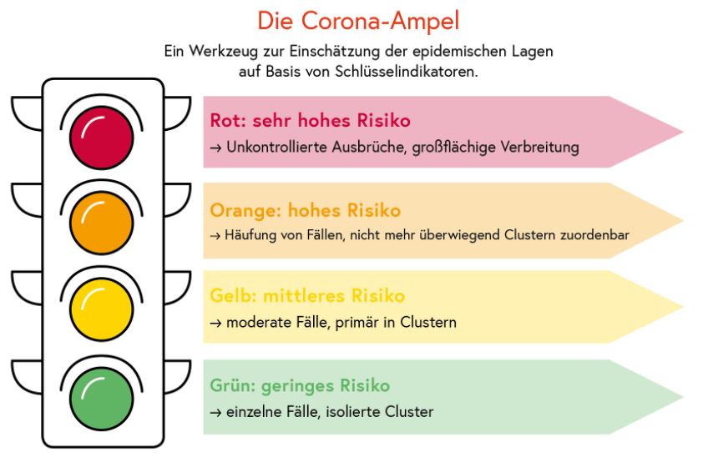On Friday, September 4 2020, Austria will launch the so-called „Corona Ampel” which will indicate with 4 colors the Corona risk situation for individual regions and the subsequent measures to be taken.
UPCOMING EVENTS
Virtual Stammtisch: Thursday, September 10, 7pm – hope many of you can join to socialize and enjoy our friendship.
https://us02web.zoom.us/j/81951012309
Meeting ID: 819 5101 2309
For more info please contact Jürgen Schatzer: juergen.schatzer@gmail.com.

Next virtual Stammtisch: Thursday, October 1, 7pm. Zoom link still to come.

Many thanks to Elana Sabajon and Jürgen Schatzer for organizing these virtual events!

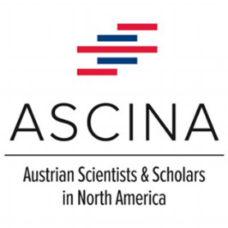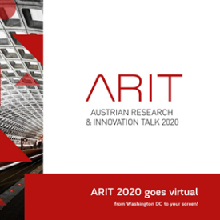 September 15: 12:00 EST (9am PDT): Join in for the Virtual ARIT2020 event - the Austrian Research & Innovation Talk 2020 . More info: https://ostaustria.org/arit-2020 . Today, research, technology and innovation are more important than ever to master global challenges. The event will focus on the outstanding achievements of Austrian researchers and innovators in North America. The ARIT has always been marked by excellent networking opportunities. This year’s ASciNA Awardees and Poster Award winners will be honored during the ASciNA awards session on Thursday, September 17, 2020.

LOOKING AHEAD:
We will not be able to celebrate the upcoming Austrian-American Day (September 25) and the Austrian National Holiday (October 26) in person. The Austria Club of WA, the Austrian American Council WA Chapter, and the Honorary Consulate of Austria in Seattle are planning a joint event in virtual form on Sunday, October 25, 2020. Please already mark your calendar - more details to come!!
In preparation for this event we invite you to participate in the project:

EINLADUNG ZUM ZUHÖREN UND EINANDER MITTEILEN
Beschreibe Deinen Heimatort, wie Du ihn in Erinnerung hast und
was Dich bewogen hat, diesen zu verlassen.
****************
INVITATION TO LISTENING AND SHARING
Describe your hometown how you remember it and
what prompted you to move away
For all details and information please see attached invitation in German or English.
We very much hope that you are interested in participating in this project and looking forward to many of your contributions!
Volunteers will then edit, compile, and present your stories to all of us. We are still working on the how, what, and when, so your input is very welcomed. Also, if you want to help us in this effort, please let us know!
Stay cool and healthy - enjoy the rest of the summer!

Herzlichst,

PS: answer to the Photo question: view of Mt. Baker from the Salish Sea near Orca Island
Eva Kammel
Honorary Consul of Austria in Seattle
office@austrianconsulateseattle.org

Attachments: Project invitation in German and English

