August 2021 Newsletter - HK Seattle

Dear Friends of Austria!
Sommer is coming to an end, and the feeling of fall is in the air! Hope you had a wonderful summer, stayed healthy and could enjoy the beauty of the Pacific Northwest – or of Austria if you had a chance to travel.
(Mt. Rainier Nat’l Park) versus 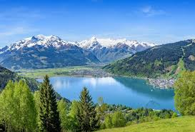 (Zell am See)
Reminder:
Gathering of Friends of Austria: Picnic in the Park: Saturday, September 11, 2021, 2-6pm, Seward Park, Shelter # 5, in Seattle. Please see attached invitation and more information at the end of the newsletter, also about Covid precautions.
Important: As we want to keep everybody safe, and the situation caused by the Covid-19 virus is evolving, we will make a final decision if we can host the event on September 7, 2021, that is also the deadline for RSVP.
Thank you for your cooperation!

TRAVEL TO/FROM Austria:
August 30: The EU is removing the USA and five other countries from the list of “Safe” travel destinations. Mandatory quarantine might be reinstated. As the restrictions change frequently, please check the latest updates for traveling to and from Austria at the website of the Austrian Consulate General in Los Angeles: https://www.bmeia.gv.at/en/austrian-consulate-general-los-angeles/travels-to-austria/coronavirus-covid-19-and-travel-information/
For the Covid related situation within Austria: https://www.austria.info/en/service-and-facts/coronavirus-information
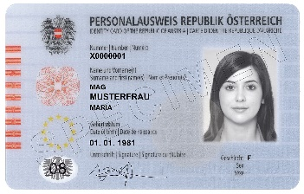 Starting in August 2021, the new Austrian ID card (Personalausweis) is EU conform, includes fingerprints, and can also be used for traveling within the EU. The Honorary Consulate of Austria in Seattle can accept applications for the Personalausweis. For more information: https://www.bmeia.gv.at/gk-los-angeles/service-fuer-buergerinnen/ausweise-dokumente/personalausweis/.

NEWS FROM AND ABOUT AUSTRIA
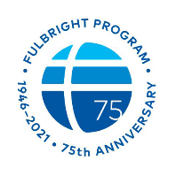 August 1: The Fulbright Program celebrates its 75th anniversary: On August 1, 1946, President Truman signed the Fulbright Act to establish the US Government’s flagship scholar/student exchange program. The first Fulbright Austria exchanges took place in 1951. Very popular became the spin off Fulbright program USTA for English teaching assistants for secondary schools in Austria: https://www.usta-austria.at/ . Every year several 100 graduates of US Universities are assisting in English language classes in Austria for a school year.
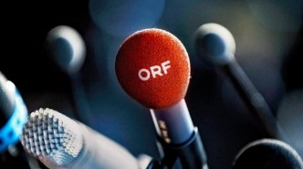 August 10: Roland Weissmann got elected as new director of the Austrian Public Broadcasting cooperation ORF, one of the main sources of information for the Austrian public. This very important post decides the direction the public media is going.

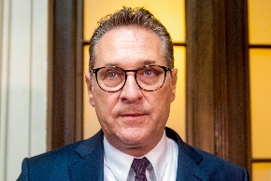 August 27: Former Vice Chancellor and leader of the right-wing party FPÖ, Heinz-Christian Strache, got sentenced to a 15-month jail time because of corruption. The defendant appealed against the verdict.

News from 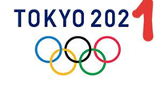
7 medals for Austria in the Olympic Games in Tokyo!
The Austrian medalists we already reported about in the July newsletter, Anna Kieshofer (Gold, road bycicle race), Michaela Polleres (Silver, Judo) , Shamil Borchashviliu (Bronce, Judo), are now joined by
Magdalena Lobning, 31, Kärnten, Bronze Olympic medal in rowing single, which was also the first time for an Austrian woman in the medal ranks in this discipline. Magdalena had a phantastic start and could keep her powerful performance all the way through the race. She dedicated so much in her life to this competition, the reward is unbelievable!
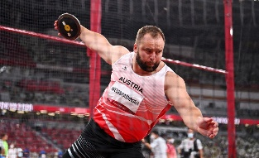 Lukas Weisshaidinger, 29, Upper Austria, won the Bronze Olympic medal in Discus Throwing. It is the first olympic medal for Austria in men’s track and field competition
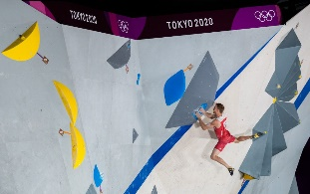 Jakob Schubert, 30, Tirol, won Bronze Olympic medal in climbing- combination (speed, bouldering and lead climbing): after a thriller that was decided in the very last competition, lead climbing, Schubert finished first in that race and could secure an amazing third place nobody was expecting. It was this sport’s debut at Olympic Games.
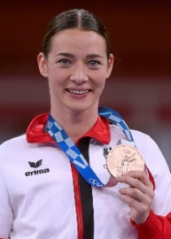 Bettina Plank, 29, Vorarlberg, won Bronze Olympic medal in Karate. Despite a very difficult selection of competitors she proved her strength in keeping calm and making excellent decisions especially when under extreme stress.

Did you know that a refugee from Vienna, Trude Forsher, who escaped the horrors of the Nazi regime, became Elvis Presley's private secretary in 1956 – 1963?
Her son, James Forsher, resident of WA, would like to invite all members of the NW Austrian community to watch a TV show he produced with Austrian filmmaker Kurt Langbein for ORF, “ Elvis und das Mädchen Aus Wien”. The documentary explores both his mom’s and Elvis Presley's journey….and how they ended up working together for over 6 years.
The German version can be found at : Elvis und das Mädchen aus Wien (Doku) - YouTube
The English version can be accessed at : https://vimeo.com/287918272
The password is elvis trude jim
James will be glad to answer any questions: James Forsher, (206)265-2382 (cell); www.forsherproductions.com
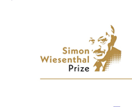Are you actively engaged in combating antisemitism and educating people about the Holocaust? Then submit an entry for the Simon Wiesenthal Prize, named in honor of the legendary Holocaust survivor and Nazi hunter from Austria. Deadline: September 30, 2021. More information: https://wiesenthalpreis.at/home

UPCOMING EVENTS
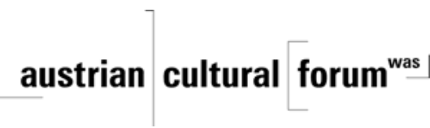 Check out the regular online film and music events organized by the Austrian Cultural Forum: https://acfdc.org/?mc_cid=487b48d54a&mc_eid=1321923619

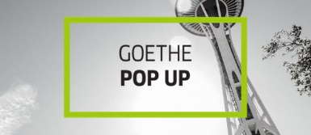 Regular events are offered by the Goethe Pop Up Seattle, ranging from book club, Summer camps, movies, and literature presentations: https://www.goethe.de/ins/us/en/sta/gps.html
Sommerkino: Goethe Pop-up:
FILM SERIES | THROUGH 9/5 | ONLINE SOMMERKINO
The lazy days of summer aren't so lazy if you're improving your German through film, right? The new Goethe on Demand platform is offering free streams of five popular German films through the month of August! Each of the five films will be available for a whole week and all come with English subtitles. The selections include All About Me, whose star Julius Weckauf attended SIFF in 2019 and won the Golden Space Needle award; I Was I Am I Will Be; Relativity; Adam and Evelyn; and Fukushima, Mon Amour.

Monthly Stammtisch – 1st Thursday of the month: Mark your calendar!!
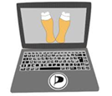 Virtual STAMMTISCH: September 2, 2021: Join the first get-together with friends of Austria after the summer break, even when only via zoom. There is so much to talk and chat about! Zoom link: https://us02web.zoom.us/j/5845087371 . Questions: please contact Elana Sabajon: youcan@askelana.com

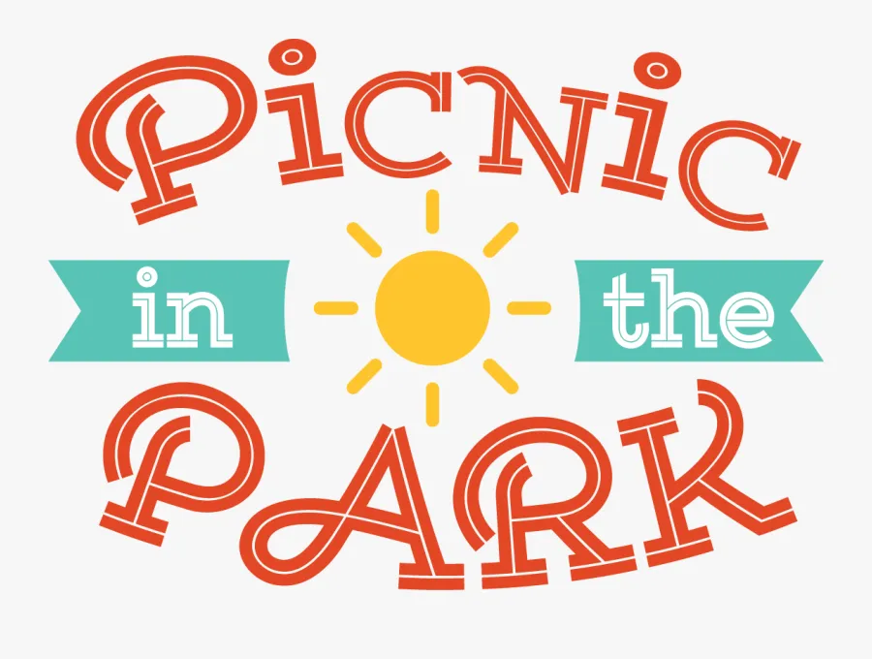 !!!!! Friends of Austria Gathering!!!!
Saturday, September 11, 2021, 2-6pm Seward Park, Seattle, Picnic Shelter # 5!
Reserve the date and bring your family along. For more details, Covid-19 precautions, contact etc. please see attached invitation. RSVP by latest September 7, 2021
Important: As we want to keep everybody safe, and the situation caused by Covid-19 is evolving, we will make a final decision if we can host the event on September 7, 2021, that is also the deadline for RSVP.
Mit herzlichen Grüβen
Eva Kammel
Honorary Consul of Austria in Seattle
office@austrianconsulateseattle.org | www.austrianconsulateseattle.org

