February 2023 Newsletter - HK Seattle
Dear Friends of Austria!
Have you heard the chirping birds’ voices already? Well, the recent snowy days made them quiet for a bit – but not for long! Spring is around the corner!
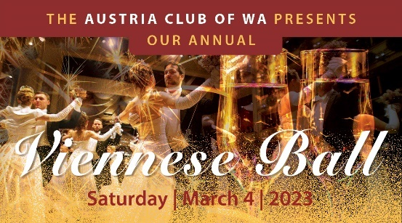 And so is the Viennese Ball in just a few days! The Viennese Ball Committee under the leadership of Eva Donahoo is working hard to make this a very special and memorable evening.
We are extremely honored that Austria’s Consul General in Los Angeles Dr. Michael Postl together with his wife Fariba will join us for this year’s Viennese Ball! It will be GK Postl’s 4th trip to Seattle within a year. The Austrian community is grateful for his visits and thankful for his and his team’s ongoing efforts to work for us Austrians living abroad and to support Austria’s position here in the Pacific Northwest. It also underscores the importance of our region for the Austrian Government and businesses.
NEWS FROM AND ABOUT AUSTRIA

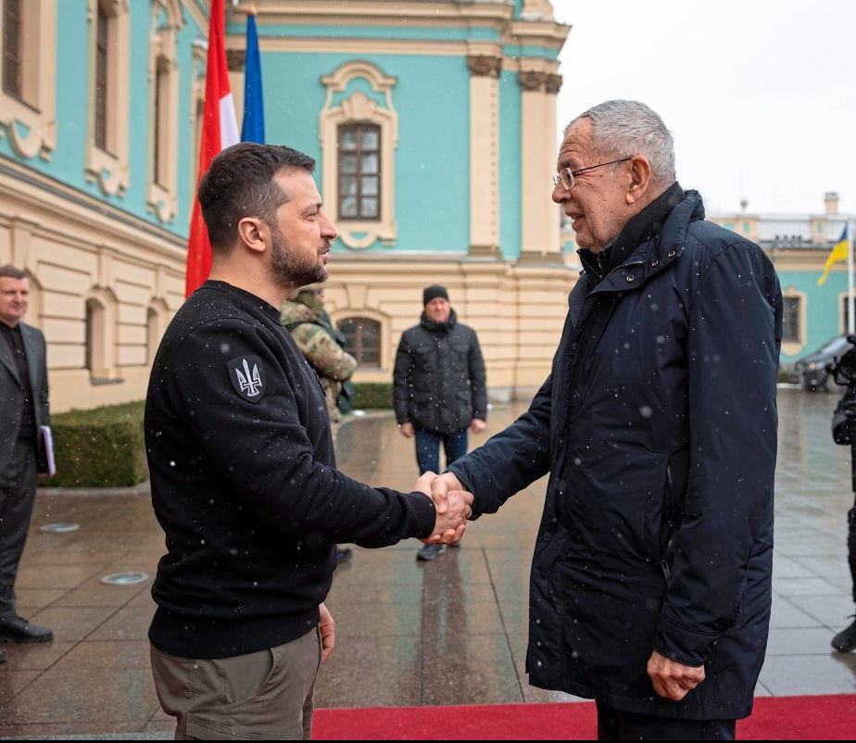 February 1, 2023: On his first trip after his inauguration to his second term, Austria’s President VanDerBellen met Ukraine’s President Volodymyr Zelensky in Kyiv and visited also the embattled city of Butscha. Focus was to reiterate Austria’s commitment to Ukraine and humanitarian assistance Austria is providing. “We are military neutral but not politically.” (Bound by its State Treaty, Austria cannot join any military alliances nor provide weapons). Austria’s Secretary for Environment, Leonore Gewessler (Green Garty), Secretary of Economy, Martin Kocher (ÖVP), and representatives of humanitarian organisations joined on this trip and discussed with their Ukraine counterparts how to best focus Austria’s support. The delegation traveled 8h during the night by the train, leaving from Przemysl, Poland, and brought loads full of generators and building materials along. VanDerBellen offered Vienna as place for negotiations but at the moment he sadly does not “see any peace doves on the horizon”.
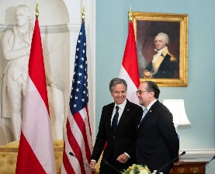 February 7, 2023: Austria’s Foreign Minister, Alexander Schallenberg, visited Washington, DC, where he met with his US counterpart Anthony Blinken. The deep friendship and cooperation between the two countries in many aspects of worldwide efforts, ranging from the war in the Ukraine, the expansion of the Strategic Partnership between Austria and the United States, to the assistance for the victims of the earthquakes in Syria and Turkey, got reinforced and valued. Mr. Blinken also emphasized Austria’s role in the conflict of the Western Balkan region to engage and eventually welcome Serbia and Kosovo into the democratic European Community.
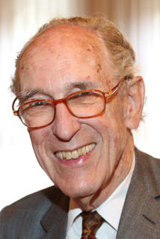 February 8: Wolfgang Schallenberg, former Austrian Ambassador, Secretary General of the Ministry of Foreign Affairs, and father of Austria’s current Foreign Minister, Alexander Schallenberg, passed away at age 92. He was a major player in the organisation of the meeting between the leader of former Soviet Union, Nikita Chruschtschow, and US President John F. Kennedy 1961 in Vienna. Wolfgang Schallenberg accompanied the National Fund of the Republic of Austria for Victims of National Socialism from the very start in 1995 and helped to shape its course with his experience and commitment. He worked to serve the surviving victims of Nazism with incredible dedication and commitment, well into advanced age until 2018.
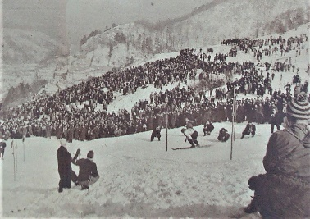 “Schizentrum” Kaltenleutgeben bei Wien: enjoy watching images from the 1950ies from this subburb of Vienna, where not only Alpine ski races took place but also indoor skipistes and fanatic fans of the ski heros having their moments. Unfortunatley climate change and the lack of snow made the maintenance of a ski piste not feasible any more: https://tvthek.orf.at/profile/Studio-2/13890037/Studio-2/14167168/Ski-Geschichte-Kaltenleutgeben/15332784
January 18, 2023: The Apprenticeship Cooperation, initiateld by the Austrian Embassy, moved closer to implementation by the visit of US Secretary of Labor, Marty Welsh, in Austria. He visited several apprenticeship programs to learn firsthand about the Austiran apprenticeship model.
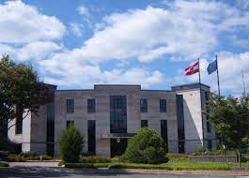 After almost one year of vacancy, Austria will soon have again an Ambassador in the United States. Ms. DDr. Petra Schneebauer got designated. More information is coming soon!
EU commission and the US are imposing additional sanctions aiming to block any evasions of sanctions on doing business with Russia. This might bring complications for Raiffeisen Bank International which was active in Russia since 1996. RBI was one of the few institutions in Russia that stiil could participate in SWIFT, the international electronc transfer.
February 6 – 19: Alpine Ski World Cup in Courchevel/Meribel, France: Austria won 3 silver (Women’s downhill, men’s combination, men’s parallel race) and 4 bronze medals (women’s Super G, and men’s and women’s combination, men’s giant slalom), but unfortunatley no Gold Medal. That is for the ski enthusiasts in Austria very disappointing, it only happened last time in 1987.
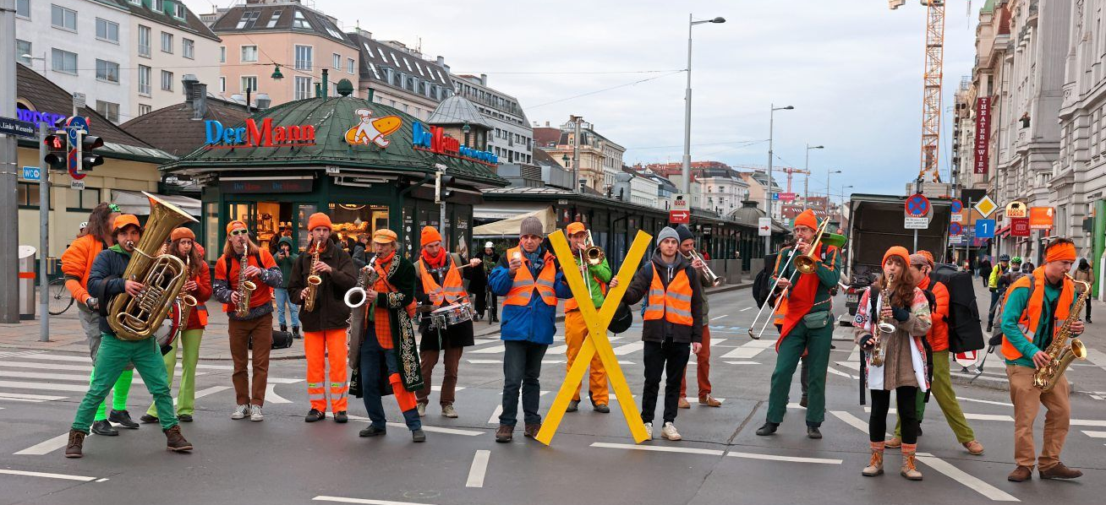February 13: Climate activists of the “Last Generation” staged demonstrations in Vienna blocking major roads that lasting for 2 weeks and expandes also into other cities. Their main objectiv is demanding from the government more aggrssive actions against climate change.
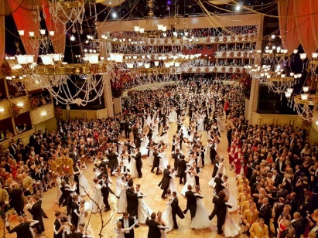 Feburary 16: Famous 65th Vienna Opera Ball was finally back after 2 years of Covid cancellations! Over 5,000 ball guests, 150 pairs of the opening committee, and viewers of the live broadcast enjoyed this event. The regular seats got removed, the parquet floor laid and 650 arrangements and bouquets decorate loges, tables and walls. Over 500 people were working on the set-up and take down for 50h straight to minimize the disruption of the regular Opera performances. 150 musicians in 8 different areas were entertainining the guests. “The Opera Ball is humankind’s eternal longing for fairy tales” according to Lotte Tobisch (1926–2019) - the legendary organiser of the Vienna Opera Ball. Dedicated to solitarity, 10% of proceeds will be donated to Austrians in need. Tickets rannge from Euro 315 without a seat to several thousand to loge seats. https://www.wien.info/en/music-stage-shows/dance/vienna-opera-ball-363454
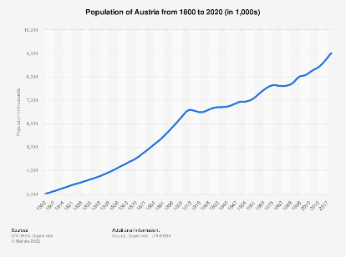2022 Statistics: Austria’s population breached the 9 Million mark: 9.1 Millions, an increase by 1.4%. About half of the increase is due to the relocation of Ukraine citizens. The largest increase was registered in the capital city Vienna. The % of residents with non Austrian citizenship increased from 17.7% to 19%, again concentrated in Vienna with 34%. The majority of foreign residents come from Germany. The population of Vienna was 1.9 Mio, now the 5th largest city in the EU and has seen the highest growth compared with 10 largest cities in EU. Life expectancy for women is 82.6 years, for men 77.7 years. About ½ of the land use in Vienna is reserved for green spaces and bodies of water. Only about 26% of the Viennese use their own car for transportation, about 30% public transporation.
Movie “Sachertorte” Amazom Prime – cute comedy love story! Recommended by Aviva Peltin
Carnival Season (Fasching) In Austria ended with Ash Wednesday. It is celebrated with funny costumes, events, parades and some special food: Faschingskrapfen, a fluffy, jam-filled doughnut. It is said that the “Krapfen” dates back to ancient Greek times to serve for their goddess some sweets as a sacrifice. It appeared in Vienna in the 19th century when a then famous chef called Cäcilie Krapf created the “Cilly Balls”.

UPCOMING EVENTS
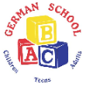 March 4: 10-12 noon: Open House at the ABC German School in Bellevue, WA; https://abcgermanschool.com/ . For more information also about summer camps and immersion Preschool and Kindergarten programs, please contact the Principal Nadja Helmer-Penry: nadja@abcgermanschool.com
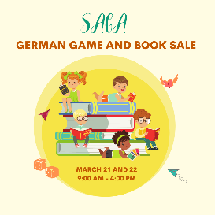 March 21-22: SAGA German Book and Games Sale; for more information: inof@sagaschool.org

Check out the regular online film and music events organized by the Austrian Cultural Forum: https://acfdc.org/?mc_cid=487b48d54a&mc_eid=1321923619

Virtual Stammtisch for German Learners: once a month via zoom: Next meeting: Wednesday, March 8, at 6pm. The virtual Stammtisch for German learners is an opportunity to get together, speak German, and have fun. Sabine Sullivan is a native speaker and will host the Online-Stammtisch. If you would like to attend or have any questions, please contact Sabine Sullivan: sabine.sullivan@zoho.com
Monthly Stammtisch – 1st Thursday of the month: Mark your calendar!!
Please contact Jürgen Schatzer juergenschhatzer@gmail.com for details for the upcoming one. The location is rotating throughout the greater Seattle Area. There is so much to talk and chat about!
Movie Sachertorte: A sweet love/romance story; a bit kitschy but something if you are not up for heavy duty stuff like murder and aliens; on Amazon Prime Video; https://www.imdb.com/video/vi2189542681/?ref_=tt_vi_i_1
Austria Club of WA newsletter is back again! Please see the first edition: “ACW Nachrichten” attached! For more information and how to support or become a member, please contact the Club’s president Michael Brandstetter: michael.brandstetter@gmail.com. Consider joining the club and meet many Friends of Austria!

Mit herzlichen Grüβen
Eva Kammel
Honorary Consul of Austria in Seattle
office@austrianconsulateseattle.org | www.austrianconsulateseattle.org

