February 2024 Newsletter - HK Seattle
Dear Friends of Austria!
Today we can enjoy one extra day! Wishing you a relaxing extra time doing what you always wanted to do!
TRAVEL TO/FROM Austria: no further Covid related restrictions are currently in place
Please check the latest updates for traveling to and from Austria at the website of the Austrian Consulate General in Los Angeles: https://www.bmeia.gv.at/en/austrian-consulate-general-los-angeles/travels-to-austria/coronavirus-covid-19-and-travel-information/
NEWS FROM AND ABOUT AUSTRIA
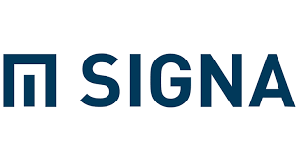January 31, 2024: The Republic of Austria has applied for bankruptcy against SIGNA, the largest real estate company in Austria; Since a couple of months the giant real estate company is trying to avert this step after several of its sub companies already had to declare bankruptcy. Founder and co-owner Rene Benko, one of the richest entrepreneurs in Austria, is accused of tax debts and not completed financial obligations. In addition, conversations between Benko and highest officers of the Ministry of Finances under former Chancellor Kurz are under scrutiny as favorable treatment of SIGMA were discussed.

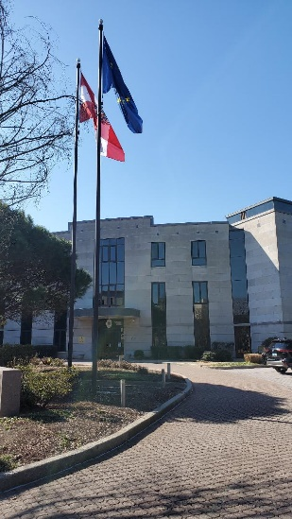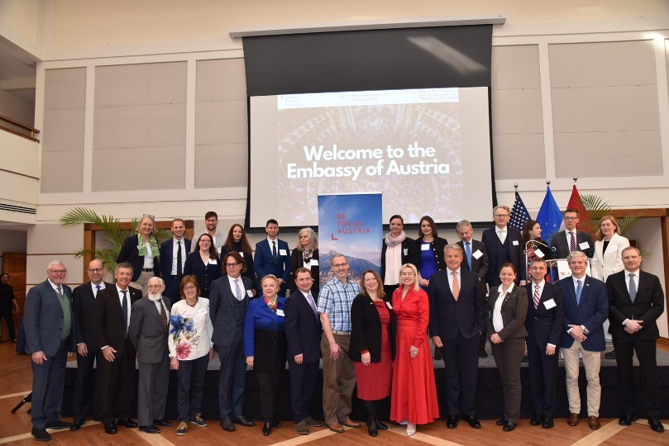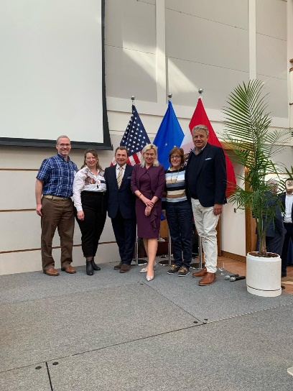
February 8-9, 2024: The biannual Consular Conference in DC, organized by Austria’s Mme Ambassador Petra Schneebauer and her wonderful team, was filled with interesting information and provided also time to socialize and exchange with fellow representatives of Austria (Consul Generals, Honorary Consuls, Tourism, culture, business etc.) from all over the USA. The West Coast team is growing! In CA, OR (just opened), WA, CO, and (soon also) AK passionate and engaged HCs are here for everything Austria! Besides talks, discussions about newest and important information we also got treated with culinary specialties like Faschingskrapfen and Sachertorte. Social highlight was the reception at the residence of Mme Ambassador!

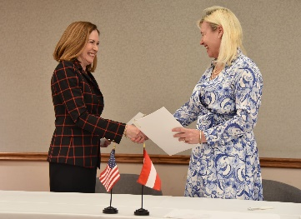 February 20: Austria’s Ambassador to the US Petra Schneebauer and US Assistant Secretary of State for Educational Affairs Lee Satterfield signed a Memorandum of Understanding (MoU) between Austria and the US to establish a “Working Holiday Program, promoting mutual understanding by offering young Austria ans US citizens the opportunity to get to know the culture, everyday life and working world in the other country.

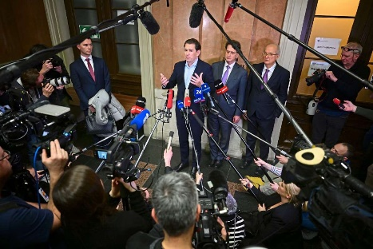 February 23: Former Austrian Chancellor Sebastian Kurz and his former chief of staff Bernhard Bonelli were convicted to 8 resp. 6 months of jail time for making false statements in front of the parliamentary committee inquiry about the naming of high ranked positions in order to obscure the otherwise shattered image of a “clean, corruption free” OeVP party. The decision was immediately appealed and is therefore not (yet) being enforced.
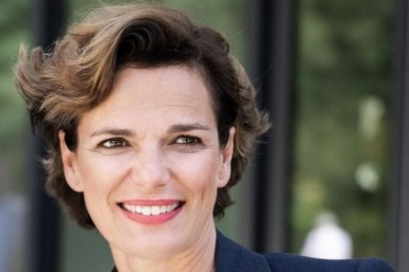 Pamela Rendi-Wagner, former Minister of Health and leader of the SPOe, and a trained Physician, Professor for preventative medicine at the Medical University of Vienna, became the head of ECDC (European Center for Disease Prevention and Control). She is highly qualified for this critical position.
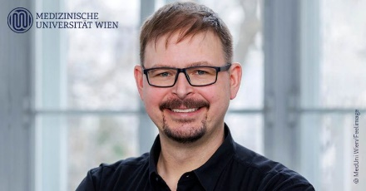 Florian Kramer, Austrian-American virologist and Endowed Professor at the Icahn School of Medicine at Mount Sinai in New York, will join the faculty of the Medical University of Vienna as Professor of Infection Medicine on March 1st. Prof. Kramer started his career with studies in Vienna and became a world renown specialist in development of vaccines. He will split his time with the Icahn School of Medicine at Mount Sinai where he worked and researched since 2019. His laboratory investigates antibody reactions to RNA-viruses.
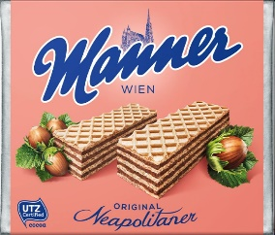 A cooperation of the well-known “Manner Schnitten” production facility in the 17th district in Vienna and the “Fernwärme” Wien, the distant heating system in Vienna, makes it possible that the heat “waste” originated by the production of the waffles, will be used to provide heat for about 600 households.
2023 marked an exceptional year for Austria's tourism sector, particularly in terms of travel from the USA. With over 830,000 hotel guest arrivals and over 2 million guest overnights, it was one of the most successful years ever for US travel to Austria. The renewed strength of the US market, coupled with a growing desire among travelers to explore Europe in general – and Austria in particular – was evident throughout the country.
Our capital, Vienna, recorded its best year yet from the US, and in our mountain- and ski resorts, American English is increasingly heard. Austria Tourist Information
Great opportunity: Do you know an Austrian who is just about to move to the USA?
The http://www.on-media.at/ "Plus 4 Format" is working on a documentary "Die Auswanderer" and is looking for persons who plan on moving to the US (or other places abroad) in the near future. Especially of interest would be persons who want to realize a business idea abroad.
For more information please contact
Adelina Kosykh, journalist for Puls 4 Format „Die Auswanderer“.
a.kosykh@on-media.at oder call +436764315753.
Many thanks in advance for any help!
"Servus TV", http://www.servustv.com/, an Austrian TV station, is working on a documentary about Austrians living in the USA. They are looking especially for people living in Idaho who are interested in sharing their views, chatting about their lives abroad, and are interested in participating in this exciting documentary. Actor Wolfgang Fierek will be riding a motorcycle through the USA and plans to meet with Austrians of all walks of life.
If you are interested of know of someone, please contact journalist Julia Dungl: +43 664 887 49438 or mailto:Julia.Dungl@servustv.com

UPCOMING and PAST EVENTS

Elections in Austria 2024 - A guide for new citizens
When: 20 March 2024, 2:30 – 3:45 PM EDT
Where: Online

New and prospective Austrian citizens regarding the upcoming elections are invited to attend a webinar to introduce them to the political system and political choices they have as voters in the impending EU and Parliamentary elections.

In addition, there will be information on registering to vote (note – voter registration for the EU election must be undertaken by 24 April 2024). The chief editor of Der Standard, one of Austria’s leading newspapers, Dr. Eric Frey will be on the panel of speakers, which will be hosted by British/Austrian journalist Nikolas Pöllinger.
For more information and how to register: https://www.eventbrite.co.uk/e/elections-in-austria-2024-a-guide-for-new-citizens-tickets-803509838557?mc_cid=7f9268a359&mc_eid=1321923619

ABC German School Open House , Saturday, March 9, 2024; 10-12noon, 2101 112th Ave NE # 110, Bellevue, WA 98004. The ABC Schoon offers German Immersion programs for children, teens, and adults. For more information: Nadja Helmer-Penry, Principal: nadja@abcgermanschool.com ; ABCGermanSchool.com
EGLS (Eastside German Language School, https://wp.egls.us/) German Book Club: Saturday, March 16, 2024, 10am. For more info: info@egls.us

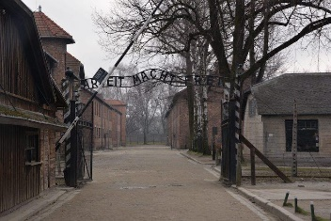 Learning Lessons of the Holocaust through Human Stories, July 2-13, 2024: Are you a teacher and want to deepen your understanding of Holocaust history? Then join the trip to Poland and Austria this summer, organized by the Holocaust Center for Humanity in Seattle. Teachers can receive scholarship up to $5,000. For more information and to register: Vienna & Poland Tour - Holocaust Center for Humanities .

Check out the regular online film and music events organized by the Austrian Cultural Forum: https://acfdc.org/?mc_cid=487b48d54a&mc_eid=1321923619
Book presentation: March 7, 2024 at the ACF in New York: by Austrian historian Alix Frank-Thomasser, “Advokaten 1938: The fate of the lawyers and trainees registered with the Austrian Regional Bar Associations who were barred from practicing in the legal profession from 1938 to 1945”. More information about this fascinating book (2nd edition also in English): http://www.advokaten1938.com/new-edition-2022.htm

Virtual Stammtisch for German Learners: once a month via zoom: Next meeting: at 7pm. The virtual Stammtisch for German learners is an opportunity to get together, speak German, and have fun. Sabine Sullivan is a native speaker and will host the Online-Stammtisch. If you would like to attend or have any questions, please contact Sabine Sullivan: sabine.sullivan@zoho.com

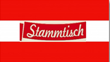Monthly Stammtisch – 1st Thursday of the month: Mark your calendar!!
Next one: Thursday, March 7, 2024; 7pm; Location: Epulo Bistro: 190 Sunset Ave Suite B, Edmonds, WA.
Please contact Jürgen Schatzer juergenschhatzer@gmail.com for details for the upcoming one. The location is rotating throughout the greater Seattle Area. There is so much to talk and chat about!

Mit herzlichen Grüβen
Eva Kammel
Honorary Consul of Austria in Seattle
office@austrianconsulateseattle.org | www.austrianconsulateseattle.org

