2022 January Newsletter - HK Seattle
Dear Friends of Austria!
Hope you all had a Guten Rutsch ins Neue Jahr! – a good start of the New Year!
Let us be optimistic that it will get easier soon to get together again and to celebrate our friendship, traditions, and common roots. Especially during these times of restrictions, we need to continue fostering and contributing to our local Austrian Community. Now is THE opportunity to do just that by becoming a member and volunteering for the Austria Club of WA. As the club is now in the phase of restructuring, you will have the opportunity to shape the Club as a platform and magnet for everyone in the Austrian community here in the Pacific Northwest, and to make sure that every generation gets heard and listened to their needs, interest, and wishes. Please contact Rosie Mulholland mulho@comcast.net or Jürgen Schatzer juergenschatzer@gmail.com for more information, also about the upcoming elections for the Club Board positions.
Many thanks go out to the current board members who dedicated a lot of time, energy, and ideas to the Club for us to benefit from it. You are the engine behind the Club! Vielen herzlichen Dank!
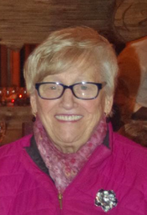 I want to take the opportunity to express my sincere gratitude to Rosie Mulholland. She was and is the heart and soul of the Club for many, many years. Together with Sigrid Vierthaler, Rosie was one of the “Founding Mothers” of the Viennese Ball, 22 years ago, and served in several capacities on the board of the Club, and as president since 2017. Her generosity, her unwavering support and engagement for the Club on so many levels is extraordinary, demonstrated especially during the last 2 years, the most challenging times for a social club. With dedication she planned every event to the detail so that as many Club members as possible could enjoy the time.
Her empathy for us, her warmth, her open heart for the happy but also sad periods in our lives, her lovable, huggable personality is very special to Rosie – we all love Rosie!
Now Rosie plans to step down as Club president. She has more than earned to just enjoy upcoming Club activities, friendships, get-togethers as very special guest without having to worry about any of the details.
Rosie, thank you – Danke Dir von ganzem Herzen!

TRAVEL TO/FROM Austria:
Current as of January 24, 2022: Currently to enter Austria coming from the USA, pre-registration, 2G (vaccinated or recovered + PCR test) is required. Proof of booster shot eliminates the necessity for a PCR test.
As the restrictions change frequently, please check the latest updates for traveling to and from Austria at the website of the Austrian Consulate General in Los Angeles: https://www.bmeia.gv.at/en/austrian-consulate-general-los-angeles/travels-to-austria/coronavirus-covid-19-and-travel-information/
For the Covid related situation within Austria: https://www.austria.info/en/service-and-facts/coronavirus-information

NEWS FROM AND ABOUT AUSTRIA
Covid-19 related News from Austria:
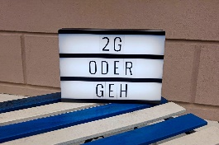 The lockdown for unvaccinated older 15 years started on November 15, 2021 and stays in effect until January 31, 2022. About 1.1 mio (~15%) people living in Austria feel these restrictions that hinder them from visiting restaurants, theater, sports facilities, hair salons, any shops that are not essential, etc. where proof of vaccination or recovery is required. The PCR test alone is not sufficient. 75% of Austrians are vaccinated at least once.
January 7, 2022: Chancellor Karl Nehammer was tested positive for the Omnicrom variant of Covid-19. He already received the booster shot and felt almost no symptoms and could end his quarantine after the required period of days. He reiterated that the 3 jabs probably reduced the symptoms to mild and urged to get vaccinated and/or boosted. He probably got infected by a security guard.
January 15: Germany put Austria into the “high risk” category of nations. That renders a blow to the winter tourism industry dashing hopes for decent a season.
BTW, 70-80% of Corona cases in Austria with a known origin of infection in past time activities originated in Apre-Ski scenarios.
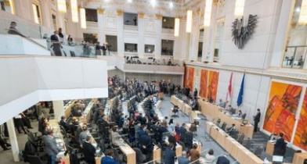 January 20: Austria’s parliament passend with a broad majority (137 out of 170) the Covid vaccine mandate for all adults over 18 years with the only exemptions if you are pregnant or for medical reasons or for those who have recently recovered from Covid. This is the first general, wide reaching Covid vaccine mandate in Europe.
February 1: general vaccination mandate goes into effect for everyone with residency in Austria over 18 years. About 80% of the affected group is already vaccinated. Recovery from Covid can be substituted for an vaccination for up to 180 days. Random checks will be administered only after a couple of weeks after this law will take effect. Adjustement to this law will be done according to epidemiologistic developments.
Vienna State Opera had to cancel all performances for the first week of January because of Covid disruptions. These are its first cancellation outside of a lockdown.
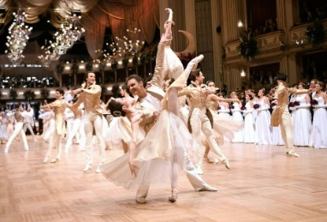 Wiener Opernball 2022: although the preparations and ticket sale (already sold out) were already underway, Bogdan Roščić , director of the Vienna Opera, could not guarantee that the event can take place on February 24, 2022, even under very strict Covid requirements (full vaccination (incl booster shot if applicable) and negative PCR test (no more than 2 days before)). On December 8, to the disappointment of many, the Opernball 2022 got canceled because of the unpredictable Covid-situation.

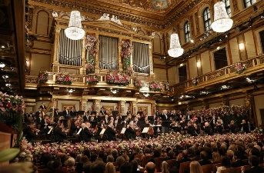 The Vienna Philharminoc Orchestra had to cancel their tour end of January to Germany and France because of too many Covid cases wihtin the orchestra. This concert was recorded beforehand and will be aired in near future. The orchestra is optimistic though that the planned concerts in February, including performances in New York, NY and Naples, FL, can take place as planned.
**********************************************************************************************
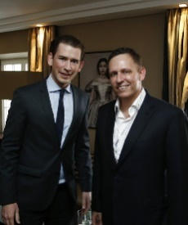 Dec 30: Former chancellor Sebastian Kurz accepted the job as “Global Strategist” with the US investment company of German-American Peter Thiel. Hightech-Investor and co-founder of Paypal, Thiel is also known as one of the very few close supporters in Silicon Valley of former US president Trump and a fan of the thinking that old-fashioned democracy is not capable enough and should be best replaced by a regime led by business people.
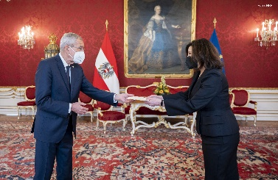 January 12: Ambassador Victoria Kennedy (wife of late Senator Eduard Kennedy) was honored to meet Austria’s President Alexander Van der Bellen and presented her credentials, which officially makes her the U.S. Ambassador to Austria. "I look forward to working hard to strengthen our bilateral ties!"

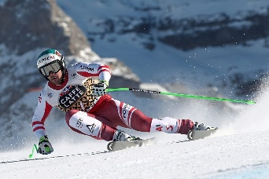January 15: downhill victory in Wengen, Switzerland, for the Austrian skier and current world master Vincent Kriechmayr. He won this famous race just coming out of Covid quarantine and with a top speed of 150km/h (93mi/h). Wishing him and the rest of the Austrian ski team good luck for the upcoming Olympic Winter Games!
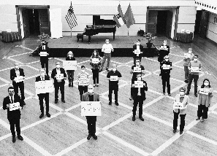January 27: International Holocaust Remembrance Day: commemoration of the anniversary of the liberation of the concentration camp in Auschwitz-Birkenau on this day 1945, marked by several events in Austria, as also at the Austrian Embassy in D.C. with Ambassador Martin Weiss and staff. NEVER FORGET – WE REMEMBER.
Following events are streamed by local organizations:
Holocaust Center for Humanity in Seattle: “Hours of Freedom”: the story of the Terezin composer: Thursday, Jan 27 (today!) at 7pm: https://holocaustcenterseattle.org/programs-events/693-hours-of-freedom
Music of Remembrance: Art form Ashes: https://www.musicofremembrance.org/concert/concert-art-ashes: Free screening of the concert: https://vimeo.com/667511910/dbe5651c1c

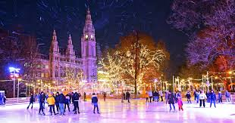 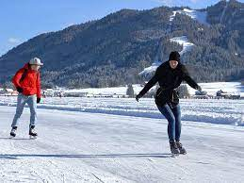 Besides skiing, ice skating is a popular winter sport in Austria and a healthy alternative especially during these times of Covid restrictions. The outdoor ice arena in front of Vienna City Hall opened with almost 10,000 m² (~ 100,000ft²) in addition to the indoor venue of the Wiener Eislaufverein. Several lakes are also prepared for ice skaters once fulfilling a required ice thickness of at least 30cm (~1ft). The Weiβensee in Carinthia is about the first to open.
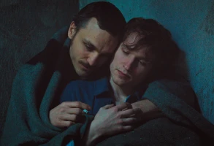 Austria’s nomination for the 94th Oscar’s international film category and shortlisted for the award ceremony: “Great Freedom (Grosse Freiheit)”, is directed by Sebastian Meise. Franz Rogowski gives yet another career-topping performance as a gay man Hans, living out his life in prison in post-World War II Germany. Hans is imprisoned again and again for being homosexual. The one steady relationship in his life becomes his long time cell mate, Viktor, a convicted murderer. What starts in revulsion grows to something called love.
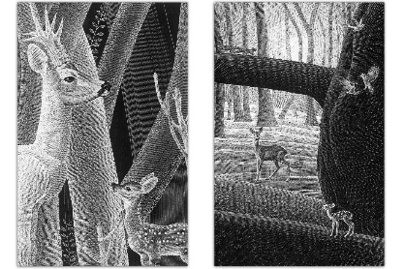”Bambi”, the classic tale written by Austrian-Hungarian journalist Felix Salten, was first published as story-installments in 1922 in the Viennese newspaper “Neue Freie Presse”. This beloved story follows the deer from an infant state of perfect innocence through his initiation into hard facts of forest life. Published as a book, “Bambi” was an immediate hit with the public.
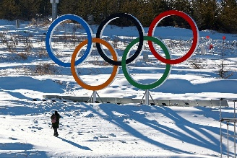 Olympic Games in Beijing: Austria is sending 106 athletes to the 24th Olympic Winter Games, the largest team of course in alpine skiing, each 11 men and women. The hope is to achieve a ranking among the 10 best winter sport nations. Wishing good luck to all Austrian athletes!
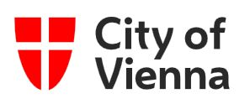 Vienna Calling – International news from the City of Vienna: https://rdir.nl.wien.gv.at/form.action?agnCI=20&agnFN=Fullview&agnUID=D.P4.eS.Ep.Fgh.A.v4mosvXdvEOqtqQUQEEnpffliywHNYEwxeeoQEuDDQlcfQpmdSMrn3pH4bBtyR3xStrzVLDNxQQzqATBJl5csA

UPCOMING EVENTS

Cancellation of Viennese Ball 2022 in Seattle: With disappointment due to the uncertain Covid situation, the Viennese Ball Committee decided to cancel the upcoming very popular Viennese Ball in Seattle, planned for March 5, 2022. An alternative “Sommerball” on June 25, 2022, is under discussion. Stay tuned for updates!
The , founded over 45 years ago with its mission of cultivating and preserving Austrian traditions in WA, and a much-appreciated platform for the Austrian community to connect and socialize, needs your engagement and enthusiasm! Several board positions including the presidency will be up for elections in February 2022. This is now an opportunity for you to engage and to bring on board a new generation with new ideas and emphasis on today’s needs and expectations of the Austrian Community in the Pacific Northwest. For more information and details please contact Rosie Mulholland: mulho@comcast.net or Jürgen Schatzer: juergenschatzer@gmail.com .
Austrian researchers in North America are eligible for the ASciNA prize – an award granted exclusively to young researchers for outstanding research in any scientific discipline. Application remain open until February 15, 2022. For more information see: https://ascina.at/ascina-award/
Auslandsösterreicher Weltbund: https://www.weltbund.at/ is representing all Austrians living abroad in political, cultural, social, and economic issues within and outside of Austria. Please check out their website for more information. They are also publishing 3x/year the Rot-Weiss-Rot magazine, an interesting publication about what’s going on in Austria. In their latest issue they are discussing an initiative to present the problematic of the “Doppelstaatsbürgerschaft” to lawmakers, a more than ever hot topic for Austrians living abroad: https://www.weltbund.at/rot-weiss-rot/rotweissrot-ausgabe-3-2021/
Check out the regular online film and music events organized by the Austrian Cultural Forum: https://acfdc.org/?mc_cid=487b48d54a&mc_eid=1321923619

Regular events are offered by the Goethe Pop Up Seattle, ranging from book club, Summer camps, movies, and literature presentations: https://www.goethe.de/ins/us/en/sta/gps.html
Monthly Stammtisch – 1st Thursday of the month: Mark your calendar!!
Virtual STAMMTISCH: February 3, 2022, 7pm: Join the get-together with Friends of Austria via zoom. There is so much to talk and chat about! Zoom link: https://us02web.zoom.us/j/5845087371 . Questions: please contact Elana Sabajon: youcan@askelana.com or Jürgen Schatzer juergenschatzer@gmail.com
Mit herzlichen Grüβen
Eva Kammel
Honorary Consul of Austria in Seattle
office@austrianconsulateseattle.org | www.austrianconsulateseattle.org

