January 2023 Newsletter - HK Seattle
Dear Friends of Austria!
We passed the 5pm sunset mark - the increase in additional daylight minutes is lifting up the spirits! As are the snow days in the mountains!
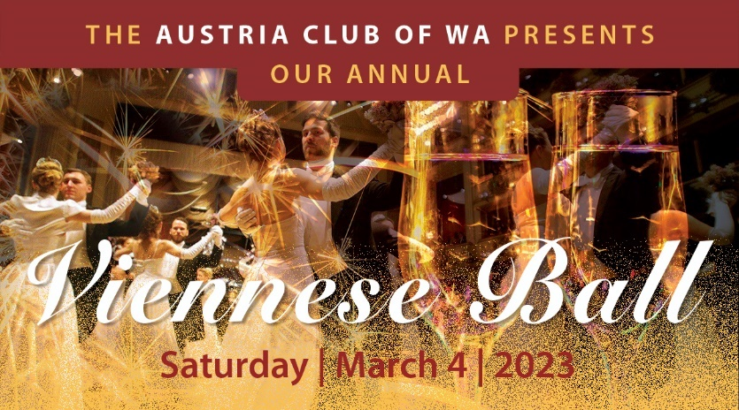 The Viennese Ball, this cherished, 200-year long tradition from Vienna, is back in Seattle after 2 years of Covid related cancellations! Let music be again an instrument of diplomacy and joy, that brings people together and lets us forget our problems for a couple of hours.

We are very excited that Austria's Consul General in Los Angeles, Dr. Michael Postl, will join us on this special evening.

This elegant evening includes a delicious dinner buffet, polonaise, dance performances, and of course dancing to live music until midnight! Do you want to brush up on your dance steps? A complimentary dance lesson from 4-5 pm just before the event is included, led by members of the Pacific Ballroom Dance Team PBD.
Again, this year, the City of Vienna is sponsoring this event and provides traditional “Damenspenden” (gift for the ladies) with a special greeting from Vienna’s Major Michael Ludwig.
For more information, tickets, etc: www.austriaclubwa.com . If you want to participate in the dance lesson, have dietary restrictions, or any other questions, please don't hesitate to contact Eva Donahoo ewdcpa@comcast.net or Eva Kammel office@austrianconsulateseattle.org

Get ready for this beautiful evening! It will be fun!

NEWS FROM AND ABOUT AUSTRIA
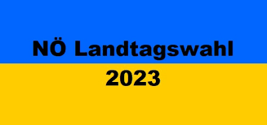 January 29: State Elections for Niederösterreich (Lower Austria): 56 representatives were on the ballot in Austria’s largest state (area) and with 1.7 Mio people, 2nd largest in population. The election rendered a huge loss for the party dominating for many years, the conservative ÖVP (40%; -10%), also losing the absolute majority. The social democratic SPÖ (20.6%, -3% ) also lost, whereas the far right party FPÖ (24%, +10%) reached the most votes ever. Both smaller parties, the “Grüne” (Green Party) (7.6%, +1%) and the liberal NEOS (6.7%, +1.3%), could achieve small increases. The ÖVP will still nominate the Governor, Johanna Mikl-Leitner, who will continue in her position, but a coalition with another party needs now to be negotiated. The massive win of the far right and the substantial loss of the mainstream parties will trigger serious discussions within the main stream parties ÖVP and SPÖ about leadership and directions. (Results are still preliminary)
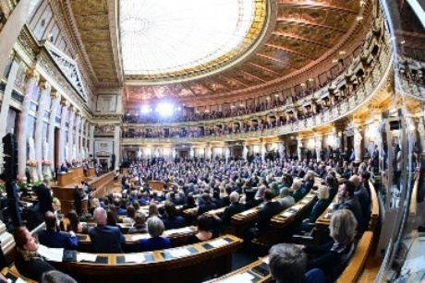 January 12: After 5 years of reconstruction, at a cost of 422 Mio Euro, the historical rooms of the 140 year old Austrian Parliament building can be used again. In a festive opening ceremony almost all of the top Austrian politicians were present. New is the 550m² ( 6,000 ft²) big glass dome ceiling.
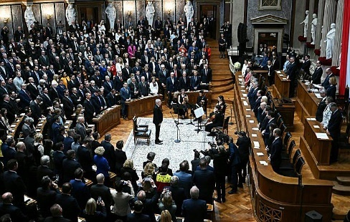 On January 26, 2023, the first important event in the newly renovated Parliament building was the festive Inauguration of Austria’s President Van der Bellen to his 2nd term. He got re-elected with a decisive majority. In his notable acceptance speech he stressed the importance for Austria of being democratic, pro-Europe, providing a home for everyone living in Austria, the untouchable human rights and the right for freedom, about not having done enough to fight climate change, the necessity to recognize and to fight constantly against anti-democratic and authoritarian tendencies but also giving hope for being able to weather the serious challenges facing the country and its people. He was welcomed by standing ovation by the members of the Parliament and invited guests.
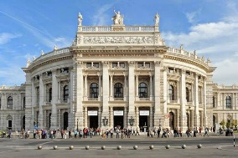 January 13: Serious accusations of child pornography and domestic violence against the famous and very popular actor and member of the Vienna Burgtheater, Florian Teichtmeister, led to an immediate cancellation of his contract and ban on any stage and TV appearance. All hopes for a Oscar Nomination for best international feature film of Marie Kreutzer’s movie “Corsage”, where he plays Emperor Franz Joseph, one of the 2 main characters, are of course dashed.
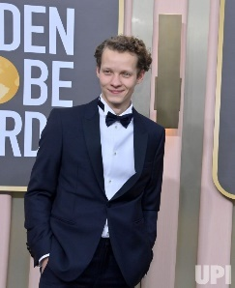 Felix Kammerer, 27, highly praised member of the Burgtheater in Vienna since 2019, had his screen debut in a lead role as Paul Bäumer, the main character and central figure of the story, “All Quiet on the Western Front” (Im Westen Nichts Neues). The movie got 9 Oskar nominations. He is the son of two esteemed Opera singers, Hans Peter Kammerer and Angelika Kirchschläger.
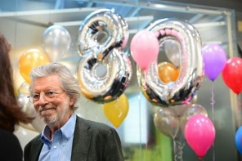 January 14: Oskar Bronner, son of legendary cabaretist Gerhard Bronner, celebrates his 80th birthday. With only 27 years, he founded 1970 the polit magazine “profil” and economy magazin “trend”, a new concept at that time. He then lived in New York and dedicated many years of his life to art, painting and sculpture. After his return to Austria in 1986 he founded “Der Standard”, now one of the largest and most important Austrian newspaper. The “Bronner Family” is still the sole owner of the newspaper.
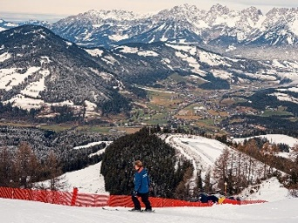 January 19: the legendary “Hahnenkamm” Alpine downhill races in Kitzbühel are on the calendar. After a snowy December, many regions in Europe suffer under too mild and dry weather, especially in lower regions in Austria, like in Kitzbühel. With great efforts it was possible to prepare a safe piste for the races but the tourism industry and the environment are suffering. Effects of climate change can be seen here first hand. Less than 20% of Tirolyan ski resorts can get by without producing snow. Everyone in Austria, where skiing is a national sport, is hoping the snow to come! And it came just in time for the races! Austrian Vincent Kriechmayr won the first Hahnenkamm downhill race on January 20, the Norwegian Aamodt Kilde a day later the second race.
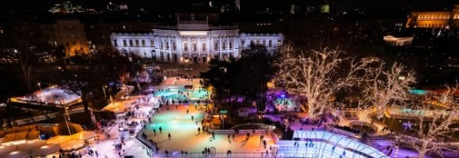 January 19 – March 3: After the famous Christkindlmarkt in front of the Vienna City Hall moved out, the “Wiener Eistraum” (Vienna Ice Dream) moves in! An area of almost 10,000m² (~100,000 ft²) stretching from the City Hall, Burgtheater to the Parliament invites to get your skates out and enjoy this very special atmosphere on ice.
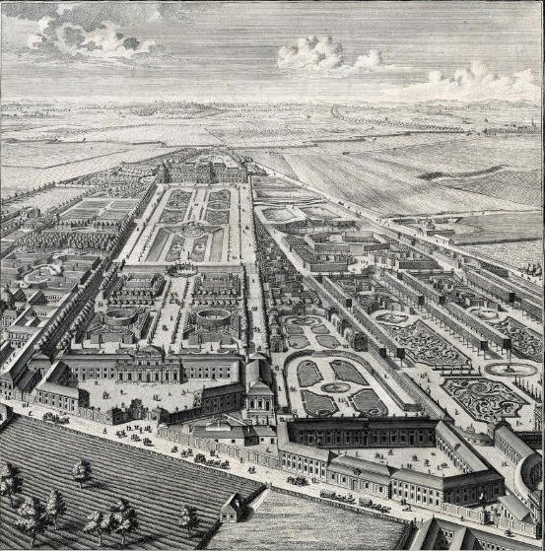 December 2, 2022 – January 7, 2024: 300 years of the Upper Belvedere; a special exhibition marks the start of the 300th anniversary of the completion of the Upper Belvedere, from 1723 to the present day. It served, among many other occasions, as the summer residence of Prinz Eugene of Savoy (1723), wedding reception for Marie Antoinette (1770), first publicly accessible museum initiated by Maria Theresa (1777), and the signing of the Austrian State Treaty (1955).
December 4, 2022: Karl Merkatz, here with Ingrid Burkhard, passed away at the age of 92. He was best known for his roles as “Mundl” or “Bockerer”. In the TV series “Ein echter Wiener geht nicht unter” ( A real Viennese never succumbs) he became an icon for the resilience of the Viennese worker who fought against job loss, role in society, and hardship with humor, anger and yes, with alcohol. He also was playing at the most renowned German language theaters.
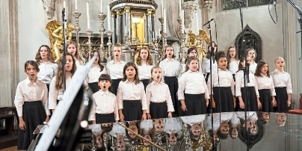 Vienna Girls Choir: founded 2004 for girls 8 – 15 years, receive vocal training following the methods used for the Vienna Boys Choir. They host their own concerts but also recite together with their male colleagues, the Vienna Boys Choir, most recently at the New Year’s Concert 2023 of the Vienna Philharmonic Orchestra and at the re-opening ceremony of the Austrian Parliament Building. Further integration with the Boys Choir also with the special music gymnasium (high school) are in the planning.
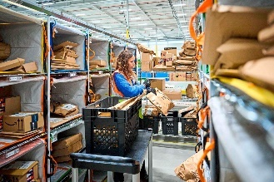 Amazon is planning the 6th distribution Center in Austria in St. Valentin near Amstetten. Local residents are in stark opposition to this project which would create about 100 jobs. Mostly the loss of rural landscape, increase in traffic and emission are the main objections.
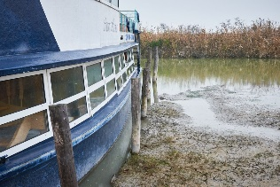 Neusiedler See: In October 2022 the large inland lake “Neusiedlersee” SE of Vienna in Burgenland, was at its lowest water level since 1965. The ferry service had to be suspended (Photo of a stuck Ferry in Mörbisch). Big restoration efforts are now under way to save that jewel of a water body. Cooperation with Hungary is necessary as about 1/3 of the lake’s area is in Hungary. Even in a fast and optimal scenario, experts doubt if a restoration into its original form is possible.
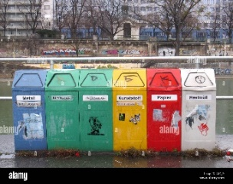 Recycling is getting easier in Vienna: only separation into 3 categories paper, glass, and all other packing materials becomes necessary. Modernized sorting equipment does the rest!
Summer Course for German Language and Culture in Austria are offered by the Diplomatic Academy of Vienna from August 7-25, 2023, in Vienna: www.da-vienna.ac.at/summer_course

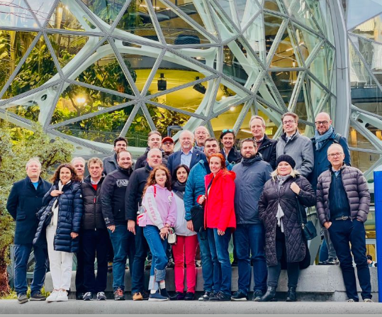 January 9-12, 2023: After the visit of CES 2023 in Las Vegas, where Austria was among 24 Nations achieving highest ranking of “Innovation Champion”, a delegation of 25 CEO/CTOs of Austria IT Consulting Companies visited Seattle. Their schedule was filled with meetings at Microsoft, Blue Origin, Boeing, and UW among others, gathering newest information about quantum computing, cybersecurity, AI in industry, data centers, and nanotechnology.
UPCOMING EVENTS

February 11, 2023; 2-5pm: SAVE THE DATE: SAGA Kinderfasching. The SAGA School is planning its annual "Kinderfasching" for Saturday afternoon, February 11th. Fasching is a European celebration including music, games, and lots of fun. Parents and children are encouraged to dress in costume. This event is open to the public. Looking ahead: March 21 and 22, 2023: SAGA German Book and Game Sale: SAGA needs to thin out its inventory! SAGA will feature new and used games for sale or on a donation basis. More information on this or any other information about SAGA: info@sagaschool.org; www.sagaschool.org/
Eastside German Language School http://www.egls.us is hosting a “Fasching” celebration on Saturday, February 11, 2023, 11-12pm at the FUMC in Bellevue, WA. For more information: Dr. Angrid Henning, principal: principal@egls.us
ABCGermanSchool.com in Bellevue, WA, is hosting a “Tag der offenen Tür” (Open House): Saturday, March 4, 2023; 10-12 noon; Meet & Greet with teachers, individual tours, and German pastries and crafts! For more information: Principal Nadja Helmer-Penry: nadja@abcgermanschool.com
Austrian American Council – WA Chapter under the new leadership of Christina Calio, is fostering positive Austrian American friendship in the Pacific Northwest region through communications and programs. Cultural, historical, and current affairs outreach is directed towards interested groups and individuals of diverse backgrounds and ages. In a special emphasis, the AAC -WA Chapter assists the integration of newly recognized Austrians to the Austrian American Community here in the PNW. For more information, please contact Christina Calio: christina@caliomusic.com
Are you interested in going on a photo tour in Europe? Fellow Austrian Magrit Baurecht, together with her husband Jim Nilsen, are organizing fascinating photo tours in Europe, from Tulips in Netherlands, Slovenian Alps to Timeless Toscana: https://photographytraveltours.com/photographing-the-netherlands-in-spring/
Check out the regular online film and music events organized by the Austrian Cultural Forum: https://acfdc.org/?mc_cid=487b48d54a&mc_eid=1321923619
Deutsche Welle - The International News Information Channel from Germany – aired in many different languages: for news in German: https://www.dw.com/de/themen/s-9077
Virtual Stammtisch for German Learners: once a month via zoom: Next meeting: Wednesday, February 15, 2023, at 6pm. The virtual Stammtisch for German learners is an opportunity to get together, speak German, and have fun. Sabine Sullivan is a native speaker and will host the Online-Stammtisch. If you would like to attend or have any questions, please contact Sabine Sullivan: sabine.sullivan@zoho.com
Monthly Stammtisch – 1st Thursday of the month: Mark your calendar!!
Next one: Thursday, February 2, 2023; 7pm; location: Queen Anne Beerhall; 203 W Thomas St, Seattle. Please contact Elana Sabajon youcan@askelana.com or Jürgen Schatzer juergenschatzer@gmail.com for questions. The event is also posted on Meetup: Austrian – Österreichische Gruppe”. The location of the Stammtisch is rotating throughout the greater Seattle Area. There is so much to talk and chat about!
Lastly, The Austria Club of WA, www.austriaclubwa.com is holding its annual membership meeting on February 11, 1-4 pm at the German House in Seattle, 613 9th Ave, Seattle. Besides meeting again with friends, several board positions are up for elections. The Austria Club of WA needs your active participation to being able to continue its wonderful work in providing a platform for bringing Friends of Austria together and to foster Austria’s traditions. For any questions, please contact the club’s president, Michael Brandstetter: michael.brandstetter@gmail.com
Mit herzlichen Grüβen
Eva Kammel
Honorary Consul of Austria in Seattle
office@austrianconsulateseattle.org | www.austrianconsulateseattle.org

Atachments: Viennese Ball flyer

