March 2021 Newsletter of HC of Austria in Seattle

Dear Friends of Austria!
What an amazing Ski season we had! Record snowfall in the Cascade Mountains buried even Covid frustration and the ski resorts could run until June…! Hope you could get out and enjoy the wintry scenes in the mountains! (image from “Alpental” near Snoqualmie Summit)
Due to my planned trip to Austria, the Honorary Consulate of Austria in Seattle will be temporary closed for in-person visits from April 12 – May 9, 2021. I will try to accommodate as many applications beforehand as possible. Please contact me ASAP if you need an appointment before April 12. I will be able to answer emails during this time, maybe with a bit of delay.
For consular assistance please contact the Consulate General of Austria in Los Angeles: Tel: 310 444 9310 or by email: los-angeles-gk@bmeia.gv.at

Austrians living in the beautiful Pacific Northwest have a dilemma to choose between:
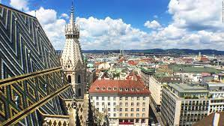 Vienna, most livable city in the World or….. WA ranks 1st as best state in USA! https://www.usnews.com/news/best-states/washington
What a hard choice !

NEWS FROM AND ABOUT AUSTRIA
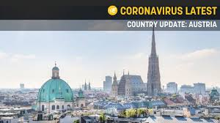 In March there was a stark uptick of Covid-19 cases in Austria, averaging about 3,200 new infections/day. The ICU beds are close to being filled up. The newest spike is partly due to the British variant of the virus which is, especially in the Eastern part of the country, prevalent by now. The strong existing restrictions will be not lifted at least until after the Easter Holidays. Especially in the Eastern region, there will be an even more drastic lockdown over the Easter Holidays. The neighboring countries also increased the restrictions on travel, movement, tourism and business.

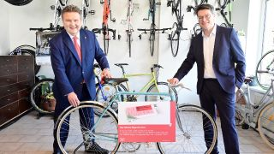City of Vienna extends a popular program: “Reparaturbon”: up to € 100 will be refunded if the Viennese decide to repair things like bike, cell phone and other electronic devices, clothing, furniture, etc instead of replacing it. So far up to 190 tons of greenhouse gases could already be avoided and additional jobs created. If the life cycle of such items could be extended by just one year within the whole EU there could be a saving of about 4 Mio tons of CO₂, that is an equivalent of the emissions of 2 Mio cars.
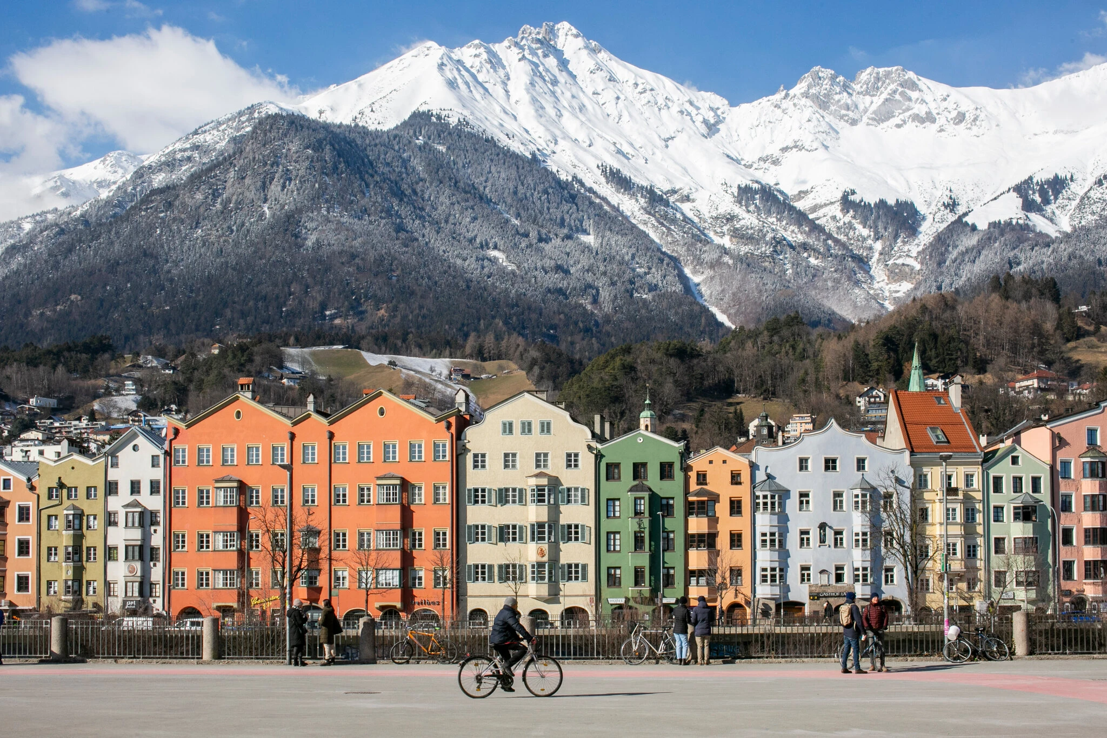March 11: The vaccination against Covid-19 of the whole population aged 16 and older living in Schwaz district in Tyrol near the city of Innsbruck is a pilot program to study how effective the Pfizer vaccine works against the new “South Africa “variant. This is the first real-life study on this question. 100,000 extra doses of the vaccine will be distributed in exchange for allowing a multinational team of scientists to collect data. This region has been one of Austria’s hardest hit by the coronavirus. A large percentage of the population is participating in this study. The movements across borders to neighboring other Austrian states and other nations have been restricted or partly closed.
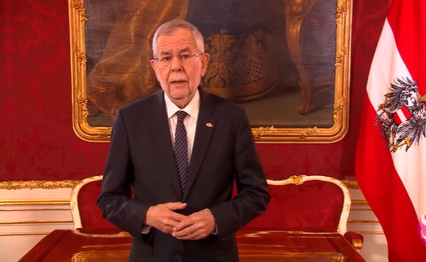March 14: Austria’s President Alexander VanDerBellen commemorates 1 year of the Pandemic. He reminds us that nobody got spared, and some of us had to suffer greatly. He urges to direct the understandable frustration not against each other but to show empathy and to work together so that we can overcome the common enemy as soon as possible, while not to forget how fragile our society is.

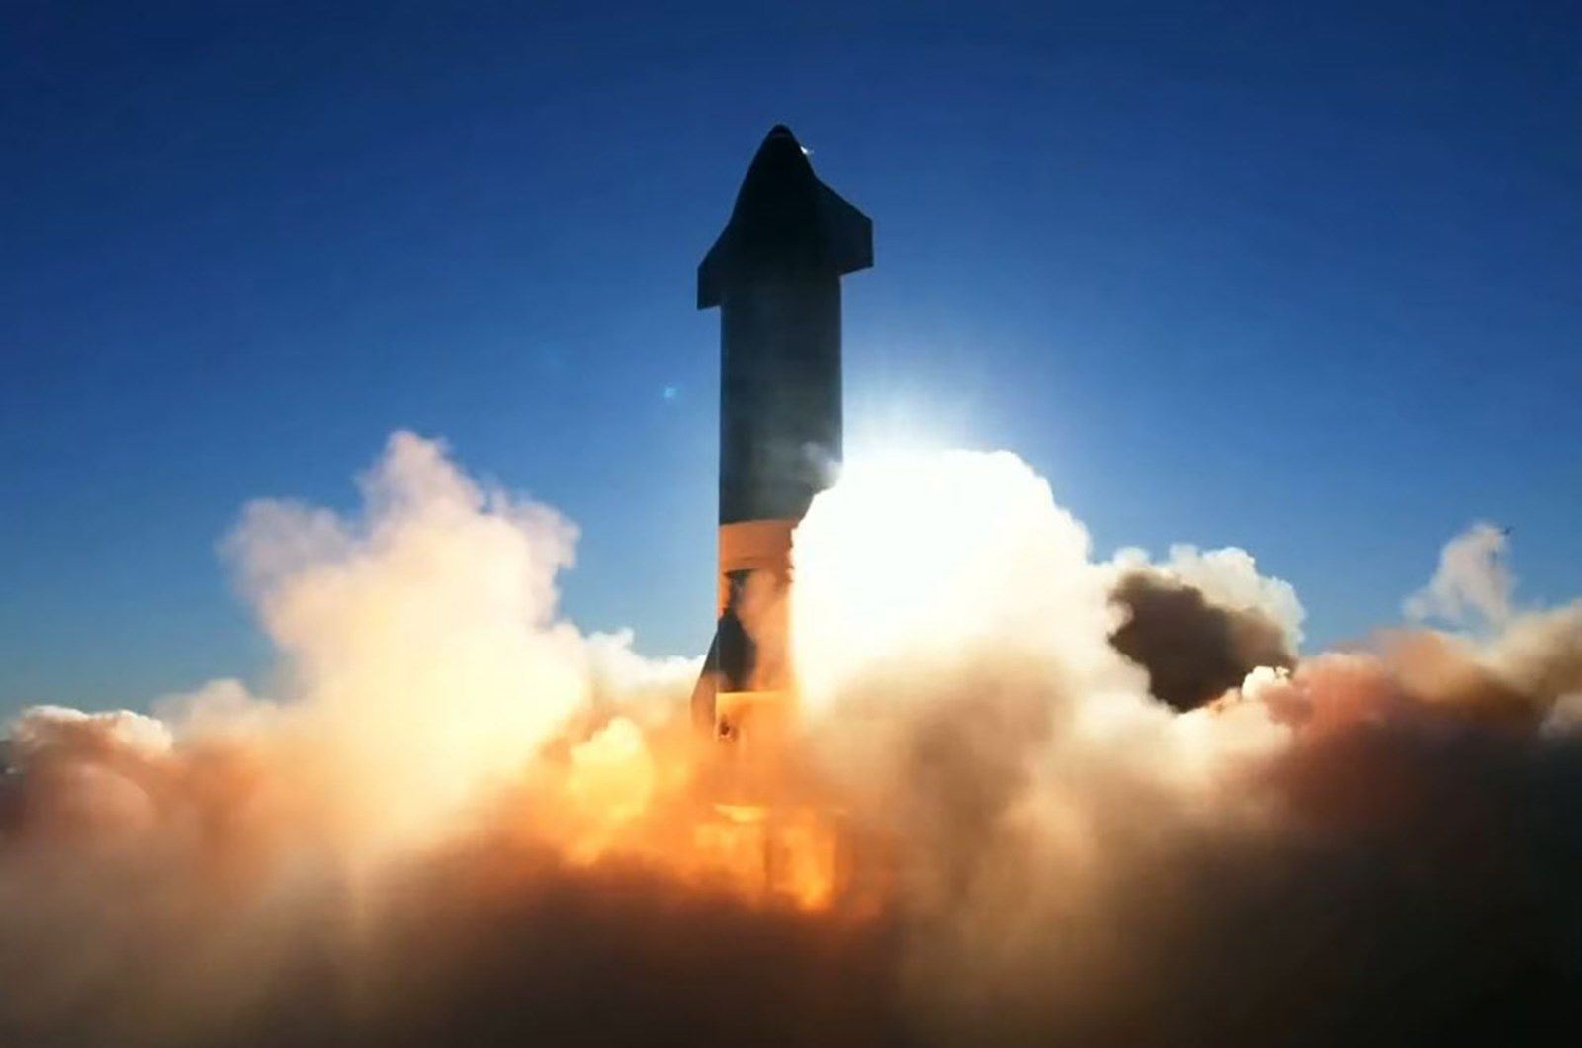 Schoeller-Bleckmann Oilfield Equipment (SBO), located in Ternitz, Lower Austria, is bracing for a time in the near future where oil production will not be as important anymore. It launched a cooperation with Elan Tusk’s Space X company and delivers high quality, high durable materials. The company tries to expand also into geothermal, hydrogen, and semiconductor industries.

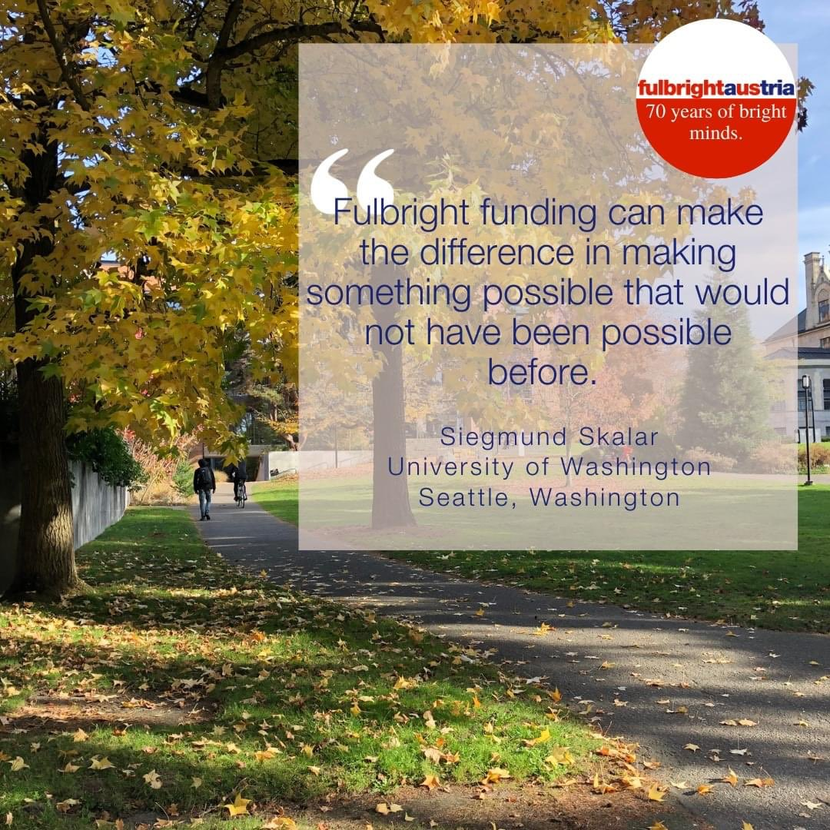 Starting now until May 1, 2021: application process for the Fulbright Austria Student program has started! You must be Austrian citizen, residing in Austria and have completed a bachelor’s degree then you can apply for a Master degree and study in the US. For more information: https://www.fulbright.at/programs/in-the-usa/students/grant-details/austrian-fulbright-student-program

UPCOMING EVENTS
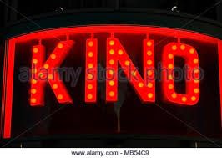 Friday, March 26, 2021: 8pm: Heimatkino: „Die Vaterlosen“ (Drama, Österreich, 2011). Come join watching an Austrian movie together! Here is the
Zoom link: https://us02web.zoom.us/j/83927561306
For more information, please contact Jürgen Schatzer: juergen.schatzer@gmail.com

Monthly Stammtisch – 1st Thursday of the month: Mark your calendar!!
STAMMTISCH: Thursday, April 1, 2021: 7 – 9pm:
Hope many of you can join, bring your favorite drink and let’s enjoy time together! There is so much we can talk and chat and laugh about! For any questions, please contact Jürgen Schatzer: juergen.schatzer@gmail.com
zoom link: https://us02web.zoom.us/j/5845087371

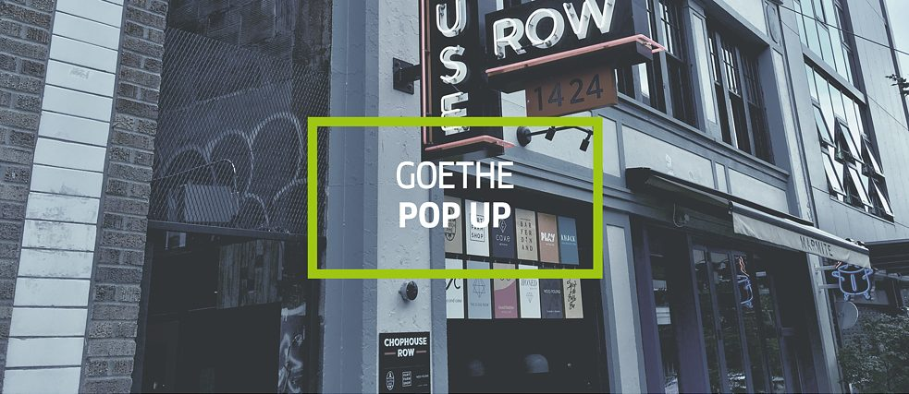Goethe-Pop up Institute in Seattle: check out their offerings, ranging from book clubs to film screening: https://www.goethe.de/ins/us/en/sta/gps.html
Online Offerings by the Austrian Cultural Forum: acfny.org
March 2 – March 31,2021: Online Concert Sinfonia De Carnaval – Anna Lang and Alois Eberl from the city theater of Gmunden, Upper Austria
https://acfdc.org/events-2021/sinfonia-de-carnaval?mc_cid=f651772cfc&mc_eid=1321923619
March 18 – 28, 2021: Online Environmental Film Festival: 2 Austrian film (“Earth” and “Wood”)
https://acfdc.org/events-2021/dceff?mc_cid=f651772cfc&mc_eid=1321923619

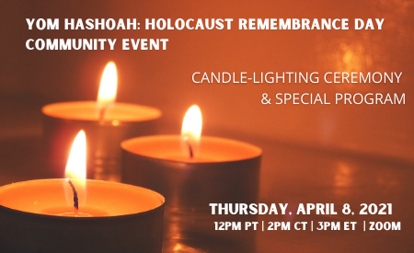Thursday, April 8; 12-1pm: Yom Hashoah: Holocaust Remembrance Day: Hope you can join the virtual remembering organized by the Holocaust Center for Humanity in Seattle:
https://holocaustcenterseattle.org/programs-events/645-yom-hashoah-holocaust-remembrance-day-community-event
Interesting Read: Detailed article about the life, suffering, experiences living as young woman of Jewish descent in Vienna before/during/after WWII was published by Nathan Parker Weston. He pieced together the lives of Helmuth and Paula Bettauer (son and daughter-in-law of the famous Austrian author and journalist Hugo Bettauer (e.g. Stadt ohne Juden) based on his aunt Paula’s entries on application forms to obtain federal subsidies after the end of the war. Nathan Parker Weston, a native of Seattle, is the great-grandson of Hugo Bettauer,
Weston, Nathaniel P. 2021. "Memoirs in Miniature: CM/1 Forms and Fragmentary Understandings of the Holocaust." Humanities 10, no. 1: 22. https://doi.org/10.3390/h10010022

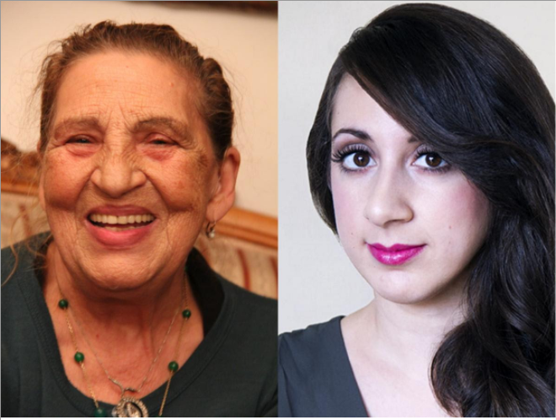 Music of Remembrance is honoring Austrian Romani artist and writer Ceija Stojka, who survived 3 concentration camps to become a noted painter and writer. At the same time, the imaginative young American composer Mary Kouyoumdjian is also saluted, whose powerful “To open myself, to scream” was inspired by Stojka’s life and art.
https://www.youtube.com/watch?v=J7Tcq_Dp5DI
Music of Remembrance (https://www.musicofremembrance.org/) is a Seattle based chamber music organization remembering the Holocaust through music.

April 17-18,2021: International Children’s Friendship Festival http://childrensfest.tacawa.org/
Instead of learning from children hosting tables of their respective countries, this year you can enjoy beautiful and inspiring video contributions from children around the world.
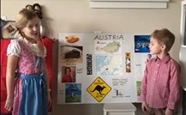Especially heartwarming is Austria’s contribution produced by Mia and Max Stoklas. Enjoy this sweet video!
https://drive.google.com/file/d/1GEAatypkX7PdfAtkxnLWqyiuMKdlXD4U/view?usp=sharing

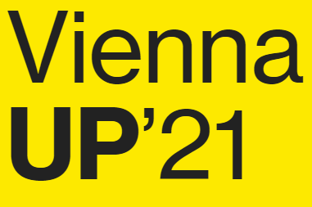 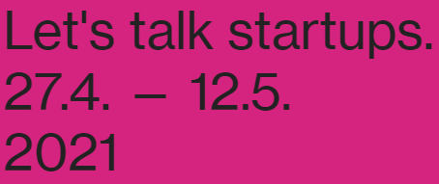 April 27 – May 12: Vienna UP’21: https://viennaup.com/ . Why ViennaUP? Get involved in one of the most diverse and fastest growing start up scenes in Central Europe. There is already a great digital lineup of international and local events such Wired Pulse, 4Gamechangers, Investors Summit, many more to follow! ViennaUP is a unique festival with a series of online events organized from the community for the community of startups, investors and talents. The events are accessible online from all around the world. ViennaUP´21 paves the way for exploring new forms of partnerships for tomorrows pioneering business solutions. Curated by the Vienna Business Agency.

Wishing you all blessed Easter and joyous Passover holidays and a lot of sunshine brightening up your spring days!
Herzlichst,
Eva Kammel
Honorary Consul of Austria in Seattle
office@austrianconsulateseattle.org | www.austrianconsulateseattle.org

