March 2022 Newsletter - HK Seattle
Dear Friends of Austria!
The colors of spring are here, helping to uplift the heavy mood caused by the horrific, unjust, and brutal war Russia is waging against peaceful Ukraine. How can this happen in our present time? We can only hope that peace will come soon, peace that can last and is just for the brave Ukrainian people.
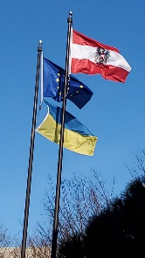 As of now, about 35,000 refugees registered in Austria, and more are expected to arrive in the next couple of weeks. Several thousand more transit through Austria. After Poland and Czech Republic, Austria is under the biggest pressure according to an index prepared by the EU’s executive based on the number of refugees as well as the size of the population. There are increased efforts under way by the government, numerous organizations, and by the people opening their homes to support the mostly women and children arriving in Austria to resume a somewhat normal life while waiting what the next months will bring. Among the many supportive measures, all Austrian Universities have implemented support for Ukrainian students, ranging from waiving tuition, increased financial support, fast track recognition of foreign academic qualifications, teaching materials and language support for teachers and students of all grades.
If you want to help Ukrainian refugees in Austria, here are some options:
https://start.wien.gv.at/hier-koennen-sie-helfen .
https://www.derstandard.at/story/2000133660733/wie-man-menschen-aus-der-ukraine-jetzt-helfen-kann
Among them:
Nachbar in Not: https://www.roteskreuz.at/spende-nachbar-in-not
Caritas: https://www.caritas.at/spenden-helfen/auslandshilfe/katastrophenhilfe/laender-brennpunkte/ukraine
SOS- Kinderdorf: https://www.sos-kinderdorf.at/helfen-sie-mit/spenden/hilfsprojekte/ukraine?gclid=Cj0KCQiAmeKQBhDvARIsAHJ7mF42v-qm7HKfNaR3nuPt7SRzGbKUafIyqIq6ahr9PWQJPtbRtF0KdIgaAjqpEALw_wcB

April 11-14, 2022: Visit of Consul General of Los Angeles and Trade Commissioner (Advantage Austria, Los Angeles), in Seattle. CG Dr. Postl and TC Volker Ammann are planning visits to some of the companies and political players in Seattle, and also with Austrians and their businesses of any size.
CG Postl expressed his wish to also meet with the Austrian community. Therefore, we are organizing a dinner at the Salmon House at Lake Union, 401 NE Northlake Way, Seattle, on Tuesday, April 12, at 6pm. Please let me know if you can come by latest April 8, 2022, via email: office@austrianconsulateseattle.org. The cost/person is $50, that includes the buffet and drinks. Please indicate if you have any dietary wishes and how many of you are coming. We need an exact head count. We ask everybody to show proof of vaccination when coming to the event. Wearing masks indoors is optional.

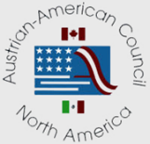 New leadership at the Austrian American Council West - WA Chapter:
As Michael Brandstetter (michael.brandstetter@gmail.com) took over the presidency of the Austria Club of WA, he stepped down as the head of the Austrian American Council West – WA Chapter. Thank you, Michael, for your efforts and energy you spent in past years dedicated to keep going what Claire Rood started and nurtured for so many years.
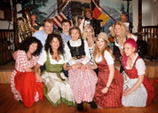 Congratulation and thank you, Christina Calio, for stepping forward and taking on the now vacant leadership. Christina’s communicative, approachable personality, combined with her love for Austria and her knowledge and admiration for how much her mother Claire Rood has done for this organization for so many years, makes her the perfect person in this role. (Christina far left in the photo). Claire Rood started the WA Chapter in 1997 and served as president until 2015, even travelling to Washington DC when President Clinton declared September 26th Austrian-American Day in 1997.
Christina: “My sisters Monica, Ingrid, my father Wolfgang, and I were so proud of our mother’s accomplishments. While I could never fill her shoes, I am thankful for the opportunity to contribute to the great Austrian American community in the Seattle area and to promote Austrian heritage and culture among all people. I welcome your ideas and suggestions and thank you in advance for your support!
Christina: christina@caliomusic.com

Both, Christina and Michael, now need your support, so please step forward volunteering, it is for the benefit of all of us!

TRAVEL TO/FROM Austria:
There are no significant changes for traveling to/from Austria since February. 3-G is required (either proof of vaccination or negative Covid test, or proof of recovery). If you get an exemption from 3-G, then you are required to register upon entry and quarantine for 10 days. Returning to the USA, you need a negative PCR test. As the restrictions change frequently, please check the latest updates for traveling to and from Austria at the website of the Austrian Consulate General in Los Angeles: https://www.bmeia.gv.at/en/austrian-consulate-general-los-angeles/travels-to-austria/coronavirus-covid-19-and-travel-information/

NEWS FROM AND ABOUT AUSTRIA
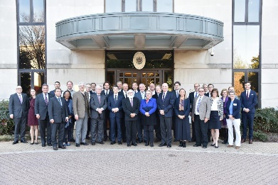 Consular Conference at the Austrian Embassy in Washington, DC, March 3-4, 2022: It was an honor to participate in this event that brought together the official representatives of Austria working in the USA. We got briefed on the newest developments in Austria, new laws and initiatives, and also had time to get to know and learn from each other as most of us work on our own, spread out throughout the country. Highlight was the dinner reception at Ambassador Martin Weiss’ residence.

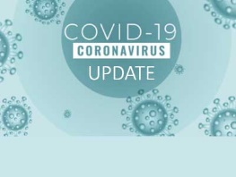 Extreme high Covid case numbers in Austria, reaching a peak Mid-March with almost 50,000 new cases per day (compare to 3,000 in WA state). That triggered the reinstating of some protective measures, among them the mask requirement and 3G regulation for restaurants and indoor public places. Mostly the Omnicom BA.2 variant is the cause for this spike. Luckily the number of severe illnesses and deaths is relatively low.
For the Covid related situation within Austria: https://www.austria.info/en/service-and-facts/coronavirus-information
Vaccination status: Austria: 76.3% received at least 1 dose of vaccination (WA State: 81.2%), Austria: 54% are fully vaccinated (WA: 74%)
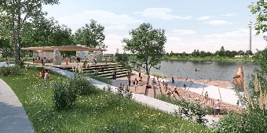 Remodeling of a stretch of Vienna’s “Neue Donauinsel” – The Sunken City - will start fall 2023 and will bring larger green beach and relaxation areas to a favorite summer escape for the Viennese people.
March 1: Opera Star Anna Netrebko who holds a dual citizenship Russia and Austria is cancelling all public performances in the near future. Her previous support of Russia’s president Putin brought up many critical voices. She denounces any form of war and hopes for an immediate solution to the conflict. She critizizes that artists are demanded to speak out publicly about their political opinion.
March 3: Health Minister Wolfgang Mueckstein (a physician, Grüne) resigned after only 11 mo in office. He cited the constant security risks, threats to him and his family at his front door; maybe also a role did play the difficulty to convey politicians to follow science and not politics in their decision making. Johannes Rauch took over the agenda. He has no medical background (besides that his wife is a physician) but experience in the banking sector, social service, and as leader of the Green Party in Vorarlberg.
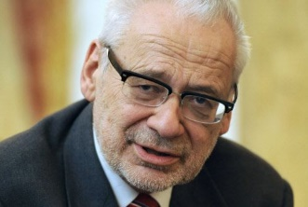 March 14: Former Vice Chancellor and head of ÖVP, Erhard Busek passed away at age 80. Among other positions, he was Minister for Economic, Interior, and Foreign Affairs. Before he entered politics he worked as journalist and was famous for his elegant language often embedding irony. He was respected for his enthusiastic embracement of Europe and for his passion for sustainability, reaching far into the future. He was credited with: “He was honest, maybe too honest for politics”. His passing came as a surprise, just 2 days prior he was actively debating about how research and Universities should react to the Ukraine crisis. He suggested that staying in communication with the Russian colleagues in research is the best way to keep a channel open for exchange of information and dialogue.
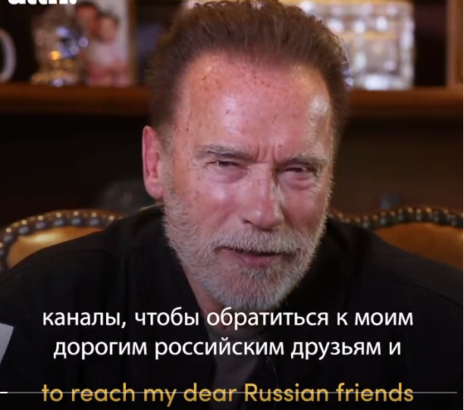 March 17: Arnold Schwarzenegger video – A powerful message to the Russian People: https://twitter.com/i/status/1504426844199669762

UPCOMING EVENTS
April 2, 2022; 1-3pm: Open House at ABC German School for New program!! Bilingual English/German Kindergarten/1.Klasse for students 5 and 6 years. Aligns with WA State Common Core Standards. For more information: www.ABCGermanSchool.com
ABC School moved to a larger building in Bellevue and is staging a fundraiser to secure the funds to perform necessary upgrades in the new building. “The only fires in this school, will be the fires in the children’s bellies when baking Brezeln in the ABC kitchen!” For more information: https://www.gofundme.com/f/abc-german-school

The annual International Children’s Friendship Festival is back in person! April 23, 2022; 11:am - 6pm; Fisher Pavilion, Seattle Center. http://childrensfest.tacawa.org/about-us/. As we did in the past, we will participate with a “Cultural Table”, an opportunity to showcase Austria’s culture with a display table and young people of the Austrian community presenting as “ambassadors”. Please contact Eva Kammel (office@austrianconsulateseattle.com) if you have ideas for this event and/or you and your child(ren) would be interested in volunteering. It is a fun way to connect and present our homeland! Volunteers are needed!!!
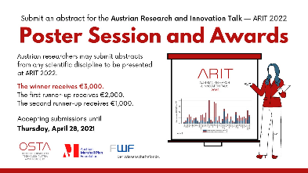 ARIT (Austrian Research & Innovation Talk) - Calling Austrian researchers conducting researcher in any scientific discipline in North America: accepting submissions for the 2022 @AT_MarshallPlan Foundation Poster Awards. Deadline: April 28, 2022. For more information, please visit: https://www.ostaustria.org/arit2022/poster-session

April 29, 2022, 9am -5pm: Consular Days for declarations for Austrian Citizenship of descendants of victims of National Socialism at the Honorary Consulate of Austria in Seattle, WA: if you have completed the online questionnaire regarding Austrian Citizenship pursuant to Article 58c of the Austrian Citizenship Act and, according to our records, we have yet to receive your declaration and supporting documents, you will have the possibility to file your declaration in person in Seattle. Please inform the Austrian Consulate General (via email: los-angeles-ka@bmeia.gv.at or phone: 310 444 9310), if you wish to file a declaration on this occasion. If a sufficient number of applicants indicate their interest, a second Consular Day will be offered on April 28th. Appointments will be given in the order of the received request.

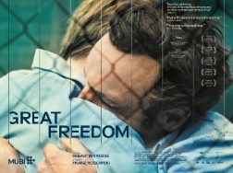 WA State Premiere of “Great Freedom (Grosse Freiheit), the latest film from Austrian writer-director Sebastian Meise, featuring German shooting star Franz Rogowski and Berlinale Silver Bear Awardee Georg Friedrich in the leading roles, took place at the NorthWest Film Forum in Seattle( https://nwfilmforum.org/) . The film paints a stirring portrait of gay resistance and resilience in post-war Germany, and was Austria’s official submission to the 2022 Academy Awards.

Check out the regular online film and music events organized by the Austrian Cultural Forum: https://acfdc.org/?mc_cid=487b48d54a&mc_eid=1321923619

Regular events are offered by the Goethe Pop Up Seattle, ranging from book club, Summer camps, movies, and literature presentations: https://www.goethe.de/ins/us/en/sta/gps.html
SIFF (Seattle International Film Festival, https://www.siff.net/): April 14-24, 2022: check out their latest program that includes also German language film and film with connection to Austria
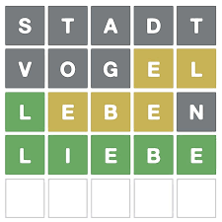 Have you heard about “Wordle”, that fun daily online word game that has captured the attention of millions and is now published daily by New York Times? Well, if you love this kind of game and, even better, also want to brush up your German , try the German version Wördl at wordle.at , but be careful, it is addictive! Have fun!
Monthly Stammtisch – 1st Thursday of the month: Mark your calendar!!
Virtual STAMMTISCH: April 7, 2022, 7pm: Join the get-together with friends of Austria via zoom. There is so much to talk and chat about! Zoom link: https://us02web.zoom.us/j/5845087371 . Questions: please contact Elana Sabajon: youcan@askelana.com or Jürgen Schatzer: juergenschatzer@gmail.com
Mit herzlichen Grüβen and peaceful Holidays!
Eva Kammel
Honorary Consul of Austria in Seattle
office@austrianconsulateseattle.org | www.austrianconsulateseattle.org

