March 2023 Newsletter - HK Seattle
Dear Friends of Austria!
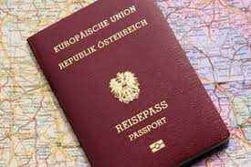 Travel Season is upon us! Please check the expiration date of your Austrian passport and schedule an appointment now before the travel season rush begins! For more information about required documents and to schedule an appointment please contact Eva Kammel at: office@austrianconsulateseattle.org
Notice: Due to a trip out of town there will be no in person meetings at the Honorary Consulate of Austria in Seattle from March 28 – April 9, 2023. Emails will be answered but please excuse delayed replies.
A BIG THANK YOU goes to the Viennese Ball Committee under the leadership of Eva Donahoo and all volunteers who helped to make this special evening a big success. The guests enjoyed this sold-out event and celebrated with dance and music, making new friends and connecting with longtime ones.
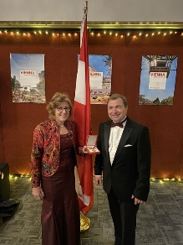 A very special Thank You also goes to Consul General of Austria in Los Angeles, Dr. Michael Postl, who traveled to Seattle to join us at the Viennese Ball. It was a special honor for me to receive from him the Decoration of Honor in Gold from the Republic of Austria for my service as Honorary Consul. I am honored and thankful.
NEWS FROM AND ABOUT AUSTRIA
Landtagswahlen in Niederoesterreich: Facing the loss of the absolute majority in recent elections, in a drastic course change the ÖVP Niederösterreich under the leadership of incumbent Governor Johanna Mickl-Leitner agreed to a coalition formation with the far right party FPÖ. And this despite the fact that the FPÖ refused to directly vote for her to confimr her As next NÖ Governor and deep rooted divisions between the parties but also between their two leaders.
Landtagswahlen Kärnten March 4: SPÖ: 39% (-9%); FPÖ: 24.6% (+1.6%); ÖVP: 17% (+1.6%), TK: 10.1% (+4.4%); Grüne: 3.9% (+1%). The SPÖ lost, the ÖVP and FPÖ could secure a small increase, wheras the Team Känrten gained the most. The Green Party again could not reach the 4% necessary to gain a seat in the state parliament. Negotiations for the government formation are ongoing.
SPÖ: the Social Democratic Party (center-left), one of Austria’s major parties, is undergoing restructuring and will vote for the leadership in a new format, namely by the votes of members. The incumbent leader, Dr. Pamela Rendi-Wagner, faces, besides her main competitors, the Governor of Burgenland, Hans Peter Doskozil and a local Viennese politician, Andreas Barbler, about 70 other candidates eying for the leadership role. This type of base democracy is a first and therefore not without challenges. The final decision will be annnounced at the next party convention in June.
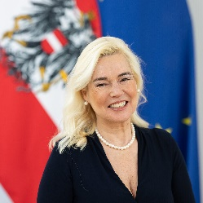 March 6: The new Austrian Ambassador to the United States, DDr. Petra Schneebauer, arrived in Washington DC and she will assume her duties after the accreditation ceremony at the White House. The position was vacant for over half a year. Ambassador Schneebauer, born in Wels, OÖ, studied in Vienna and Salzburg, earning PhD degrees in both, law and philosophy. Her career path shows several ambassadorships and leading positions in diplomatic organisations. Welcome to the USA!
March 8: News fitting for International Women’s Day: Austria has the highest share of female Startups in the EU! 36% have at least one female cofounder (in EU: 21%, but still an increase form 13% in 2010).
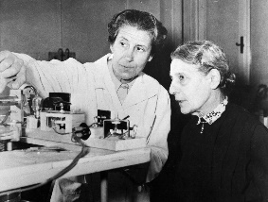Berta Karlik (1904-1990) (left, with Lise Meitner at the Vienna Institute for Radium Research (Institut für Radiumforschung, in the 1950ies), was not only one of Austria’s leading female Physicists, but also broke barriers blocking especially female researchers at that time. Among many “firsts” was the bestowing of the University Professorship to a female researcher and directorship of the Radium Institute in Vienna in 1947. Membership to the Austrian Academy of Sciences as first female got her granted only in 1973. Prof. Karlik was especialy active during the Naziregime in supporting and rescuing many of her jewish colleagues. Among her outstanding research was the discovery of the Element 85, today called Astat. She proposed the name Viennium for that element, but instead 2 US researchers got the Nobel Prize awarded for the discovery and could choose the name. https://www.derstandard.at/story/2000144205822/die-physikerin-die-wien-beinahe-ins-periodensystem-brachte
Alpenland , a new documentary by Robert Schabus, the story of people caught between the two opposite poles of economy and ecology, who have a deep bond with their living environments despite difficult conditions. https://www.alpenland-film.at/en/trailer?mc_cid=fcc9f3ff11&mc_eid=1321923619
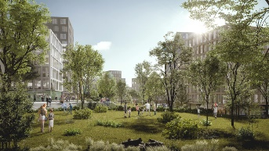 “Village im Dritten” is a housing development in Vienna’s 3rd district with over 2,000 apartments including the necessary infrastructure like groceries, child care etc. The new concept is based on providing the necessary energy exclusively by a combination of geothermal, solar voltaic and “Fernwärme” (distance heating). It will serve as a role model for affordable, sustainable housing. Plan for completion: 2027
https://www.wien.gv.at/verkehr-stadtentwicklung/erdsondenfeld-village-im-dritten.html
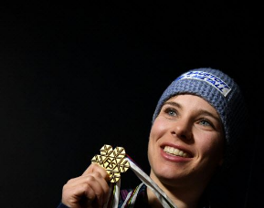 Nicole Schmidhofer announced the end of her active ski racing career, exactly 16 years after her debut ski world cup race. She was world cup champion in Super-G in 2017, won 4 world cup races (downhill and Super-G) and 8 further medals. She also breached the Austrian record in speed racing with unbelievable 217 km/h (=135mi/h). In December 2020 she suffered severe injuries after a terrible accident where she ripped all her left knee ligaments. Nevertheless, she worked hard for a comeback and achieved this year placements among the best 10. Her immediate goal is to finish her education as rehabilitation trainer where she can pass on her experience and determination to regain strength after an injury.
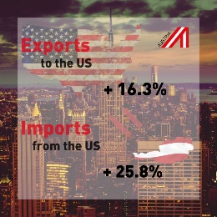 Bilateral Trade between Austria and the USA was expanding in 2022:
Austrian exports to the US rose by 16.3% to 13 bio Euro
Austrian imports from the US increased by 26% to a total of 7.2 bio EUR

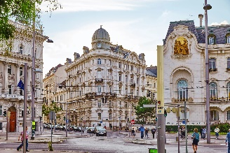 Time Magazine: World’s greatest Places 2023 to visit:Vienna ranked among 50 extraordinarly destinations to explore https://time.com/collection/worlds-greatest-places-2023/6261757/vienna/

UPCOMING EVENTS
April 22-23, 2023; 11:00am – 6:00pm at the Fisher Pavilion Seattle Center, 305 Harrison St, Seattle. Various nationalities are represented through music, folk dancing, art, and cultural tables. The children celebrate their international friendship through experiencing the rich tapestry of the world’s cultures.
Volunteers needed!!!! If you, and/or your child, grandchild can volunteer at the Austria Cultural Table for 1-2h either on Saturday 4/22 or Sunday 4/23, this would be wonderful! Our young friends are the best ambassadors! And it is a fun, easy task, and also provides the opportunity to learn, watch, and observe other cultures at the same time. Please contact Sabine Sullivan for more information: sabine.sullivan@zoho.com

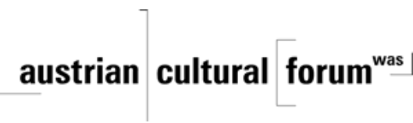 Check out the regular online film and music events organized by the Austrian Cultural Forum: https://acfdc.org/?mc_cid=487b48d54a&mc_eid=1321923619
Virtual Stammtisch for German Learners: once a month via zoom: Next meeting: Wednesday, April 12, 2023 at 6pm. The virtual Stammtisch for German learners is an opportunity to get together, speak German, and have fun. Sabine Sullivan is a native speaker and will host the Online-Stammtisch. If you would like to attend or have any questions, please contact Sabine Sullivan: sabine.sullivan@zoho.com

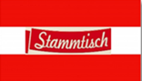Monthly Stammtisch – 1st Thursday of the month: Mark your calendar!!
Please contact Jürgen Schatzer juergenschhatzer@gmail.com for details for the upcoming one. The location is rotating throughout the greater Seattle Area. There is so much to talk and chat about!
Wishing you 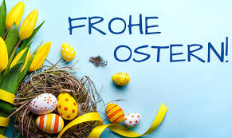 or
while relishing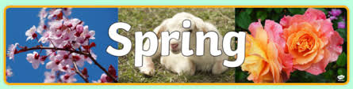!
Mit herzlichen Grüβen
Eva Kammel
Honorary Consul of Austria in Seattle
office@austrianconsulateseattle.org | www.austrianconsulateseattle.org

