HC Newsletter May 2021
Dear Friends of Austria!
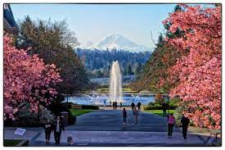Springtime in the Pacific Northwest is hard to compete with! Nature is bursting with colors, perfume like smells and a lot of vitamin D. Everyday a rhododendron, azalea or other flowers are cheering us up with their colorful greetings. And a lot of sunshine in addition – this must beat the Covid blues!

Since May 18, 2021, there are new travel guidelines for traveling from the US to Austria! For the newest updates please always check the website of the Austrian Consulate General in Los Angeles: www.austria-la.org
All travelers must still register online (at earliest 72h) before traveling to Austria (pre-travel clearance, https://entry.ptc.gv.at/en.html)
ENTRY RESTRICTIONS
To reduce the spread of COVID-19, Austria currently is still restricting the entry of most travelers arriving from outside the European Union. The entry ban includes travelers arriving from the United States. There are some exemptions though, e.g. all Austrian citizens and persons living in the same household are allowed to enter. There are more changes expected to be issued before the summer travel season starts. So, please always check the website of the Consulate General for the latest updates and exemptions: www.austria-la.org.
Any person who claims one of the exceptions, that includes all Austrian citizens arriving from the USA, must present upon entry into Austria ONE of the following:
- a CERTIFICATE OF VACCINATION against COVID-19 meeting the following requirements:
Vaccination valid for entry no earlier than 22 days after the first inoculation and up to 9 months after the last (2nd) inoculation;
Authorized vaccines: BioNtech/Pfizer, Moderna, Johnson&Johnson/Janssen, AstraZeneca, or Sinopharm/BIBP
- a CERTIFICATE OF RECOVERY from COVID-19 (infection within the past 6 months) or proof for the presence of neutralizing antibodies (not older than 3 months)
- a negative COVID-19 test taken no earlier than 72 hours (PCR test) or 48 hours (antigen test) prior to entering Austria. In this case, the person seeking entry must observe a 10-day quarantine at their residence or at an appropriate accommodation at their own cost. Quarantine may be terminated upon presentation of a negative COVID-19 test taken no earlier than five days after entry. There are some exemptions from the quarantine, e.g. urgent family reasons.
That means, if you are fully vaccinated you only need to register online (Pre-travel clearance) but you do not need a test/quarantine in addition!
For activities within Austria, one follows the “3-G rule”: Geimpgft – Genesen – Getestet (vaccinated, recovered, tested): You need one of the “G” fulfilled to participate in indoor and outdoor activities.
If you need to update your travel documents, please contact the Honorary Consulate of Austria in Seattle ASAP to ensure your new passport arrives in time: office@austrianconsulateseattle.org. Now it is about 1 year that I can also accept at the HC in Seattle passport applications with fingerprints, submitted by residents from the Pacific Northwest, i.e., WA, OR, ID, MT, or AK. So far we have already hit 100 applications!
NEWS FROM AND ABOUT AUSTRIA
Condor Airlines http://www.condor.com resumes service from SEA to FRA on June 3, 2021 with flights Mo, Th and Saturday with an increase planned for July. This is addition to the flight services to Europe from SEA offered by Lufthansa and Delta/KLM
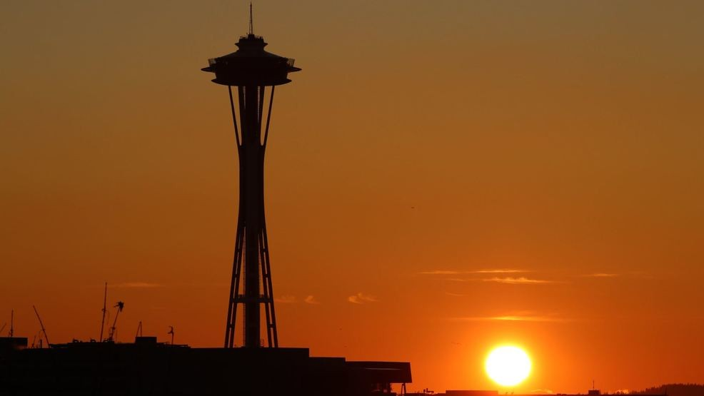 Comparison: April in Seattle – April in Vienna in 2021:
Seattle averaged 50% daily sunshine percentage in April -- more than Miami (47.6%). It was the sunniest April here in at least a decade. Vienna had its coldest and wettest April in the last 25 years. A study further suggests that Seattle may warm by 4.6 F (= 2.6C) by 2050. That change could bump Seattle from an official "Mediterranean cool summer" climate to a "Mediterranean hot summer" climate designation. Anybody is complaining about rainy Seattle?!?
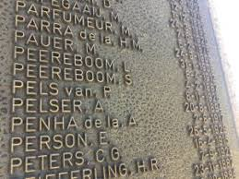 May 5: On this day in 1945, US forces liberated the Nazi concentration camp of Mauthausen in Upper Austria. To give the thousands of victims a face, their names were projected from May 4 to 6 onto the outer walls of the former concentration camp. Because Each Name Matters – We Will Never Forget
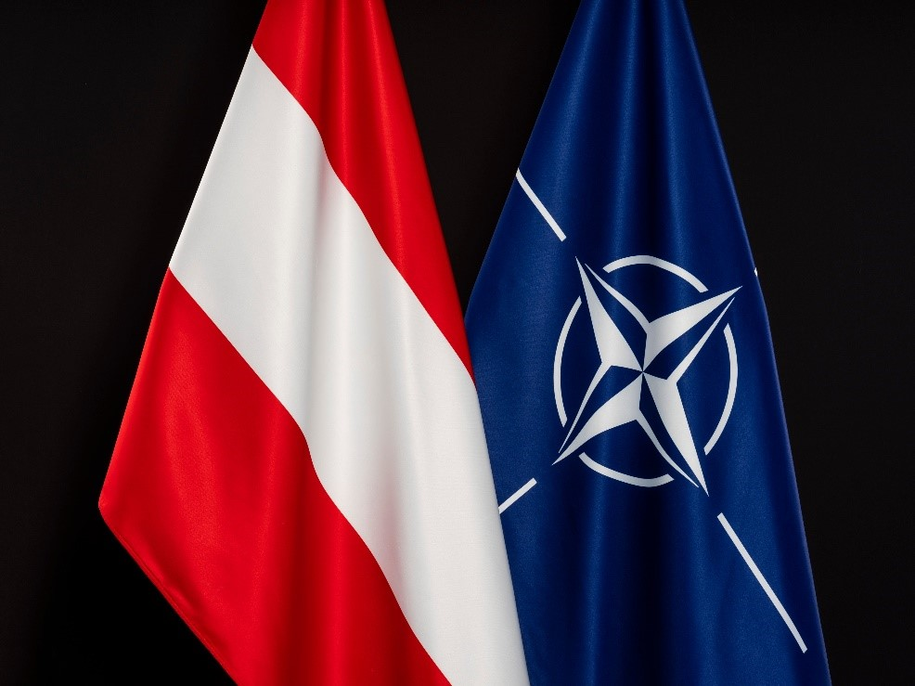 May 10: Austria’s Foreign Minister Alexander Schallenberg signed an agreement which paves the way for the formal establishment of the NATO Liaison Office to the OSCE (Organization for Security and Co-operation in Europe) and other international organizations in Vienna. As a reminder: Austria is bound to permanent neutrality by the 1955 Austrian State Treaty and its constitution, which prohibits entry into military alliances and the establishment of foreign military bases on Austrian territory. Austria is also not a member of NATO.
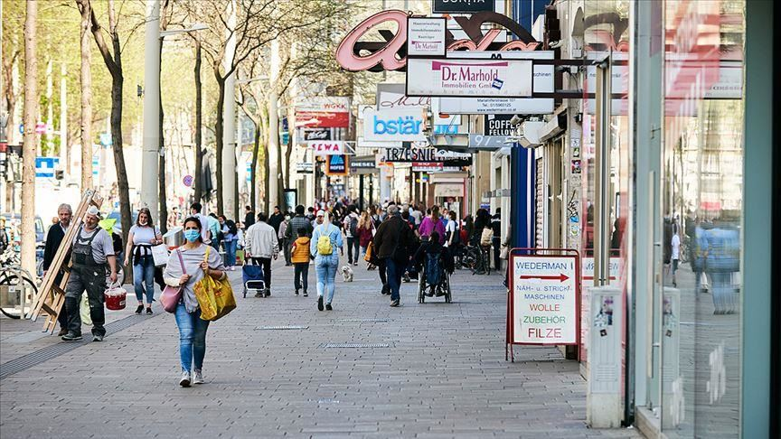 May 19: Austria is opening after a long and strict lockdown! It paid off, the infection rate fell dramatically and is now hovering around a low number. In all areas there will be almost normal business, accompanied by an intense testing strategy.
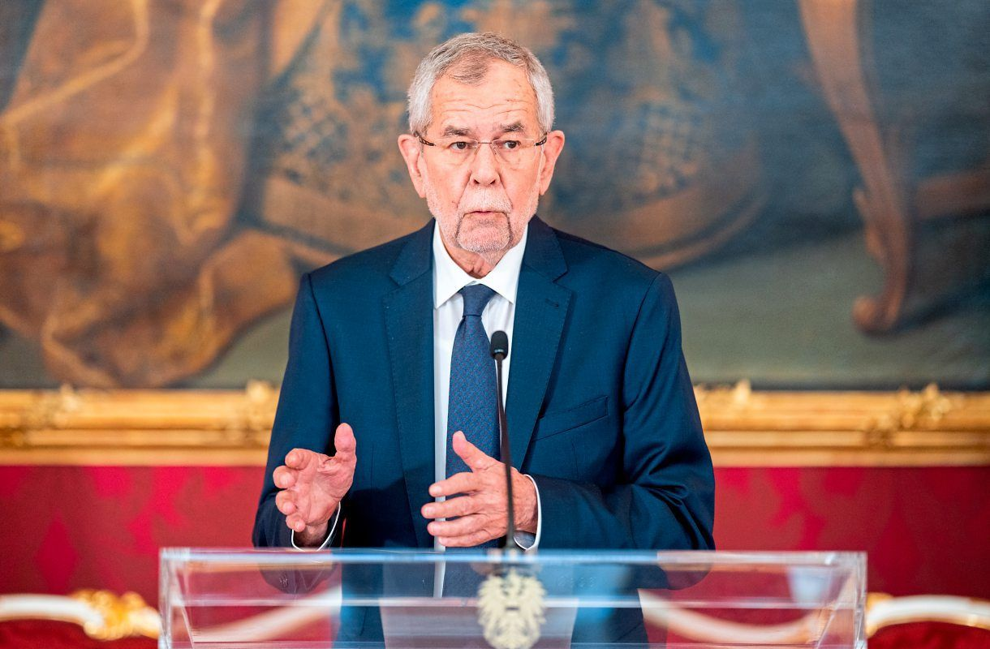 May 21: Austria’s President, Alexander VanDerBellen, reminds politicians of all parties to respect the democratic institutions and warns against weakening them. Besides the pure paragraphs of laws there is also decency required and expected. His speech addresses the current heated political debate, and he stands up for more dialog and openness for political discussion: https://twitter.com/vanderbellen/status/1395756270175596548
addressed in a speech the current heated political debate. He reminds politicians of all parties to respect the democratic institutions and warns against weakening them. Besides the pure paragraphs of laws there is also decency required and expected. He stands up for more dialog and willingness to cooperate:
https://twitter.com/vanderbellen/status/1395756270175596548
Wiener Hauptbahnhof (Vienna Central Station) ranked second (behind Lepzig) for Passenger Convenience in Europe. This underscores the importance transportation by railroad is playing in Austria.
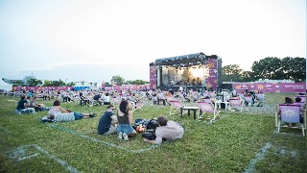 After a long stretch of lockdown, Vienna is gearing up for a culture summer with over 1,000 events planned to make sure the city residents and visitors get their local dose of culture.
Something “Zum Schmunzeln” (to smile about):
Language quiz: courtesy to Michael Brandstetter who picked this up from the newspaper “Der Standard, 5/3/2021”.
Ausgeruht wurde auf der Scheslong, man frisierte sich vor der Psyche, wusch die Hände im Lavor, spazierte auf dem Trottoir. Junge Mädchen waren im Backfischalter, da fing man vielleicht auch schon langsam an, auf Lepschi zu gehen. Marantanna! Solange man nicht als Luftikus durchs Leben ging, war alles gut, sonst hätte noch ein ordentlicher Palawatsch dabei herauskommen können. Zumindest hat es die Omi noch so erzählt.
Can you still follow?!
And here a comparison between the work attitude of Europeans and Americans:
European out-of-office reply: “I’m away camping for the summer. Email again in September”
American out-of-office reply: “I have left the office for two hours to undergo kidney surgery, but you can reach me on my cell anytime”.
UPCOMING EVENTS
Check out the regular online film and music events organized by the Austrian Cultural Forum: https://acfdc.org/?mc_cid=487b48d54a&mc_eid=1321923619

Check out the regular events offered by the Goethe Pop Up Seattle, ranging from book club, Summer camps, movies, and literature presentations: https://www.goethe.de/ins/us/en/sta/gps.html

Monthly Stammtisch – 1st Thursday of the month: Mark your calendar!!
Virtual STAMMTISCH: Thursday, June 3, 2021: 7 – 9pm:
Hope many of you can join, bring your favorite drink and let’s enjoy time together! There is so much we can talk and chat and laugh about! For any questions, please contact Jürgen Schatzer: juergen.schatzer@gmail.com
zoom link: https://us02web.zoom.us/j/5845087371

Mit herzlichen Grüssen
Eva Kammel
Honorary Consul of Austria in Seattle
office@austrianconsulateseattle.org | www.austrianconsulateseattle.org

