May 2023 Newsletter – HK Seattle
Dear Friends of Austria!
After we managed the early heatwave in May, we can now enjoy the beautiful spring blossoms and the abundance of sunshine while cooling off at night. Seattle at its best!
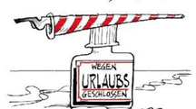 The Honorary Consulate of Austria in Seattle will be temporarily closed for vacation from June 19 – July 5, 2023. If you need consular assistance during this time, please contact the Consulate General of Austria in Los Angeles with any questions or in case of emergency: www.austria-la.org.
Please contact me right away if you need a new passport (everyone gets a new passport, there are no” renewals” anymore) or any other assistance in consular matters so that we can set up an appointment before I am heading out of town.
TRAVEL TO/FROM Austria: No further Covid related restrictions are currently in place. With May 12, 2023, also the vaccine requirement for international travelers entering the USA is not longer in effect. This means starting May 12, noncitizen nonimmigrant air passengers will no longer need to show proof of being fully vaccinated with an accepted COVID-19 vaccine to board a flight to the United States.
Please check the latest updates for traveling to and from Austria at the website of the Austrian Consulate General in Los Angeles: https://www.bmeia.gv.at/en/austrian-consulate-general-los-angeles/travels-to-austria/coronavirus-covid-19-and-travel-information/
NEWS FROM AND ABOUT AUSTRIA
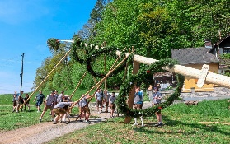 May 1: Tag der Arbeit (Labor Day) in Austria: Demonstrations for and against social demands and issues. Points of discussion: inheritance tax, increase of taxes on the rich, fight against inflation and increase of cost of living. The main contenders for the leadership position of the SPÖ used the mass events to promote their cause, ahead of the upcoming member vote.
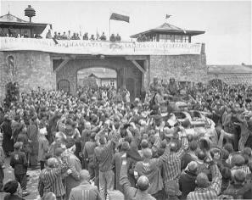 May 8: Commemoration of the liberation of the concentration camp Mauthausen by the US Army 78 years ago on May 5: Members of the Austrian government, together with many international politicians, youth organisations and over 10,000 guests were reminding of the importance of civil courage and resistance and “NO” to exclusion.
The concentration camps in Mauthausen, Upper Austria, and nearby Gusen were already built only a few months after the “Anschluss” in 1938. It was mainly run as a labour camp to mine a nearby quarry by incarcerated political opponents. About 190,000 prisoners from all over Europe got there transported. Especially in the last weeks of the war a huge number of them came from Germany, causing even more lethal conditions. Thousands of them died from starvation or disease. Almost 90,000 of the prisoners did not suirvive, about 3,000 of them perished in the last few days of the war. The last mass execution was carried out just a few days before the liberation. The victims were 33 Upper Austrian opponents of the regime. On May 5, 1945, units of the 3rd US Army finally liberated the about remaining 40,000 prisoners in those camps. Many of them were so weak and frail that they died in the weeks after inspite the medical help provided by the US Army medical units.
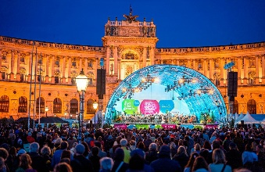 May 8: At the Fest der Freude (Festival of Joy) the liberation from the NS-regime 78 years ago was celebrated in Vienna at the Heldenplatz, at the same place where 1938 Hitler celebrated the “Anschluss”of Austria. President VanDerBellen put his remarks under the motto “Civil Courage” to remind us to be vigilant and fight against the steady, slow deterioration of democratic values. No action is no solution, words are also doing their job. The crowd offered standing ovation also to the then following story told by survivor Anna Hackl.
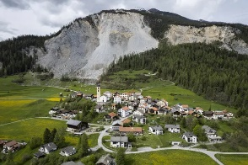 May 10: Scary images form Brienz, Graubünden in Switzerland. A rockslide could be imminent by a shifting mountainside. It is hard to predict whether the village will survive. The 70 villagers were told to leave immediately. A probably cause is climate change: Due to shrinking glaciers and thawing permafrost high in the mountains the rock becomes unstable. Lower down, heavier rainfall causes erosion and slippage. Swiss glaciers have lost more than half of their volume in the last 100 years. The situation of the glaciers in Austria are similar worrysome.
May 11: Talks between high ranking US and China officials take place in Vienna, the first since about 1 year ago. These beforehand non disclosed meetigs may be the start of a thawing of the forzen US-China relations. Vienna offerd to serve as place for dialogue also for the future.
May 13: 67th Eurovision Song Contest: Substituting for and displaying solidarity with the Ukraine, the last year’s winner and therefore the would-be host country, Liverpool (UK) hosted a splendid, euphoric week-long festival of 37 nations competing under the motto: “United by Music”. The display of unity among European nations embracing the Ukraine was demonstrated by the cheery and festive crowed. The Swedish singer Loreen https://www.youtube.com/watch?v=Vul5zgC5Yvg won ahead of Finland. Austria’s duo Teya&Salena ranked on 15th place with their song: “Who the Hell is Edgar?” https://www.youtube.com/watch?v=ZMmLeV47Au4 .
May 16 : The Austrian World Summit https://www.austrianworldsummit.com/ with Arnold Schwarzenegger, Austrian’s President VanDerBellen, UN Secretary General Antonio Guterres, among others takes place in the Hofburg, Vienna. The annual summit on Climate Change under this year’s motto “We have the power” will focus on climate protection, security and peace, circular economy, and green cities.
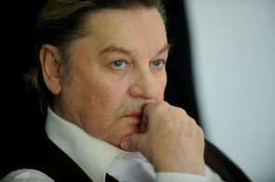May 18: Popular movie actor Helmut Berger (Steinberger), 78, native of Bad Ischl, passed away unexpectedly. In the hight of his carriere in the 60ies and 70ies, he palyed the main character in Oscar Wilde’s adaptation “The Picture of Dorian Gray”, “Gewalt und Leidenschaft (Conversation Piece)”, and Arthur Schnitzler’s “Reigen”. He was in close relationship with director Luchino Visconti, his death derailed Berger’s life greatly. Scandals and mostly minor roles followed.
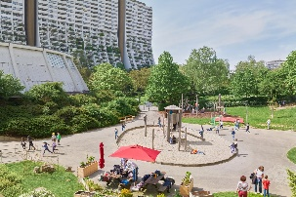 Article about Vienna’s housing/rental situation, now a successful model since over 100 years: “Social Housing”: NYT Article about Vienna's housing solutions. Interesting to learn how Vienna mostly avoided the mainly profit oriented real estate markets and the world wide housing crisis. The rent controlled majority of apartements has an appreciated cooling effect on the otherwise soaring rental fees. Austria’s capital is repeatedly ranked as the most livable city in the world, largely thanks to easy access to affordable living conditions. Once a tenant signs a contract, it never expires – even if they become rich(er)!
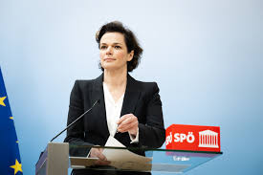 May 22: Change in the leadership of the Social Democratic Party SPÖ: Dr. Pamela Rendi-Wagner lost the vote in a referndum of all party members. She immediately resigned as party leader and will withdraw from politics all together. The decision about the new leader will be made between the 2 remaining candidates, Andreas Babler and Hans Peter Doskozil, at the next party assembly on June 3.
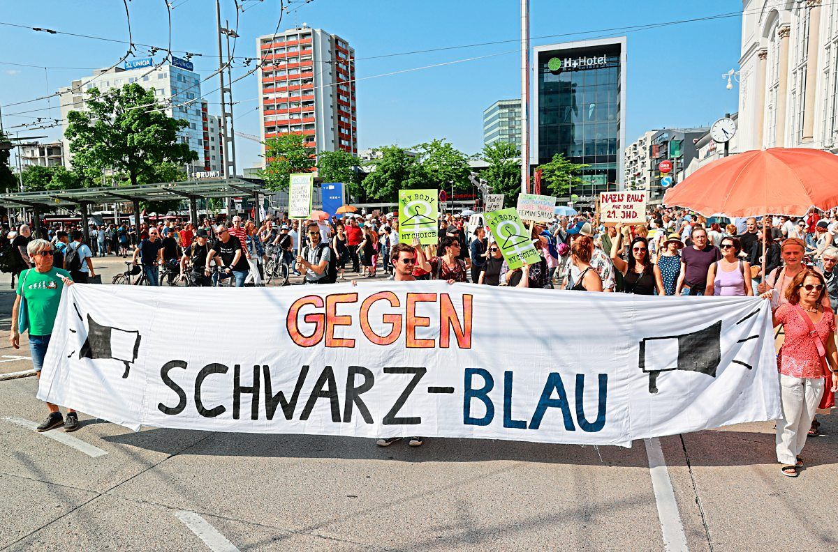 May 29: Demonstration in Salzburg against the newly formed coalition of ÖVP and the right wing FPÖ for the state government. This is especially critiziesed as incumbent Governor Haslauer very clearly positioned himself against any coalition with FPÖ during the campaign.
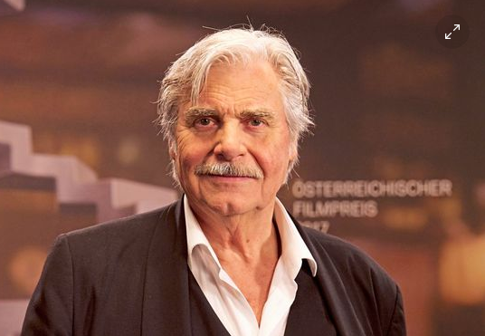 May 30: Well known actor at the Vienna Brugtheater, Peter Simonischek, 76, native of Graz, passed away after a severe illness. He starred in the movie “Toni Erdmann” (“European Actor 2016 Award), played the “Jedermann” at the Salzburg Festival, and toured with his wife Brigitte Karner, who was named “Actress of the Year”. He also played in several succeccful movies and TV series, e.g. “Herrenjahre”, Fürchten und Liebe”, “Gebürtig”, and many others. For his performance as Afzal in “The Who and the What” he earned the “Best Actor” award.
UPCOMING and PAST LOCAL EVENTS
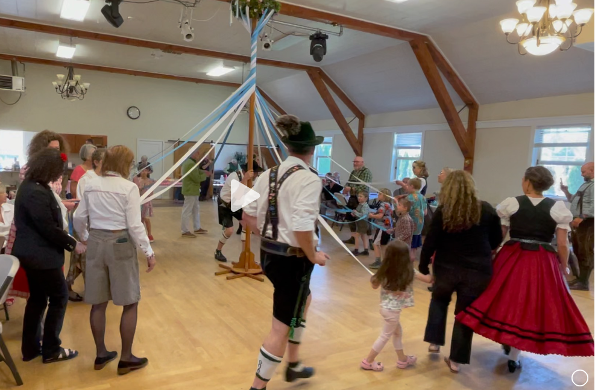May 28, 2023: Many thanks to the Austria Club of WA, its president Michael Brandstetter and the many volunteers for organizing a lovely Maifest! The Schuhplattler and the Bert Carlson Band made this traditional celebration of spring entertaining and a fun time to catch up with friends. For more information about the Austria Club and how to become a member, please contact Michael Brandstetter: michael.brandstetter@gmail.com
Check out the regular online film and music events organized by the Austrian Cultural Forum: https://acfdc.org/?mc_cid=487b48d54a&mc_eid=1321923619
Virtual Stammtisch for German Learners: once a month via zoom:
Next meeting: Friday, June 16, 2023, at 6:30pm. The virtual Stammtisch for German learners is an opportunity to get together, speak German, and have fun. Sabine Sullivan is a native speaker and will host the Online-Stammtisch. If you would like to participate or have any questions, please contact Sabine Sullivan: sabine.sullivan@zoho.com

Monthly Stammtisch – 1st Thursday of the month: Mark your calendar!!
Next one: Thursday, June 1: 7pm; Valentin Caspaar has opened his house in Kirkland for the next Stammtisch THIS THURSDAY, June 1, 2023, 7pm. Please contact Valentin for detailed information and address: vcaspaar@yahoo.com or 206 890 2768. Would be great if you can join! https://www.meetup.com/austrian-stammtisch-and-events/events/293775702/
Please contact Jürgen Schatzer juergenschhatzer@gmail.com or Elana Sabajon youcan@askelana.com for more information about the regular Stammtisch. The location is rotating throughout the greater Seattle Area. There is so much to talk and chat about!
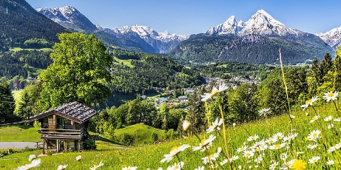 Enjoy spring!
Mit herzlichen Grüβen
Eva Kammel
Honorary Consul of Austria in Seattle
office@austrianconsulateseattle.org | www.austrianconsulateseattle.org

