2021 November/December Newsletter - HK Seattle
Dear Friends of Austria!
We almost made it to the shortest day of the year, ready for the season of light and hope to brighten our hearts and spirits! We all need this “booster” on optimism and joyfulness.
TRAVEL TO/FROM Austria:
As the restrictions change frequently, please check the latest updates for traveling to and from Austria at the website of the Austrian Consulate General in Los Angeles: https://www.bmeia.gv.at/en/austrian-consulate-general-los-angeles/travels-to-austria/coronavirus-covid-19-and-travel-information/
For the Covid related situation within Austria: https://www.austria.info/en/service-and-facts/coronavirus-information
November 8: end of travel restrictions entering the USA for travelers coming from Europe
December 6: new entry regulations for entering the USA: in addition to previous requirements, all passengers age 2 or older must present a negative Covid-19 test not older than 24h prior to departure.
December 20: Tightening of restrictions for entering Austria: 2G-: All travelers to Austria must be vaccinated /recovered and also provide a negative PCR Test taken within 24h upon entry or proof of booster shot to avoid a 10 day quarantine.

NEWS FROM AND ABOUT AUSTRIA
Covid-19 related News from Austria:
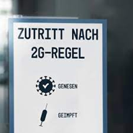November 8: for almost all social activities (hair salon, gastronomy, theater, etc ) the 2G (geimpft or genesen) rule was introduced: you need to show proof of vaccination or that you had recently recovered from Covid for being able to participate.
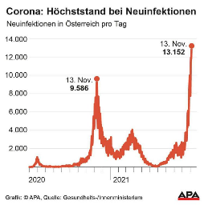 November 15: Austria’s government declared a targeted lockdown for unvaccinated people as infection numbers increase in a worst surge since the start of the pandemic.
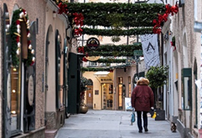 November 21: A full lockdown for all residents is ordered for at least 3 weeks. Only essential shops and businesses are open.
A general mandatory vaccination requirement will start in February 2022, with monetary fines up to $4,000.
December 12: Amid a dramatic decrease of the Covid infection numbers, the nationwide lockdown could be terminated – at least for vaccinated and/or recovered people for now (2G rule). As the states can impose regulations by themselves, different conditions are in place in different states: a so-called “Fleckerlteppich” on conditions throughout Austria. In Vienna, restaurants and hotels can open again on December 20, again following the 2G (genesen or geimpft) rule. Each patient in a hospital can receive 1 visit of 1 person per week, nursing homes have to follow the 2G+ rule (vaccinated/recovered + negative PCR test). Christkindlmarkets are open, consuming food/drinks only as Take-Away.
To allow limited family gatherings for the holidays, some ease of the restriction will be granted for Dec. 24-26 and on New Years Eve, Dec. 31.
December 18: For a fourth week-end in the row, over 40,000 participated in demonstrations against Covid measures in Austria. The far right party FPÖ and the MFG (party against vaccinations) are supporting and leading these demonstrations.
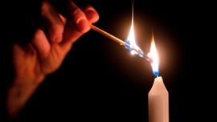 December 19: a “Chain of Light” (Lichterkette) along the Ringstrasse in Vienna is planned to demonstrate unity, respect for the health care workers, and grief over the 13,000 who died in Austria because of Covid. The leaders of ÖVP and SPÖ are supporting this peaceful rally.

Change in Austrian government:
December 2: Amid mounting accusations of corruption and misuse of taxpayer money, former Chancellor Sebastian Kurz declared his withdrawal from all political posts and to quit politics altogether, at least for now. This triggered a crisis in the government. The governing majority party ÖVP decided on Karl Nehammer, former minister of Interior, as the new leader of the party and also as the new Chancellor, after Alexander Schallenberg, the interim Chancellor, decided to step down from this post and to resume his former position as Foreign Minister. Several other ÖVP ministers also quit and new persons got nominated for these important leadership positions.
None of the political parties are ready for new, early elections at the moment, all hoping that finally stability will settle in and the government can focus on handling the severe Corona crisis and other important issues.
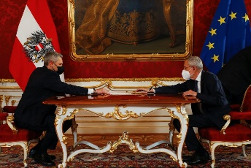 December 6: Austria’s President Alexander VanDerBellen swore in Austria’s new Chancellor Karl Nehammer (ÖVP) and several other new ministers and state secretaries. This was already the 6th inauguration of a government during his tenure, a new questionable record in Austria’s history.
For an extended interview with Karl Nehammer: https://tvthek.orf.at/profile/ZIB-2-Spezial/13887244/ZIB-2-Spezial-Bundeskanzler-Nehammer-im-Live-Interview/14116671/Nehammer-zu-CoV-Politik-und-U-Ausschuss/15055401

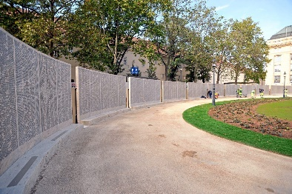 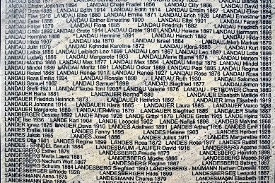 November 9: opening ceremony for the Shoah Wall of Names Memorial, which commemorates the more than 64,000 Jewish children, women and men from Austria who were murdered during the Nazi regime, in Vienna at the Ostarrichi Platz. “Gegen das Vergessen” (Never forget”). The date coincides with the Kristallnacht occuring 83 years ago.
Austrian Citizenship for Holocaust victims and their descendants: Since 1 September 2020, Holocaust victims and their descendants have been able to acquire Austrian citizenship without having to give up their current citizenship. MA 35 (Office of Citizenship) received 18,156 declarations by late October 2021. 8,398 declarations have been processed successfully and 5,396 persons have formally been granted Austrian citizenship so far. The largest number of declarations came from Israel (approximately 8,000), the United States (approximately 3,800), and Great Britain (approximately 3,000). "Holocaust victims, who were persecuted by the Nazi regime and had to flee abroad, and their descendants are now able to acquire Austrian citizenship. This has been an important and long-overdue step. We must never forget this darkest chapter of our history. Austria carries great historical responsibility here. It is vital to show Holocaust victims and their descendants the respect they deserve and facilitate their reconnection with the country, which should have been their home all along but was forcefully taken from them", said Vienna’s Deputy Mayor Christoph Wiederkehr.
For more information and how to apply: https://www.bmeia.gv.at/en/austrian-consulate-general-los-angeles/service-for-citizens/citizenship-for-descendants-of-victims-of-national-socialism/

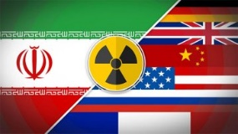 November 29: JCPOA Nuclear talk with Iran talks resume in Vienna. Austria will continue to do everything to support a successful outcome of the talks and a return to the full agreement of the treaty.

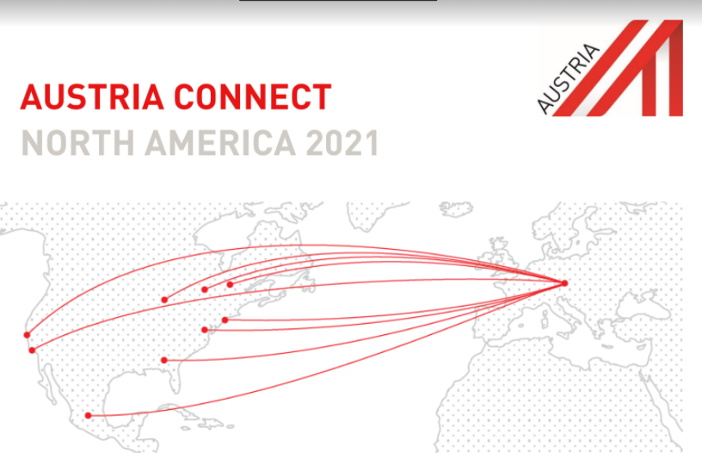 December 9-11, 2021, Denver, CO: AUSTRIA CONNECT NORTH AMERICA 2021: Event got canceled due to heightened Corona regulations; the largest networking event for the US-Austrian business community and the largest Conference for US Newcomers and Executives of Austrian Subsidiaries in the US, Canada, and Mexico https://www.advantageaustria.org/us/events/AUSTRIA_CONNECT_North_America_2021.en.html

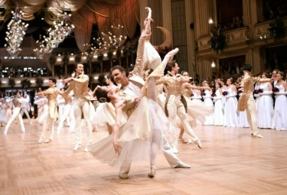 Wiener Opernball 2022: although the preparations and ticket sale (already sold out) are underway, Bogdan Roščić , director of the Vienna Opera, cannot guarantee that the event can take place on February 24, 2022. And if so, then very strict Covid requirements will be in place: full vaccination (incl booster shot if applicable) and negative PCR test (no more than 2 days before)
As of December 8: to the disappointment of many, the Opernball 2022 got CANCELED because of the unpredictable Covid-situation.

The Diplomatic Academy’s well-established “Summer Course for German Language and Austrian Studies” will take place from 18 July – 11 August 2022 in Vienna. The program is designed to meet the special needs and interests of adult learners (minimum age 18 years) from different professional backgrounds from all over the world. The Summer Course combines four weeks of high-quality and varied programs. Their website (https://www.da-vienna.ac.at/en/summer_course) contains all details on the Summer Course in 3 languages (English, French and German).
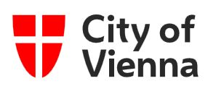 Vienna Calling – International news from the City of Vienna: https://rdir.nl.wien.gv.at/form.action?agnCI=20&agnFN=Fullview&agnUID=D.P4.eS.Ep.Fgh.A.v4mosvXdvEOqtqQUQEEnpffliywHNYEwxeeoQEuDDQlcfQpmdSMrn3pH4bBtyR3xStrzVLDNxQQzqATBJl5csA

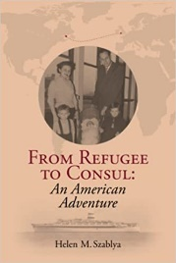 “From Refugee to Consul: An American Adventure” - Helen Szablya’s autobiography second volume. Helen, long time Honorary Consul of Hungary Emerita and a very good friend of the Austrian community in WA, has the fondest memories of the helping hands Austrians extended to her and her young family after they escaped from Hungary to Austria in 1956. A deeply personal memoir and a true American adventure with global reach, this autobiography continues where her book My Only Choice: Hungary 1946 - 1956 leaves off and takes the reader on an epic journey to 2020.
https://www.amazon.com/Refugee-Consul-American-Adventure/dp/0578313510/ref=sr_1_1?crid=4J70L0E9OKMK&keywords=from+refugee+to+consul+an+american+adventure&qid=1636756831&sprefix=from+refugee%2Caps%2C275&sr=8-1
UPCOMING EVENTS

The , founded over 45 years ago with its mission of cultivating and preserving Austrian traditions in WA, and a much-appreciated platform for the Austrian community to connect and socialize, needs your engagement and enthusiasm! Rosie Mulholland, soul and heart of the Club for many years, is stepping down as president. Also, several other board positions will be up for elections in February 2022. We cannot thank Rosie and the board members enough for all they did and gave for the Club, for us Austrians in WA. Their dedication and work is very much appreciated.
This is now an opportunity for you to engage and to bring on board a new generation with new ideas and emphasis on today’s needs and expectations of the Austrian Community in the Pacific Northwest. THE AUSTRIA CLUB NEEDS YOU !! Please consider engaging in this rewarding and much valued cultural connection to our homeland. For more information and details please contact Rosie Mulholland: mulho@comcast.net or Jürgen Schatzer: juergenschatzer@gmail.com

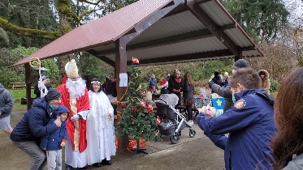 Many thanks go out to all who helped organize the Christkindlmarkt for Friends of Austria on December 12, 2021! Cold and rainy weather could neither deter St. Nikolaus nor the many guests dropping by, including their families! It was a fun crowd exchanging delicious cookies, stollen and chocolate goodies, caroling, or chatting while staying warm with hot cider. Thanks for the generous donations, these will serve as a down payment for our next event – let’s cross fingers this will be the Viennese Ball on March 5, 2022! The final decision if safety concerns allow this event to be held will come at the beginning of January.
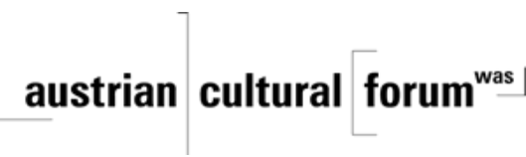 Check out the regular online film and music events organized by the Austrian Cultural Forum: https://acfdc.org/?mc_cid=487b48d54a&mc_eid=1321923619
Regular events are offered by the Goethe Pop Up Seattle, ranging from book club, Summer camps, movies, and literature presentations: https://www.goethe.de/ins/us/en/sta/gps.html
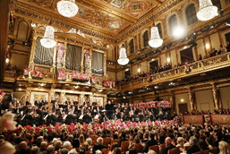 January 1, 2022: New Year’s Concert 2022 with Vienna Philharmonic Orchestra. Maestro Daniel Barenboim will be leading the Vienna Philharmonic Orchestra in this traditional masterpiece broadcasted around the world from the Golden Hall at the Musikverein. Watch out for announcement when it will be aired at your local PBS Station; in Seattle area: KCTS9 at 8pm

Monthly Stammtisch – 1st Thursday of the month: Mark your calendar!!
Virtual STAMMTISCH: January 6, 2022: Join the first get-together with Friends of Austria in the New Year via zoom. There is so much to talk and chat about! Zoom link: https://us02web.zoom.us/j/5845087371 . Questions: please contact Elana Sabajon: youcan@askelana.com or Jürgen Schatzer juergenschatzer@gmail.com
Wishing you all
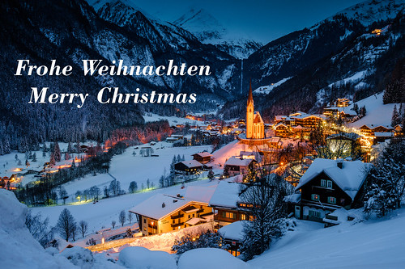 and 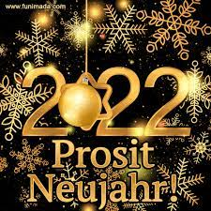
Heiligenblut near Grossglockner

Wishing you and your family to stay healthy and in good spirits, cherishing the rays of sunshine granted to us.
Mit herzlichen Grüβen
Eva Kammel
Honorary Consul of Austria in Seattle
office@austrianconsulateseattle.org | www.austrianconsulateseattle.org

