2021 October Newsletter - HK Seattle
Dear Friends of Austria!
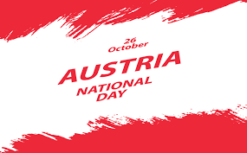 On October 26, 1955, Austria declared its everlasting neutrality, committed to defend it and to contribute as neutral nation to peace in the world. Since 1967 this day is declared as National Holiday. Austria can consider itself fortunate to have been granted this everlasting neutrality so it could work on a prosperous and peaceful progress to overcome the ashes of WWII as well as towards peace and equity around the world. Of course, even in peaceful Austria there were and - actually right now - are political rollercoasters but overall, democracy is fully functioning and correcting wrongful deviations. Of course, as a small nation the international contributions and influence are limited but nevertheless, Austria can and is playing a role model for example by the steps taken to mitigate the effects of climate change.
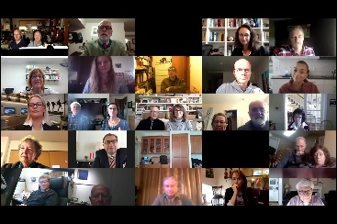 Thanks to all who helped with the event commemorating the National Holiday and who could join the celebration on October 24 via zoom. Highlight was an interesting Q&A session with our new Consul General Dr. Michael Postl, where dual citizenship was the main topic. Here is a follow up to some questions posted during the Q&A session:
- Question on loss of US citizenship for dual citizens who serve the compulsory time with the Austrian Army: According to existing information, a compulsory military service in Austria does not lead to a loss of the US citizenship. The official information of the State Department can be found here:
Advice about Possible Loss of U.S. Nationality and Foreign Military Service (state.gov)
- Question regarding proof of German language skills for family members of Austrians when applying for residency permit:
There are certain exemptions to this requirement, among others serious physical or psychological health problems. Nevertheless, according to existing judicial precedents, advanced age alone does not qualify for that exemption. There is the option to apply first for a 6 months Visa D and take a language course during that time. For more information on this topic: Nachweis von Deutschkenntnissen ("Deutsch vor Zuwanderung") (SDG) (oesterreich.gv.at)
Further memorable were the virtual journey to the 9 State Capitals, presented with a personal touch by locals of the respective regions, and the musical performances by our friends Alsu Shakirova and Andrew Schirmer. Even power outages followed by crashed computers could not undermine this wonderful get-together! If you did not have a chance to participate, here is the link to the recording:
https://drive.google.com/file/d/1qUQKIdbS5sDS_b_Yp3vgKq9tPW_9miFA/view?usp=sharing
TRAVEL TO/FROM Austria:
The USA’s new travel policy that requires vaccination for foreign national travelers to the United States will begin on November 8, 2021. The policy will affect those coming to the U.S. by land and air, and it requires proof of vaccination and a negative COVID-19 test within three days of travel. The decision, which affects 33 countries — including China, India, Brazil and most of Europe — comes after pressure from the European Union and the travel industry, and it's happening days after the U.S. announced eased land-border rules for fully vaccinated travelers from Canada and Mexico.
As the requirements change frequently, please check the latest updates for traveling to and from Austria at the website of the Austrian Consulate General in Los Angeles: https://www.bmeia.gv.at/en/austrian-consulate-general-los-angeles/travels-to-austria/coronavirus-covid-19-and-travel-information/
For the Covid related situation within Austria: https://www.austria.info/en/service-and-facts/coronavirus-information
NEWS FROM AND ABOUT AUSTRIA
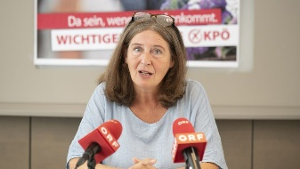 September 28: to great surprise, at the city council elections for Austria’s second largest city, Graz, capital city of Styria, the communist party under the leadership of Elke Kahr, current vice-mayor, got the most votes. Negotiations about the position of the mayor are ongoing.
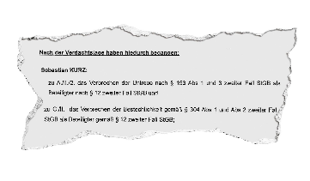 October 6: house raids by top officials of Austrian’s governing party ÖVP, the Ministry of Finance, and the Chancellor Sebastion Kurz himself: Accusation of manipulation of polls, corruption, and misuse of taxpayers money are the basis of these dramatic steps. Presumption of innocence applies.
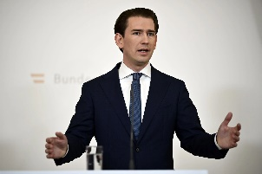 October 9, 2021: After intense days the junior coalition party, the “Green party”, decided that it cannot continue the coalition with Sebastian Kurz at the helm of the government in light of these accusations against him. That decision would have triggered a non-confidence vote against Sebastian Kurz the following week resulting in the termination of the government in the current form and again new elections after not even 2 years. Nobody was in favor of this szenario.
October 10:, 2021: Sebastian Kurz, 35, resigned as chancellor but stays at the helm of the ÖVP as party and as caucus in parliament. He described his motivation for this dramatic step as putting the country before his own person. He suggested Alexander Schallenberg, currently foreign minister to succeeed him as chancellor.
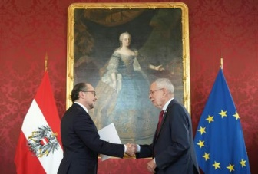 October 11, 2021, Alexander Schallenberg, 52, was sworn in as Austria’s new Federal Chancellor by President Alexander Van der Bellen. He served until now as foreign minister in the current coalition government of the conservative Austrian People’s Party (ÖVP) and the ecologist Green Party. Schallenberg, an experienced diplomat, was independent until 2020 when he joined the ÖVP. He is known for his polite and quiet demeanor and also a close ally of Sebastian Kurz.
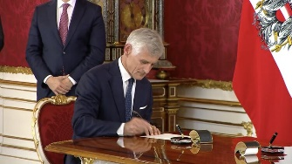 Michael Linhart has been appointed as Austria’s Foreign Minister. Michael Linhart is a career diplomat and has been serving until recently as Ambassador of Austria to France.
In this way the government can continue their work, at least for now.
In cooperation with the newspaper “Der Standard” the famous Viennese theater “Das Burgtheater” produced the storyline, reconstructed using the now publicly available chats between Sebastian Kurz and main persons of his inner circle. This artful performance and should bring a better understanding of the accusations: https://www.burgtheater.at/

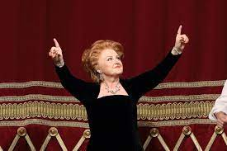 October 18: Legendary and beloved soprano star Edita Gruberová, 74 , passed away in Zurich. Ms. Gruberová, born in Bratislava, became an opara star through unforgettable productions at the Vienna State Opera. Her first appearance there was in 1970 as Königin der Nacht (Queen of the Night) in Mozart’s “Zauberflöte” (Magic Flute). 700 more followed, with her last one in a Gala dedicated to her in 2018.
Now: 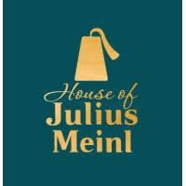 before: October 21: October 21: the legendary high-end delicatesse shop ”Meinl am Graben” in the heart of downtown Vienna reopened after massive renovations. Among other changes, the emblem used for about 100 years got changed to the Fez only to comply with criticism of racism. The hat only is now showing on a petrol color background.
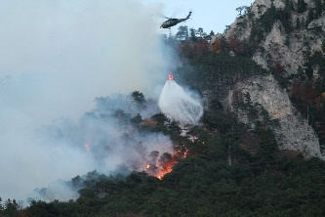 October 25: huge forest fires in the Rax region near Reichenau an der Rax: in this mountainous region difficult to access, over 100 ha (250 acres) are on fire, including in the adjecent “Höllental”. For the next few days unfortunatley no rain but high winds are in the forcarst. Nearby water reservoirs that feeds to Vienna’s water supply, is secure for now. It is already the largest fire Austria has endured and it is not yet under control.
October 26: Start of the “KlimaTicket - climate ticket”: (about € 1,000/year ~ € 3/day) allows you to use all public transport options Austria wide with a single ticket. There are also options for cheaper, more regional tickets. This valuable contributiuon to the efforts to reach the Paris climate goals was achieved by the determined negotiations by the Green Party, led by Leonore Gewessler, Minister for Energy and Sustainability.

October 28: Unfortunately Austria is experienceing a steep Increase of Covid cases with levels almost as high as a year ago, that is indicated by the “red” light of the so-called “Corona Ampel”, which means “very high” risk of infection. Only 70% of the eligible population are fully vaccinated and vaccination resistance is wide spread. Rigorous regulations are in place or getting reintroduced.
Austrian Citizenship: here is a recent documentary by ORF, Austria’s public proadcasting, about the difficulty to obtain the Austrian citizenship, especially for immigrants living in Austria, in some cases even since birth:
https://tvthek.orf.at/profile/Dok-1/13844820/Dok-1-Staatsbuergerschaft-Die-heilige-Kuh/14109864

Tender Pixel, Bytes + Film: for over 10 years the Austrian Federal Ministry for Arts and Culture supports the development of production and receptions of contemporary art that goes beyond the traditional formats of movie and TV. Deadline for submission of proposals: Nov.2, 2021. For more info see https://www.bmkoes.gv.at/Service/Ausschreibungen/kunstund-kultur-ausschreibungen.html
UPCOMING EVENTS
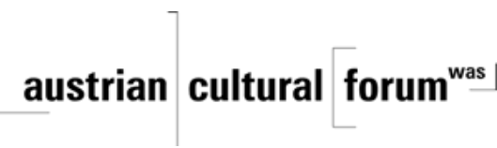 Check out the regular online film and music events organized by the Austrian Cultural Forum: https://acfdc.org/?mc_cid=487b48d54a&mc_eid=1321923619

Regular events are offered by the Goethe Pop Up Seattle, ranging from book club, Summer camps, movies, and literature presentations: https://www.goethe.de/ins/us/en/sta/gps.html
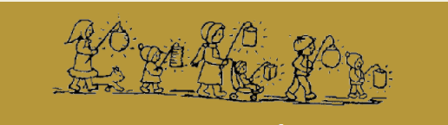 Monday, November 8, 2021; 6:30pm; SAGA School Laternenfest: meet at Fremont Ave N and N 110th St. Celebrate St. Martin's Day by singing the traditional songs and strolling with homemade "Laternen." Bring your lanterns, flashlights, and/or headlamps. The walk happens rain or shine, so make sure to dress appropriately! For more information and Covid precautions: info@sagaschool.org

Monthly Stammtisch – 1st Thursday of the month: Mark your calendar!!
Virtual STAMMTISCH: November 4, 2021, at 7pm: Join the get-together with friends of Austria, even when only via zoom. There is so much to talk and chat about! Zoom link: https://us02web.zoom.us/j/5845087371 . Questions: please contact Elana Sabajon: youcan@askelana.com or Jürgen Schatzer: juergen.schatzer@gmail.com
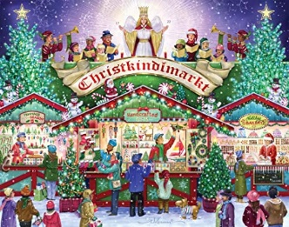 Christkindlmarkt: We are working on a Mini Outdoor Christkindl Market on Sunday, December 12, 2021, at the Rhododendron Park in Kenmore for kids and adults where we can also meet Friends of Austria in a very casual way. Please watch out for further details. If you are interested in helping with the organization or contributing ideas, please contact Eva Kammel office@austiranconsualtesettle.org.

HAPPY HALLOWEEN!!!
Have fun and be happy not to live in the 17th century where witch hunts and trials were real…..
…and tonight: the Northern Lights, a very rare spectacle of nature are visible from Seattle!
Mit herzlichen Grüβen
Eva Kammel
Honorary Consul of Austria in Seattle
office@austrianconsulateseattle.org | www.austrianconsulateseattle.org

