2022 Newsletter - HK Seattle

Dear Friends of Austria!
OCTOBER 26: HAPPY NATIONAL HOLIDAY!
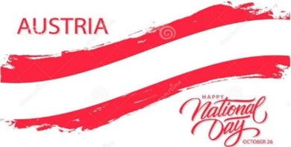
Since October 26, 1955, that date commemorates the county’s declaration of permanent neutrality as a constitutional act of parliament. This was also insisted upon by the Russian Federation to sign the declaration of independence on May 15 that year, together with the other occupying powers USA, United Kingdom and France. With this declaration Austria decided that it will not be involved in any military alliances (Austria is member of the EU but not member of NATO) and won’t allow any military basis to be established on its territory. This day is also celebrated as “Day of the Austrian Flag” and declares the re-establishment of Austria’s sovereignty after World War II. It is also said that on October 25, 1955, the last foreign soldier (a Russian) left the country after 10 years of occupation.
In his address to the nation, President Alexander VanDerBellen reminded that the public must be able to rely on the integrity of the politicians they elected into office, that a politician must always work for the good of the public and not for his/her own advantage. The permanent military neutrality and the principal of solidarity must lead society within Austria and the EU. These principles are strengthening the community and we can so master also the very challenging problems we are confronted with.
We will celebrate 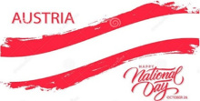 in combination with the 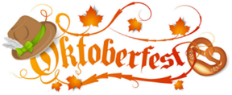 organized by the Austria Club of WA, this Saturday, October 29, 2022, 6-11pm at the Kenmore Community Hall, 7304 NE 175th St, Kenmore.
Hope you can join this social gathering filled with music, food, dancing, and making new and connecting with old friends! For more information, including ticket purchase please see attached invitation, check out the Club’s website: www.austriaclubwa.com and/or contact Michael Brandstetter: michael.brandstetter@gmail.com
TRAVEL TO/FROM Austria: no further Covid related restrictions are currently in place
Please check the latest updates for traveling to and from Austria at the website of the Austrian Consulate General in Los Angeles: https://www.bmeia.gv.at/en/austrian-consulate-general-los-angeles/travels-to-austria/coronavirus-covid-19-and-travel-information/
For the Covid related situation within Austria: https://www.austria.info/en/service-and-facts/coronavirus-information
NEWS FROM AND ABOUT AUSTRIA

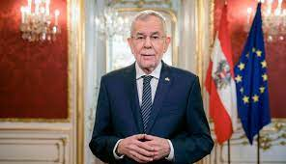 Sunday, October 9, 2022: President Alexander VanDerBellen got reelected by a clear majority (~57%) at the Presidential elections without having to go through a second round. This decisive win (his closest competitor got ~18%) was a confirmation of his well thought through and stable service during the previous 6 years in the highest office in Austria. The inauguration is set for January 26, 2023.
About 1/5 of the votes (850,000) came from absentee ballots. Thank you for participating in the elections (if you received the ballot in time!). The second round (yellow ballot, yellow envelope) absentee ballot is now obsolete.
If you have not registered yet for elections in Austria, you can do this anytime: https://www.bmeia.gv.at/gk-los-angeles/service-fuer-buergerinnen/wahlen/
Already in his first press conference after re-election, President VanderBellen had to confront the latest corruption scandal directed against members of the previous Kurz-Administration including some still active ÖVP politicians. He compared these new allegations to a massive water damage threatening the building structure of democracy. It seems though the presently governing coalition between ÖVP and Green Party still can hold on and continue to govern. For the Green Party it is important, besides high stakes policy changes in the pipeline, that the Minister of Justice, Alma Zadic, a member of the Green Party and regarded as very professional and successful, can continue her work. So new elections are not discussed, at least not yet.
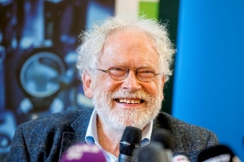 Austrian Quantum physicist Anton Zeilinger was awarded the Nobel Prize in Physics 2022! Together with Alain Aspect (France) and John F. Clauser (USA), he got recognized for their pioneering work in experiments concerning quantum entanglement, a phenomenon that occurs when two particles behave as one even when separated. Their results lead to a new technology based upon quantum information, secure information transfer, and quantum computing. He started his academic career at the University of Innsbruck and came 2003 to the Univ. of Vienna. He founded the Institute of Science and Technology Austria (ISTA) and was President of the Austrian Academy of Sciences for almost 10 years. He was and still is very engaged in explaining his and other science research to the broad public. “My advice (to young scientists) would be: Do what you find interesting, and don’t care too much about possible applications.”
Elections in Tyrol: The loss of the conservative party ÖVP (now by 35% , - 10%) and the loss of Gruene (9%, -1.5%) marked the end of the previous ÖVP/Green coalition. SPÖ (17%, +0.23%) and ÖVP are now forming a coalition government with Anton Mattle (ÖVP) as Governor and Georg Dornauer (SPÖ) as Lt. Governor.
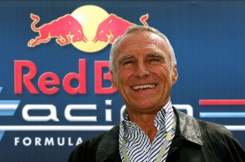 October 23: Dietrich Mateschitz passed away at age 78 after a severe illness. He founded, together with the Thai investor family Yoovidhya, the energy drink company Red Bull with HQ in Fuschl am See, Salzburg, about 40 years ago and expanded the company to a world wide imperium. He became the richest Austrian (estimated $25 Billion in assets), invested also in extreme sports events, Formula 1 car races, and controlled powerful media outlets. No other brand “Made in Austria” is as successful. He was very tight lipped about his private life, although his strong opinions and world view leaning towards the very right were no secret. His son Mark (29) could be his successor but that depends on the approval of the majority holder Thai family.
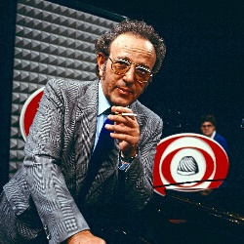 October 23: Gerhard Bronner would be 100 years old today. He shaped the comedy and carbaret scene in Austria after WWII. He and his family suffered under the Nazi regime, and his parents and brother perished in concentration camps. He could escape as a 15year old. He returned to Vienna in 1948 – convinced by Hans Weigl to give his homeland one other chance. He believed in the reincarnation of another Austria, one formed by art and intellectual effort, created by the spirit of humor. He is remembered as brilliant conférencier using the language in all its facettes. His deep seated cristisism was brought forward with humor and “Schmäh” (wit). He also wrote hundreds of songs, like ”Der g’schupfte Ferdl”, „ Der Bundesbahnblues” oder “Der Papa wird’s scho richten“ oder das Lied vom Ober „Sperrstund is“ . His son Oskar Bronner founded the major Austrian newspaper „Der Standard”.
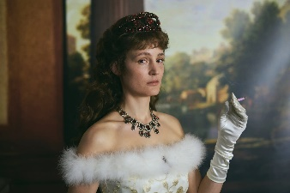 A new series on Netflix called “The Empress” about 19th Century Empress of Austria, Elisabeth (Sisi), started, decpiting the unhappy life of the wife of Emperor Fanz Josef, who had a tattoo, worked out daily and wanted more from life than just producing heirs. She got assassinated by an anarchist in 1898 at age 60.
In addition, Vicky Krieps stars as empress Sisi in “Corsage”, a film by Marie Kreutzer, debuted at the Cannes Film Festival in May. It will hit the American theaters on Dec. 23.
These new additions of movies about the Empress are probably depicting her life more accurately than the Romy Schneider “Sissi” triolgy, so popular in the 1950s.
https://www.nytimes.com/2022/10/07/movies/the-empress-corsage-sisi.html?searchResultPosition=1
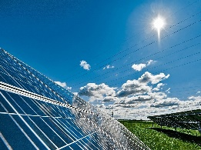 The eastern most and smallest state of Austria, Burgenland, is a pathfinder for becoming energy independent. They aim to meet this lofty goal already by 2030. A combination of increased collection of wind and solar energy should be sufficient to close the gap of already produced and total energy demand. It already achieved electricity energy indepencey 2013, unmatched in European regions.
Any Questions regarding working in Austria? The ABA (Austrian Business Agency) is here to support you! https://www.workinaustria.com/. Austrian talents abroad are dynamic, successful and innovative. And they are happy to return home if the framework conditions are right for them. ABA has now put together a new service package for precisely this target group to make the return transparent, structured and smooth for the whole family. For more information: https://www.workinaustria.com/en/news/blog/detail/building-a-bridge-to-austria-for-austrians-abroad
UPCOMING EVENTS
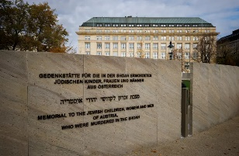 New Austrian citizen Nena Peltin of Seattle wishes to research and publish a book of personal stories of families or individuals who escaped from Nazi Austria in the 1930s and ‘40s, whose descendants have settled in the Pacific Northwest. She would greatly appreciate hearing from anyone willing to be interviewed for this book and promises not to publish anything with which interviewees are not completely comfortable. The contents of the interviews she conducts may also be used in an exhibit at the Holocaust Center for Humanity in Seattle or elsewhere. Thank you so much in advance for your participation. Please contact Nena at (206) 565-3353; peltin@comcast.net or Christina Calio, (425) 591-5775; christina@caliomusic.com for more information.

November 7, 2022, 6:30pm: Laternenfest – organized by SAGA school – open to the public. https://www.sagaschool.org/Laternenfest; Holiday Wreath and Greenery sale: info@sagaschool.org

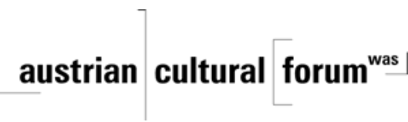 Check out the regular online film and music events organized by the Austrian Cultural Forum: https://acfdc.org/?mc_cid=487b48d54a&mc_eid=1321923619
Virtual Stammtisch for German Learners: once a month via zoom: Next meeting: Friday, November 11, 2022, at 7pm. The virtual Stammtisch for German learners is an opportunity to get together, speak German, and have fun. Sabine Sullivan is a native speaker and will host the Online-Stammtisch. If you would like to attend or have any questions, please contact Sabine Sullivan: sabine.sullivan@zoho.com .
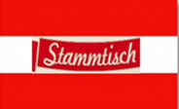Monthly Stammtisch – 1st Thursday of the month: Mark your calendar!!
Please contact Jürgen Schatzer juergenshchatzer@gmail.com for details for the upcoming one. The location is rotating throughout the greater Seattle Area.
Last but not least – there are very interesting acnnouncements for upcoming events: you hopefully mark you calendar with!
Spirit of the Christmas Season:
When: Saturday, December 03, 2022, 1pm – dusk
Where: Rhododendron Park, 6910 NE 170th St, Kenmore
If you can help out, contribute Christmas goodies, arts, and crafts, or with question: please contact: Elana Sabajon youcan@askelana.com . See also attached invitation

organized by the Austria Club of WA
When: Sunday, December 4, 2022; 3-6pm
Where: German House,613 9th Ave, Seattle
Traditional Christmas Music, food and Glühwein, and a visit by St. Nicolaus will provide a gemütliche atmosphere!
For more information, please see attached flyer and/or contact Michael Brandstetter: michael.brandstetter@gmail.com
Looking ahead: Mark your calendar –The Viennese Ball is back after 2 years of cancellations! For more information and if you want to help with the organization: Please contact Eva Donahoo: ewdcpa@comcast.net
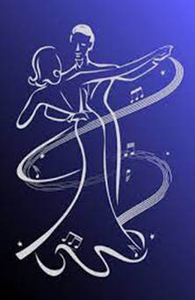 Saturday, March 4, 2023, at the Nile County Club in Montlake Terrace, WA
Mit herzlichen Grüβen
Eva Kammel
Honorary Consul of Austria in Seattle
office@austrianconsulateseattle.org | www.austrianconsulateseattle.org

Attachement: Invitation: Nat’l. Hol/O-Fest
Christkindlmarkt, Xmas Party, Viennese Ball

