2023 October Newsletter - HK Seattle
Dear Friends of Austria!
Thank you to all of our guests who could join the Austrian National Holiday Celebration at the German House! And a special Thank you to all volunteers who made this gathering so enjoyable, including the Ann Rackl Quartet who entertained us with beautiful music.
At the event we discussed
- how to Register as an “Austrian Living Abroad” – a vital resource for the Austrian authorities to stay in contact with you, keep you updated with latest information, cultural events, and in case of emergency.
- how to “Register to vote”. Every Austrian living abroad older than 16 years can sign up ANYTIME in the respective voter register (Wählerevidenz). This registration is necessary for the voting process and will be valid for the next 10 years. You will then receive the absentee ballots automatically by mail for any election you are eligible to vote.
- Austria’s Parliamentary Democracy
Links to all necessary forms, fill-in help also in English, and an overview about the Austrian Parliamentary System, the mission statements of the major political parties, and more, are collected on the HC Seattle website: www.austrianconsulateseattle.org . Thanks to the Consulate General of Austria in Los Angels for their assistance in this effort!
You can register to vote ANYTIME – so get ready now and you don’t have to worry for the next 10 years!
TRAVEL TO/FROM Austria: no further Covid related restrictions are currently in place. Please check the latest updates for traveling to and from Austria at the website of the Austrian Consulate General in Los Angeles: https://www.bmeia.gv.at/en/austrian-consulate-general-los-angeles/travels-to-austria/coronavirus-covid-19-and-travel-information/
NEWS FROM AND ABOUT AUSTRIA
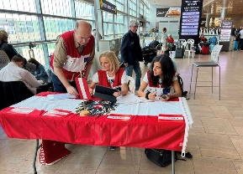 October 11: Evacuation flights for Austrian citizens were organized from Israel to Cyprus (and then from there on). This gave every Austrian citizen in Israel who wanted to leave the opportunity to do so. There are about 8,000 Austrians living in Israel and already in the first days of the horrific conflict over 300 signed up to leave. Austrian Airlines and also Lufthansa now suspended their flights to Tel Aviv until at least December 15, 2023.
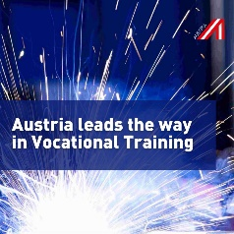 According to the latest OECD-OCDE report, “Education at a Glance 2023”, Austria leads the way in Vocational Training! 76% of senior high school-leaving qualifications are aligned with vocational training programs. 53% of Austria’s 25-34-year-olds have vocational qualifications as their highest educational attainment, surpassing the EU average of 35% and the OECD average of 32%. The report's data show that countries emphasizing vocational training witness lower unemployment rates across the board. The OECD's advice: enhance practical education, elevate the quality of vocational training, and promote its equal stature alongside academic education.
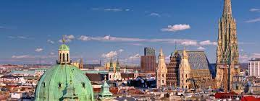 Vienna now has more than 2 Mio residents and ranks as 5th largest city within the EU following Berlin, Madrid, Rom and Paris, and as 2nd largest one in the German speaking area. Last time Vienna achieved this ranking was in 1910. The lowest recent number of residents in the 20st century occurred in 1988 with only 1.5Mio. The increase is mainly based on immigration but since 2004 also by a positive birth rate. Average age in Vienna is just 41 years, partly due to its 200,000 students. Along with Brussels, Vienna is one of the most diverse cities in the EU. As a result, today’s figures resemble those from the days of the Habsburg Monarchy!
Vienna also received this year the EU Organic Award as the Best Organic City for its “Wiener Gusto” brand. One of the largest organic farms of the country is cultivated within city limits. About 15% of the city area is dedicated to farming, and 1/3 of the farmland are certified organic farms.
If you are interested in “Vienna in Figures”, here is the latest collection of data presented in an entertaining way: https://www.wien.gv.at/statistik/pdf/viennainfigures-2023.pdf
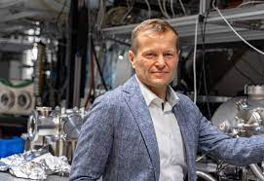 Together with Anne Huillier (France) and Pierre Agostini (Sweden), the Hungarian/Austrian Physicist Ferenc Krausz, currently director of the Max Planck Institute for Quantum Optics in Munich, received this year’s Nobel Prize in Physics for enabling the Attosecond Laser Pulse. The key experiment was carried out at the Technical University of Vienna where Krausz is full professor, and where he and his team performed the research of the ultrashort light pulses (Attosecond is 10⁻¹⁸ sec; an attosecond is to 1 second as 1sec is to the age of the universe). They can now “see” and further investigate the behaviour of electrons. Krausz is also the recipient of the most prestigious Austrian research awards.
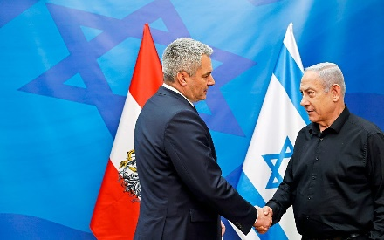 October 25: Austria’s Chancellor Karl Nehammer paid a visit to Israel and met with Israel’s Premier Netanjahu, President Yitzhak Herzog, and leader of the opposition party Jair Lapid in Tel Aviv. He labeled the massacre of October 7 as the most serious crime upon the Jewish People since the Holocaust and he will push for an increase of the EU wide support for Israel, a main priority to defend Israel’s democracy and people. Chancellor Nehammer also met with the family of an Austrian citizen who is still held hostage by the terrorist group Hamas. Chancellor Nehammer was joined on this trip by the Chancellor of the Czech Republic Petr Fiala.
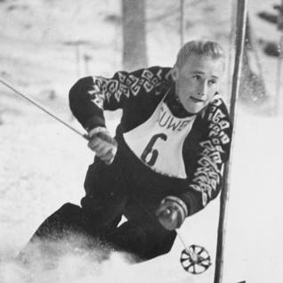 Anderl (Andreas) Molterer, skiing legend of the 50ies, passed away peacefully at the age of 92 in his hometown Kitzbűhel. He won Olympic silver and bronze, won 9 times the famous Hahnenkamm race “Streif” among the many other successes the “Weisse Blitz aus Kitz” (the White lightening from Kitz) could achieve. After his active career he resided for over 60 years in the USA and returned back to his hometown only last year.
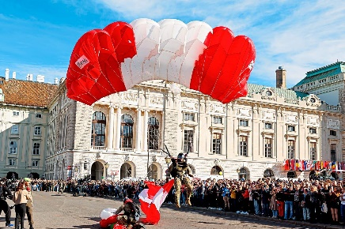 October 26: Austria is celebrating its National Holiday, commemorating the declaration of independence after 10 years of occupation after WWII by the 4 powers Soviet Union, Great Britain, the United States, and France. Austria declared everlasting neutrality on October 26, 1955, creating a buffer zone between the East and the West. The last foreign soldier left the then free and sovereign country. It marked the only Cold War era withdrawal by the Soviet Union from a territory it occupied.
In his address, President Alexander VanDerBellen reminds us to restrain from populism but strife for being there for each other. Antisemitism and hate has no place in Austria. Let’s cherish peace in the country, a special gift we should not take for granted, especially in these turbulent times.

Live and Teach English abroad in Austria
Do you know a senior in college who is looking for an exciting opportunity that allows to explore a new culture while simultaneously gaining valuable first-hand classroom experience? For decades, Fulbright Austria has worked with the Austrian Federal Ministry of Education, Science, and Research (BMBWF) to bring qualified, motivated university graduates from the United States to teach English in Austria in secondary schools all across the country.
The Austrian Fulbright Foreign Language Teaching Assistant Program (2024–25 program year) is a wonderful opportunity!
Application period: 15 October–15 November 2023. For more information: https://www.fulbright.at/programs/in-austria/teaching-assistants

Almdudler Limonade is celebrating its 66th anniversary! In 1957, the first Almdudler lemonade was produced – it was served as a wedding toast from the founder Erwin Klein to his bride Ingrid! The secret recipte using an alpine herbs extract including lemon balm, sage, gentian, elderflower and coneflower is mixed with fresh spring water, natural beet sugar and citric acid. Their HQ is in Grinzing, in the outskirts of Vienna.
UPCOMING EVENTS
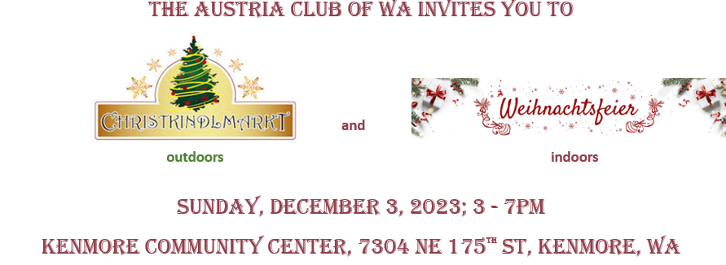
Enjoy holiday atmosphere and connect with friends, outdoors at the market and indoors with Glühwein, holiday treats and musical entertainment by Bonnie Birch.
We need donations of Holiday goodies and cookies, arts and crafts, and … volunteers. Please consider contributing!!
For information, if you want to host a booth, if you can donate, volunteer for the CHRISTKINDLMARKET and/or the Holiday Party, please contact Michael Brandstetter: michael.brandstetter@gmail.com. Also see attached invitation.
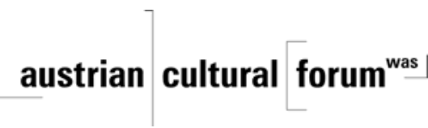 Check out the regular online film and music events organized by the Austrian Cultural Forum: https://acfdc.org/?mc_cid=487b48d54a&mc_eid=1321923619
Virtual Stammtisch for German Learners: once a month via zoom. The virtual Stammtisch for German learners is an opportunity to get together, speak German, and have fun. Sabine Sullivan is a native speaker and will host the Online-Stammtisch. If you would like to attend or have any questions, please contact Sabine Sullivan: sabine.sullivan@zoho.com

SAGA School is inviting you to participate on November 6, 2023, in their annual “Laternenfest” (open to the public) and their “Holiday Greenery Fundraiser”. For more information: https://www.sagaschool.org//

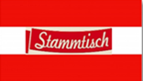Monthly Stammtisch – 1st Thursday of the month: Mark your calendar!!
Next one: Thursday, November 2, 2023; 7pm; at the “Cactus” in 121 Park Ln, Kirkland. Please contact Jürgen Schatzer juergenschhatzer@gmail.com for details. The location of the monthly Stammtisch is rotating throughout the greater Seattle Area. There is so much to talk and chat about!
And finally …..

As always – also in spooky times – if I can be of assistance please do not hesitate to contact!
und mit herzlichen (nicht verhexten!) Grüβen
Eva Kammel
Honorary Consul of Austria in Seattle
office@austrianconsulateseattle.org | www.austrianconsulateseattle.org

Attachment: Save the Date VB24, Save the date XMas

