New Years 2023 Newsletter - HK Seattle
Dear Friends of Austria!
Hard to believe – 2023 is knocking on the door! Here are some traditions happening at this time of the year in Vienna:
PROSIT NEUJAHR!! – HAPPY NEW YEAR!!!
Did you know that “Prosit” or short “Prost” comes from the Latin word prodesse, meaning to profit, to benefit? It was first used among students in the 18th century. So, with the commonly used new year’s wish “Prosit Neujahr” we wish you “may the new year be good for you”.
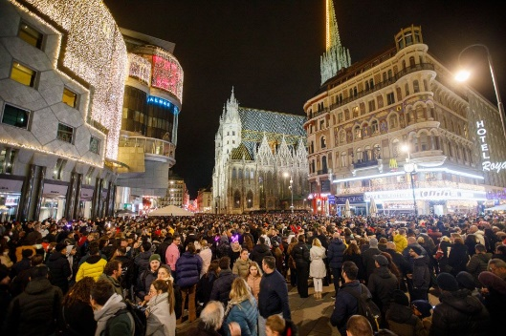 Sylvester in Vienna: after 2 years of restrictions, this year the City of Vienna is celebrating the ringing in of the New Year with its tradition: the “Silvesterpfad” (Sylvester path, an area covering almost all the 1st district about 1 mi long) is open from 2pm Dec 31 to 2am Jan 1, where over 70 open air shows will be presented in the inner city. Of course, food, drinks (yes, also alcoholic ones!) and market booths offering “Glücksbringer” (good luck charms) are accompanying this spectacle. At midnight, the “Pummerin”, the gigantic, 21-ton heavy bell of the St. Stephen’s cathedral, will ring for 7 min, followed by the 9 min long Blue Danube waltz, danced to by the crowd gathered at St. Stephen’s Square. (BTW, did you know that you will burn 60 Cal if you manage to dance the whole Blue Danube waltz?) Expected 800,000 Viennese as well as tourists from all over the world will be enjoying this spectacle. Public transportation will be running in a 5 min interval until in the wee hours of the morning to bring the visitors home safely.
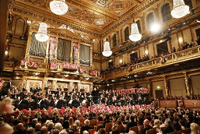 January 1, 2023: New Year’s Concert 2023 with Vienna Philharmonic Orchestra. Maestro Franz Welser-Möst will be leading the Vienna Philharmonic Orchestra in this traditional masterpiece broadcasted around the world from the Golden Hall at the Musikverein. Over 30,000 blossoms from the Viennese city parks will be decorating the music hall. Watch out for announcement when it will be aired at your local PBS Station; in Seattle area: KCTS9 at 8pm.
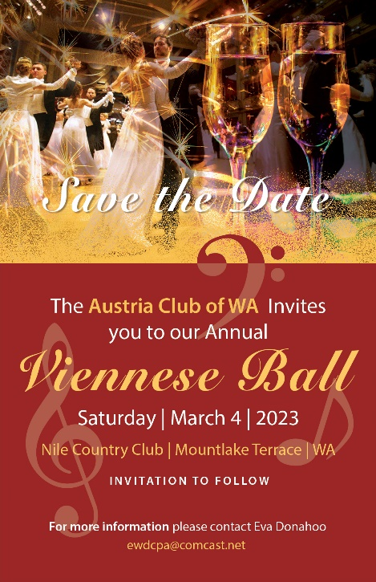 The Viennese Ball is back in Seattle after 2 years of cancellations!
If you got inspired to join the fun of dancing, music, entertainment, and forgetting the problems of the world for a few hours, please mark your calendar for March 4, 2023! Get ready for this beautiful evening!
Watch out for more details to come. For more information: Please contact Eva Donahoo: ewdcpa@comcast.net

Wishing you and your family a happy, healthy 2023, may it be filled with joy and wonderful moments - and peace for all of us.
Herzlichst,
Eva Kammel
Honorary Consul of Austria in Seattle
office@austrianconsulateseattle.org | www.austrianconsulateseattle.org

