HC Newsletter – January 2023 – Viennese Ball
Dear Friends of Austria!

The Viennese Ball, this cherished, 200-year long tradition from Vienna, is back in Seattle after 2 years of Covid related cancellations!
Let music be again an instrument of diplomacy and joy, that brings people together and lets us forget our problems for a couple of hours.
The annual social highlight held at the Nile Country Club in Mountlake Terrace, WA, organized by the Austria Club of WA (www.austriaclubwa.com), offers an elegant evening including a delicious dinner buffet, polonaise, dance performances, and of course dancing to live music until midnight! Do you want to brush up on your dance steps? A complimentary dance lesson from 4-5 pm just before the event is included, led by members of the Pacific Ballroom Dance Team PBD.

Again, this year, the City of Vienna is sponsoring this event and provides traditional “Damenspenden” (gift for the ladies) with a special greeting from Vienna’s Major Michael Ludwig:
"The Viennese Ball in Seattle is a special salute from the City of Vienna to a vibrant city of culture we entertain close friendly relations with. It is a symbol for joy, peace and international understanding.
On this note, my best wishes go out to the organisers for a most successful event, and to all visitors for a truly unforgettable evening as you enjoy the unique spirit of Vienna under the spell of traditional Viennese Waltz.
For more information, tickets, etc: www.austriaclubwa.com
If you want to participate in the dance lesson, have dietary restrictions, or any other questions, please don't hesitate to contact Eva Donahoo ewdcpa@comcast.net

Get ready for this beautiful evening! It will be fun!
Hope to see you there
Herzlichst,

PS: Please spread the word (and attached flyer) about the ball among your friends! Danke!

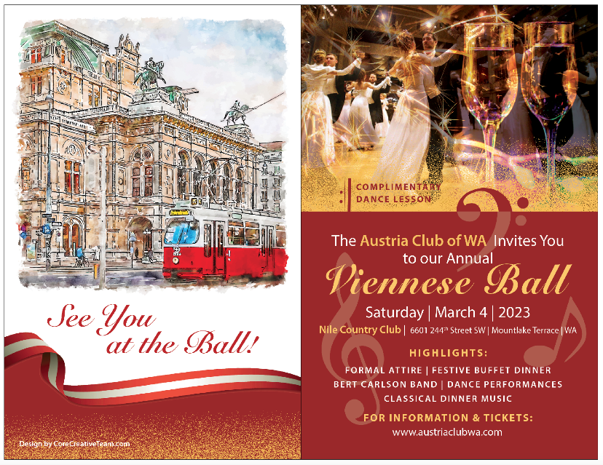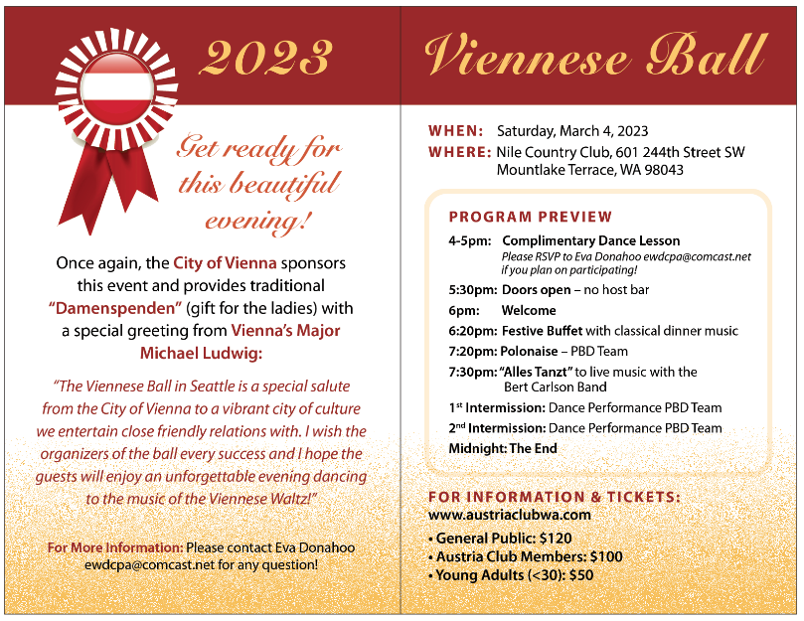

Attachemnt: Viennese Ball Flyer

