April HC Newsletter2020 -2

Dear Friends of Austria!
I hope this note finds you and your loved ones in good health and spirits as we adjust to the new normal of uncertainty in our lives.
NEWS FROM AUSTRIA:
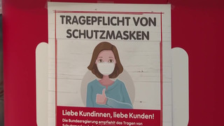 As this Covid-19 crisis is playing out globally, we are tempted to compare how different nations handle this situation, especially of course, how the situation plays out in Austria. After a rough and dramatic start of the spread of the Covid-19 virus in several skiing resorts in the Alps, the Austrian government (a coalition of the conservative and green parties) quickly took drastic measures of a nationwide lockdown, guided by recommendations of health experts. The Austrians accepted and generally complied. Although the number of infected was quite high, the number of deaths was relatively low, probably due to the existing excellent health care system and capacity in hospitals. It seems now that Austria has the worst behind, and the country is taking first steps to reopen gradually, always ready to hit the emergency break if necessary. Smaller shops are already open, they will be followed by larger ones beginning of May, and they hope to reopen restaurants and schools in segments beginning mid-May.
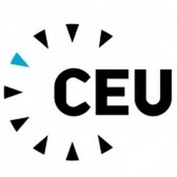April 15: The Otto Wagner Areal in the City of Vienna will become the permanent location for the Central European University (CEU). The CEU Board announces its decision to use the Otto Wagner Areal at Steinhof in Vienna’s 14th municipal district as the university’s permanent location after 2025. CEU will develop 35000 square meters of the site for classroom and office use. Further sections will be developed by the City and its partners into a housing site for up to 1500 students, and a university co-operation area as a future home for Austrian and international research institutes, university faculties and departments. The entire site, given its beauty, scale and complex history, should become an international center for learning and teaching, research and the arts and culture.
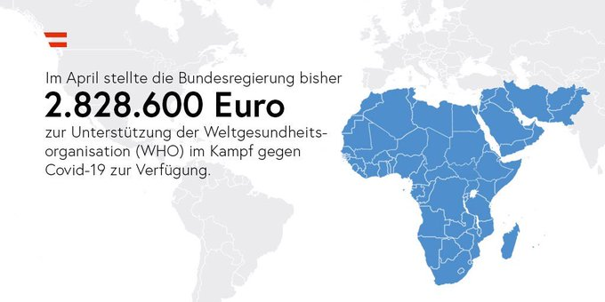 In April the Austrian government provided € 2.828.600 to the WHO in support of their vital work as the leading health agency, especially in Africa & the Middle East to contain the spread of the COVID-19 pandemic. Only together can we overcome this global health crisis.
April 15: Together with 39 other countries Austria signed a joint statement on the safety of journalists and access to information during the COVID-19 crisis underlining their support for the crucial work of journalists. Initiated by Austria, the statement is undersigned by the chairs and members of the Groups of Friends on the Safety/Protection of Journalists at the United Nations in New York and Geneva, OSCE in Vienna and OECD in Paris. It calls on all states to protect journalists’ and media workers’ safety, to safeguard a free and independent media, and to ensure unhindered access to information, both online and offline.
Austrian Postal Service: does not- at the moment - accept letters or packages from the United States and many other countries, and it seems that there are also restrictions for the postal service from Austria to USA. https://www.post.at/p/c/liefereinschraenkungen-coronavirus
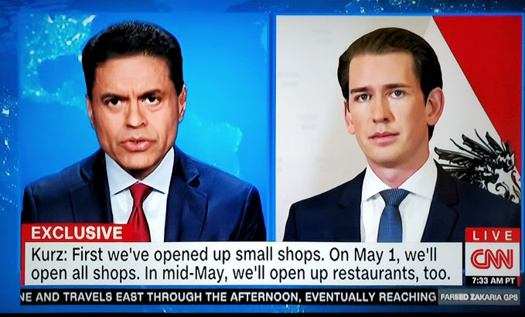 April 19: On CNN, Chancellor Sebastian Kurz was interviewed about lessons learned in Austria during the Corona-crisis. Austria decided on a strict lockdown followed by a controlled re-opening strategy. So far, the numbers look promising. But this ain't over. “It is important that we always have two weeks in between [phases]... to watch the numbers very carefully and slow down our reopening plan... And if necessary, also pull the emergency brake. As much freedom as possible and as many restrictions as needed.”
April 20: Coal power generation in Austria is history, Austria shut-down the last remaining coal-fired power station in Styria while pushing for renewable energy sources.
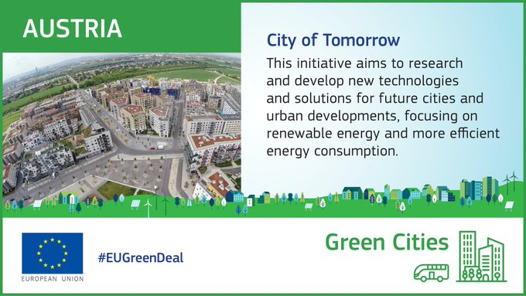 April 22: 50th anniversary of Earth Day: The EU & its Member States are committed to a greener and more sustainable future, including a Climate Neutral EU by 2050. With urban populations to double in size by 2050, cities will be instrumental in combating climate change. "City of Tomorrow" is committed to finding solutions to reduce urban climate impact while improving quality of life. Austria strongly supports the call from UN General Secretary António Guterres: “The #COVID19 crisis is an unprecedented wake-up call. We need to turn the recovery into a real opportunity to build a better future. On this Earth Day, join me in demanding a healthy and resilient future for people & planet.”
April 23: Vienna was ranked as Greenest City among the 50 most-visited cities, a list released by Resonance (a consultancy group in real estate, tourism, and economic development) on Earth Day. The ranking was based on criteria like the Austrian capital gets 30 % of its total energy needs from renewable sources, half of its population uses public transportation to get to work, access to a high number of public green spaces, city-wide recycling and composting programs, 135 farmers’ markets, air quality, and walkability.
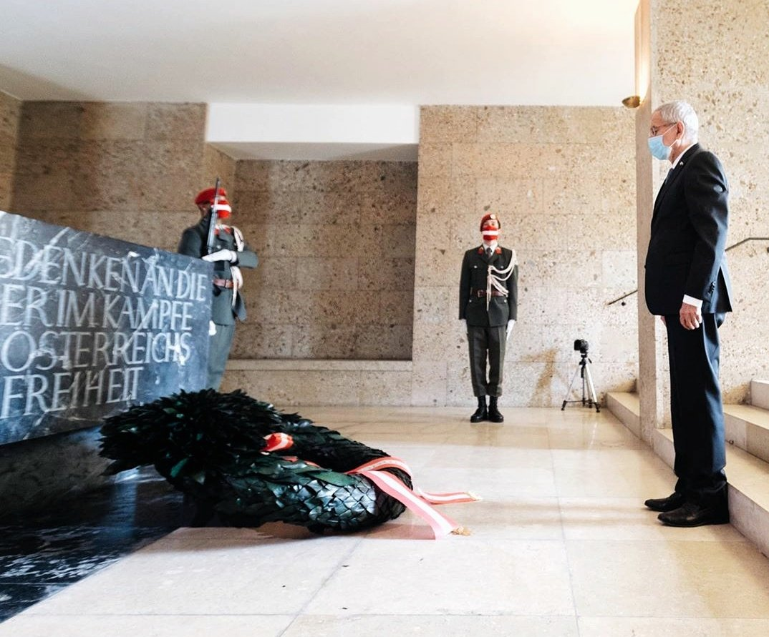April 27: Austria remembers 75 years of the 2nd Republic. Dr. Karl Renner declared independence that led eventually to a free and democratic Republic. Austria's President VanDerBellen laid a wreath in commemoration. Even such traditional ceremonies have quite a different look in times of the Corona-crisis....
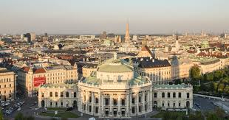 Wiener Burgtheater: everyday another member of the ensemble is presenting a thoughtful reading (Rettendes, Ablenkendes und Nachdenkliches) from their home: “My Home is My Burgtheater” https://www.burgtheater.at/myhomeismyburgtheater. Also, weekly there are different theater productions to watch for free: https://www.burgtheater.at/liebes-publikum

NEWS FROM HERE:
The public hours at the Consulate General in Los Angeles and at the Honorary Consulate in Seattle are still suspended.

Austrians for Austrians: A4A
These difficult times we are going through also show more clearly how much we need and rely on each other. The group Austrians for Austrians (A4A) continue to be ready for any kind of support, conversation, tech support or whatever there is a request for. Please see attached flyer for more information and whom to contact in addition of course to Rosie Mulholland, Eva Donahoo, Michael Brandstetter or myself. The telephone tree of the Austria Club chimed in and contacted many of you and will repeat this soon. A4A is ready for you!
One really lovely reaction came from Freya Burgstaller from Yakima who donated $300 toward this effort. We will save this money as a down payment for a “Friends of Austria” trip to Yakima for a wine tasting tour, something like a “Heurigen Tour”. We are eager to plan this trip as soon as we can!
Thank you, Freya, and all of you who contribute to this effort bringing us closer together.
Travel to Austria: Flights from SEA to Europe: currently all suspended. There are few flights to Europe from Chicago and the East Coast. There are discussions - but not confirmed yet - that flights from SEA to Frankfurt could resume by mid-May, to other European destinations by end of May. Entry to Austria from overseas is currently restricted to EU citizens only. To date, there are very few flights from Frankfurt or other European capitals to Vienna. Every person arriving from overseas must self-quarantine for 2 weeks. As restrictions change frequently, for the most recent travel information please see the website of the Austrian Consulate General in Los Angeles: www.austria-la.org. For flight information and connections please contact the airlines directly.
I share with many of you the uneasy feeling of not being able to travel to Austria right now if necessary.
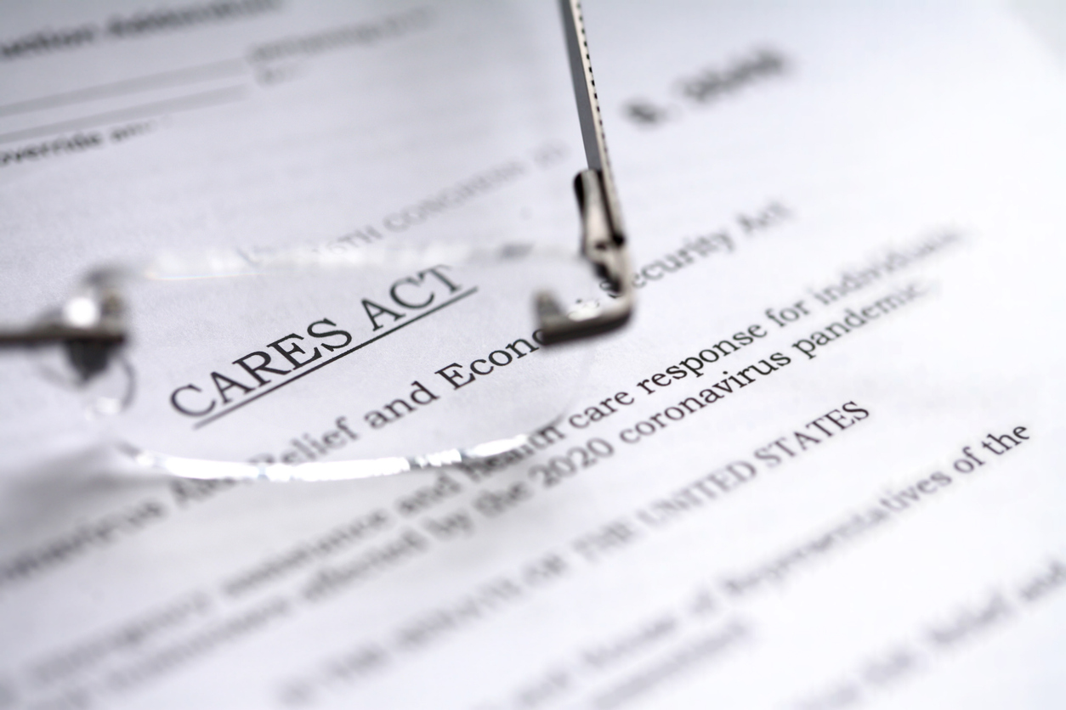 The restrictions for recipients of federal stimulus money and the new executive order by the President restricting the applications for Green Cards are fueling many questions about immigrant rights.
Ms. Cuc Vu, Director of Immigrant and Refugee Affairs of the City of Seattle (cuc.vu@seattle.gov) recommends to contact following organizations about information/donations/support for immigrant rights:
Northwest Immigrant Rights Project: www.nwirp.org and Washington Immigration Solidarity Network: www.waisn.org
More information on the impact of Covid-19 and eligibility for the CARES Act for immigrants (= non-citizens of all categories) is outlined in the attached ppt by Director Cuc Vu.
If you are a recipient of an Austrian pension and are worried about having missed the deadline for submitting the annual “proof of life”, here is a message of the Austrian Retirement Agency (PVA):
"Due to the COVID-19 pandemic and the resulting measures regarding exit restrictions as well as restrictions in international postal traffic, we hereby inform you that the Austrian Pension Agency will not stop paying out pensions in 2020 if certified certificates of being alive are not available. Irrespective of this, certified certificates of being alive will still be accepted. The restrictions also apply to individual correspondence, such as notifications, decisions and requests for necessary documents. As soon as the postal restrictions in a country are lifted, all documents will be sent with the same date of issue. It is therefore possible that letters may have become obsolete as a result of your direct contact by e-mail. “
Are you thinking of supporting a local business? The Kaffeeklatsch, a bakery and café in Lake City, Seattle, would need your support! Annette and her son Justus are working hard to keep their business afloat. Their bread, pastries and desserts are beloved by many of us, in addition they provided many times the sweet treats for Austria Club events. Go to: https://www.gofundme.com/f/kaffeeklatsch-needs-you ; At the end of the donation process if you want you can mention that you are from the Austrian community.
UPCOMING EVENTS:
All the following events are listed at the Meet-up “Austrian-Oesterreichische Gruppe”: https://www.meetup.com/Austrian-Stammtisch-and-Events/ .
You do not need to be a member to participate,
just contact Jürgen Schatzer juergen.schatzer@gmail.com or Elana Sabajon youcan@askelana.com for the links. But it would be great if you can join this “virtual component” to the Austrian community! Many thanks go out to Elana and Jürgen for organizing these events and keeping us connected especially if we cannot meet in person.
Wednesday, April 29: Movie “Silentium”, an Austrian movie from 2004, a thriller/satire with black comedy, about a man who accused a Catholic Bishop of abuse and died, while everybody wants to think he killed himself, well… almost everybody. The link https://www.meetup.com/Austrian-Stammtisch-and-Events/events/270283386/ is also posted on Meet-up Group “Austrian-Oesterreicher Gruppe “ or contact Juergen Schatzer juergen.schatzer@gmail.com
Sunday, May 10, 7pm: Movie: “Muttertag” – an Austrian 1994 comedy, satirical take on the life of a family in a public housing complex in Vienna as they prepare for Mother’s Day. The link https://www.meetup.com/Austrian-Stammtisch-and-Events/events/270283614/ is posted on Meet-up Group “Austrian-Oesterreicher Gruppe “ or contact Juergen Schatzer juergen.schatzer@gmail.com
Friday, May 15, 7pm: virtual Stammtisch – please join this next best thing to connect and have fun with other Friends of Austria! The link for the Stammtisch https://www.meetup.com/Austrian-Stammtisch-and-Events/events/270253075/ is also posted on the Meet-up group. The link for the zoom meeting will be posted on Meet-up Group “Austrian-Oesterreicher Gruppe “ or contact Elana Sabajon: youcan@askelana.com
Friday, May 22, 7pm: Spielabend – come share your favorite game we can play together! The link for this event https://www.meetup.com/Austrian-Stammtisch-and-Events/events/270253093/ is also posted on the meet-up, the link for the zoom meeting will be posted on Meet-up Group “Austrian-Oesterreicher Gruppe “or contact Elana Sabajon: youcan@askelana.com
Goethe Pop-Up Seattle: https://www.goethe.de/ins/us/en/sta/gps.html?wt_sc=seattle# is highlighting that https://kulturama.goethe.de/ is bringing international culture into your living room. German Story Time offers daily live readings of picture books in German during the quarantine. Every day, Monday through Friday, Beatrice Beckmann will read a classic or new, funny or smart book for the kids. Join on Zoom.
https://kulturama.goethe.de/event/german-story-time-250#2020-04-27T17:30:00+00:00

Nature is in full bloom. Wishing you that the beauty of nature surrounding us acts as a “Balsam auf die Seele” (balm for your soul) and to all the wonderful moms a Happy Mother’s Day – even if we only can “zoom” our thanks and feelings.
Herzlichst,
Eva Kammel
Honorary Consul for Austria in Seattle
office@austrianconsulateseattle.org

Attachments: ppt: Cares Act and immigrants; A4A

