HC Newsletter March
Dear Friends of Austria!
As we are all hunkered down in our homes, we all have to adjust to the new normal, at least for a while. Most important though is that you stay healthy and keep up your spirits!
Following the guidelines set by the Consulate General of Austria in Los Angeles and the Stay-at-Home/Stay Healthy order issued by Gov. Jay Inslee, the Honorary Consulate of Austria cannot schedule any appointments that require an in-person meeting, but of course we continue to serve via email, phone calls etc. So please reach out with any questions!
NEWS FROM AND ABOUT AUSTRIA:
Corona Virus in Austria:
February 25: the very first case in Austria was reported, a couple in Innsbruck coming from the troubled region in Italy. As of 3/25/2020: Infected people: 5,264; 28 deaths
Since March 10: non-EU/EEA/CH citizens having been to a Corona risk area (Italy, Iran, South Korea & parts of China) in the last 14 days must present a negative SARS-CoV-2 test certificate upon entry to Austria.
Since March 15, there are strict Stay-at-Home orders in place, similar to those in WA State. The military and civil servants (Zivildiener), also those who already left the army are recruited to help ease the load for the health care workers. All borders closes, also for air travel, only essential traffic and goods can go through. In Tirol, even stricter rules are imposed to stem the massive uptick of new cases, especially in remote ski resorts, like Lech and St. Anton.
March 19: The Ministry of Foreign Affairs askes urgently that Austrian Tourists currently abroad to return to Austria immediately and register at: https://www.bmeia.gv.at/reise-aufenthalt/auslandsservice/reiseregistrierung/ , necessary to get in contact with the Austrian authorities. Further information also at the Homepage of the Austrian Airlines: https://heimflug.austrian.com/
For all returning to Austria via air transport, a 14-day self-quarantine is mandatory.
March 23-25: Repatriation flights: as of March 25: 5,000 people, 28 flights organized by the Ministry of Foreign Affairs and Austrian Airlines. From Washington DC to Vienna about 300 Austrians took this opportunity on Monday, March 24. No further flights from mainland USA to Austria are planned so far.
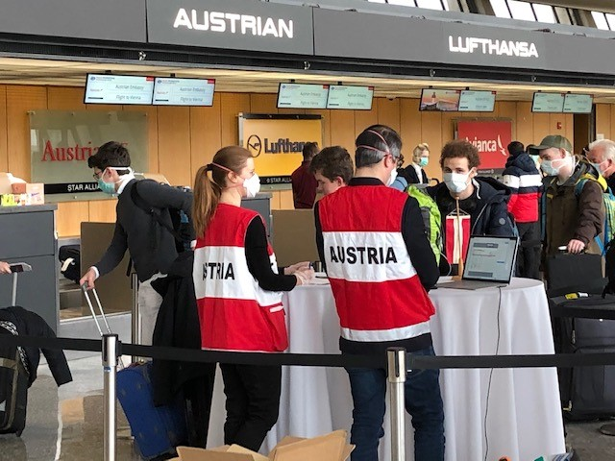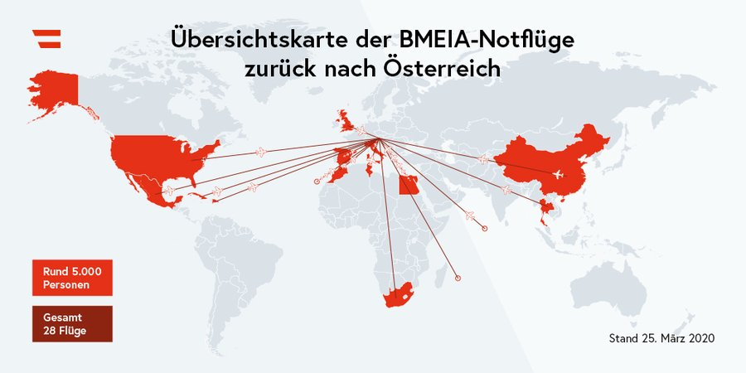
If you know of any Austrian citizen who is still in the US as a tourist and wants to return home, please direct them to these websites and /or contact Eva Kammel at office@austrianconsulateseattle.org, Tel: 425395 4382
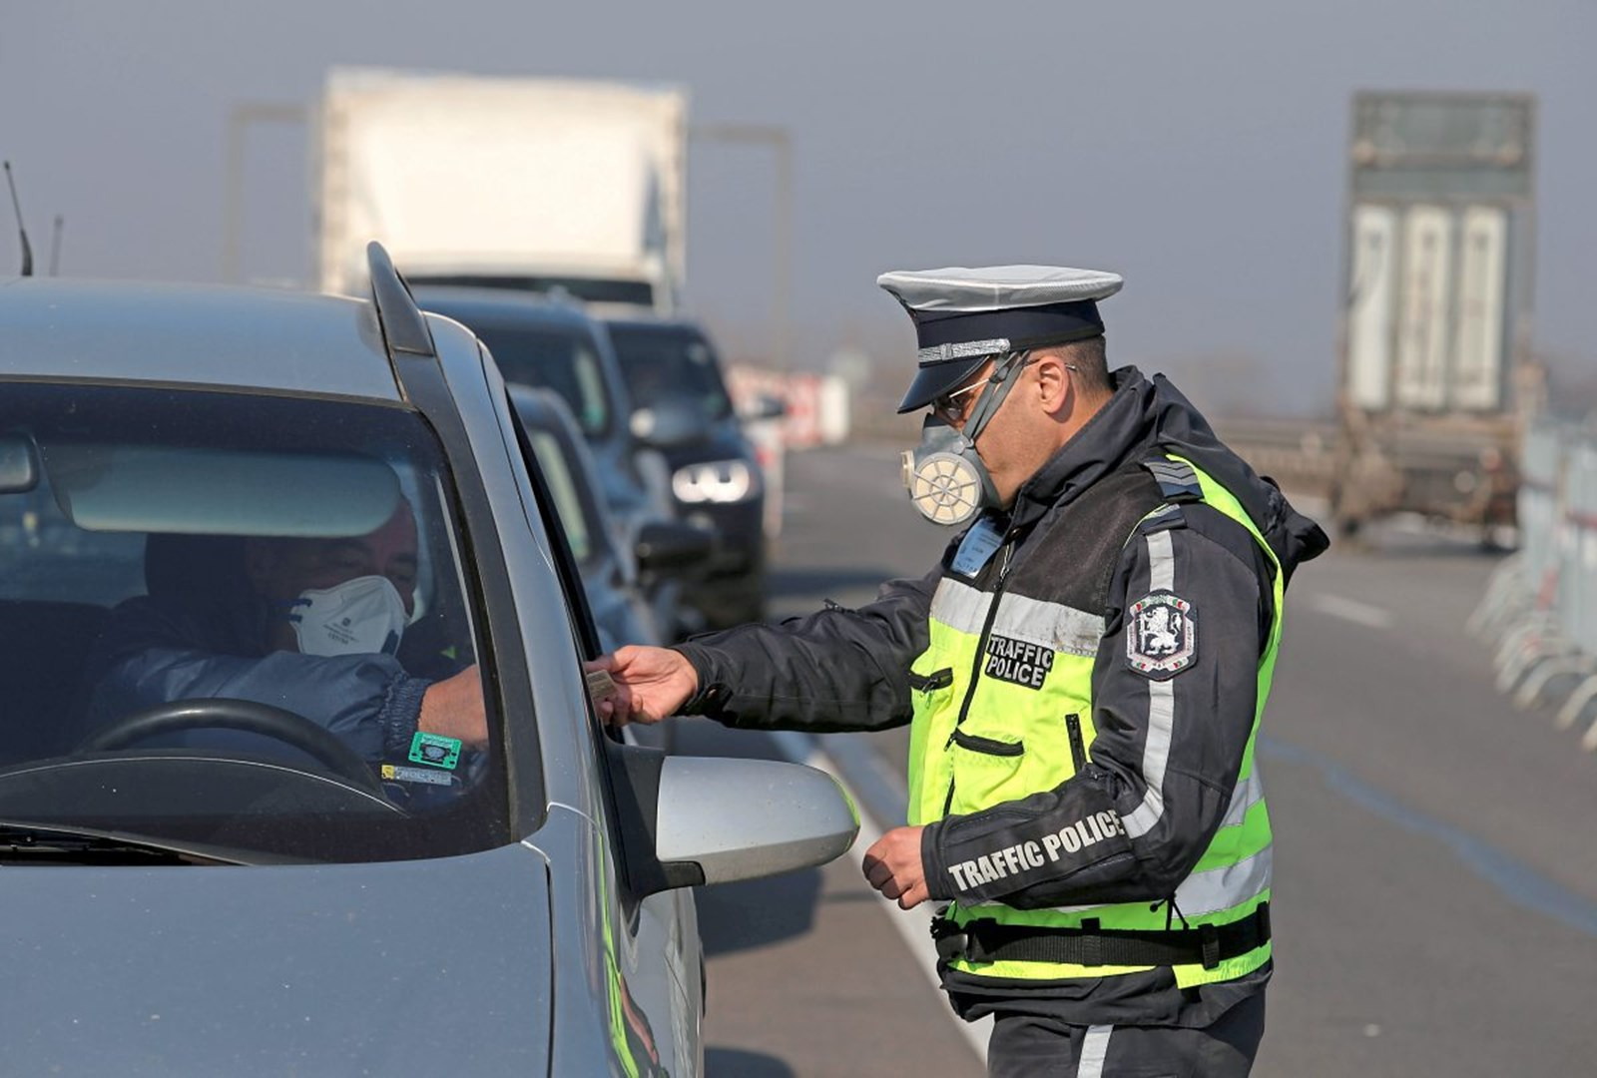 March 25: According to a Gallup International Survey, Austrians have the greatest trust in their government to handle the crisis in the right way: 50% are in total agreement with the steps the government is taking, and 38% are mostly satisfied, that bis a total of 88% in agreement, the highest mark any government worldwide has reached. Even more remarkable as the conservative-green coalition in only in power since 2 months!
The lowest rating got Thailand with 39% having no trust at all in their government. For comparison: In the US 23% have not trust, and only 8% agree totally that the government is taking the right steps.
Also interesting the attitude towards the danger of the Covid-19 virus:
In Austria: 9% are thinking that the danger is totally overrated, and 15% find it overrated.
USA: 23% think it is totally overrated and 32% overrated.
More info see: https://www.derstandard.at/story/2000116104021/vertrauen-in-krisenkompetenz-der-regierung-in-oesterreich-besonders-gross

The hard hit Italians are coming together to fight the crisis: their balcony concerts become a famous uplifting story: https://heavy.com/news/2020/03/italy-balcony-concerts-coronavirus/
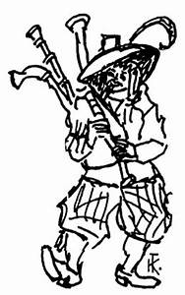And what have Austrians offer? “Der Liebe Augustin” showed us that we can survive with humor, music and 100 percentage drinks even the black pest. In 1679, Vienna was struck by the Great Plague and Augustin was a ballad singer and bagpiper, who toured the city's inns entertaining people. The Viennese loved Augustin because of his charming humor in bitter times and he became a symbol of hope. Following the legend, he survived even a night among the dead corps….. by being totally drunk
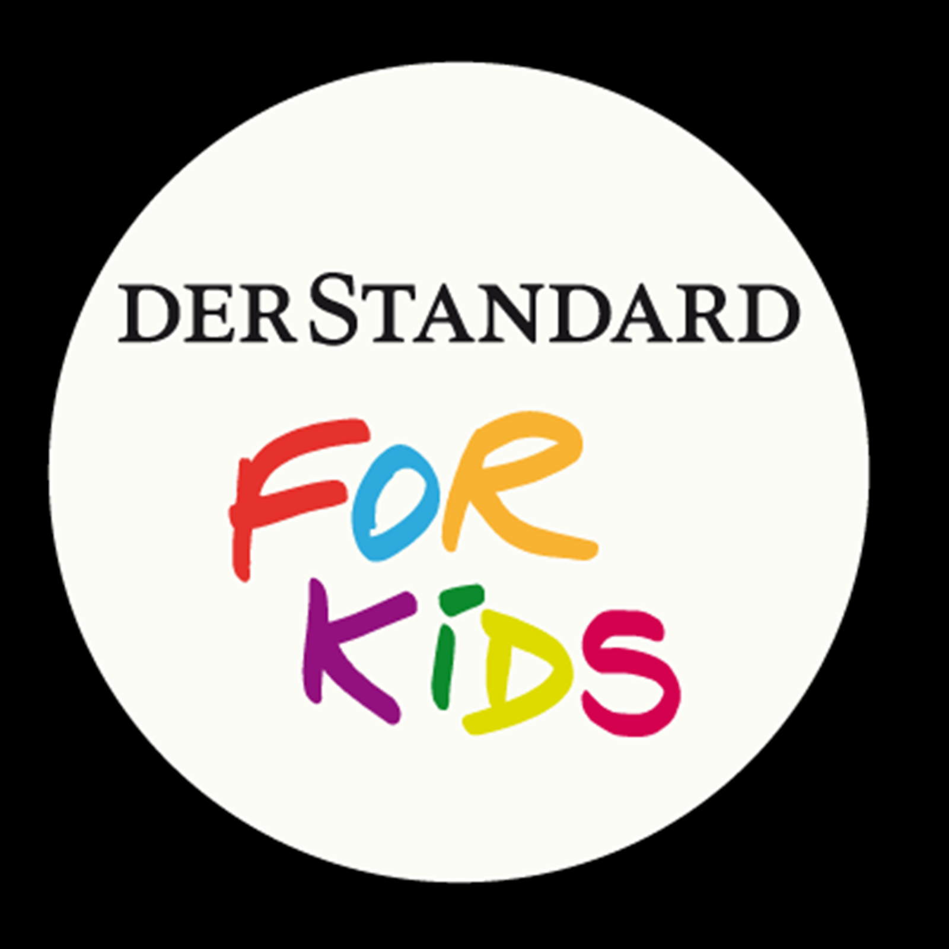 Having kids at home? Here are some “Lessons for Kids” issued by the newspaper “Der Standard” also in English: https://www.derstandard.at/story/2000115947867/a-small-lesson-about-corona

Thinking of your families overseas, and worried that - at the moment - there is no chance to visit them? This feeling is especially hard if you have aging parents, family members with whom you can have at best virtual exchanges. Today I could not even order a bouquet of flowers to a relative in a senior citizen home in Vienna as it is closed to all outside contact. Maybe this beautiful presentation by actor (Burgtheater) Maria Happel provides some comfort. https://www.youtube.com/watch?v=MJr769BACHA . Thank you, Veronika Spies for sharing!
UPCOMING EVENTS:
Sorry, ….. nothing to report, only cancellations …… no, that is not true!
Hardy Austrians are not easy being discouraged! Join the virtual Stammtisch with the Austrian Meet-up group hosted via zoom! https://www.meetup.com/Austrian-Stammtisch-and-Events . The next one will be on Tuesday, April 7, 7-9pm. Please contact Elena Sabajon for more info: youcan@askelana.com
Wishing you all that you stay healthy by following the social distancing guidelines but still remain socially and physically active by using all the tools we have and by enjoying the beautiful colors popping up around us – reminding us that nature is more than a virus and friendship is stronger than 6ft distance.
Please do not hesitate to contact me if I can assist you in any way.
Herzlichst,
Eva Kammel
Honorary Consul of Austria in Seattle,
office@austrianconsulateseattle.org

